Fighting Crimes with Predictive Analytics
CSC423 PROJECT conducted by Nandhini Gulasingam
Kun Lin (Nicole), Renel Chesak
11/23/2016

PREFACE
A quick note before the main body.

In the main body, there are some words marked with a superscript number. The number means you can find related chart or table in the Appendix part. The superscript number correspond the number in appendix list.
If you are reading on computer with word, we highly recommend you to read with the “Navigation Pane” on the side (View—Navigation Pane). With Navigaton Pane, it will lead you more efficiently to the related appendix part. If you read on papers, you can easily find the related chart or table based on this number.

Hopefully, you can enjoy the reading!

Table of Contents
PREFACE 1
ABSTRACT 4
INTRODUCTION 4
REFERENCE REVIEW 4
METHODOLOGY 5
1. General Methodology 5
2. Methodology in Renel’s Model 6
3. Methodology in Nicole’s Model 6
ANALYSIS AND RESULTS 6
1. Renel’s Model 6
2. Nicole’s Model 8
2.1 Variaable changes based on exploration and references 8
2.2 Model selection in each model category 9
2.3 Comparison of best models from different categories²² 9
2.4 Interpretation 10
2.5 Prediction 11
DISCUSSION AND LIMITATION 11
1. Discussion between two models 11
2. Discussion with reference 12
CONCLUSION 12
LIMITATION AND FUTURE 12
APPENDIX 14
1. Dummy Variables: 14
2. Dataset Description 14
3. Transformations in Renel’s Model: 15
4. Outlier Detection 16
5. Correlations 17
//6. Correlations 17
7. Correlations 18
8. Stepwise Selection Model 18
9. CP Selection Model 19
10. Adj-R2 Selection Model 19
11. Backward Selection Model 20
12. Proc GLM Stepwise Selection Model 21
13. Adj-R2 Selection: Number of variables in model. Adj-R2 for that model. 22
14. CP Selection: |CP - k+1| Number of variables in model. Adj-R2 for that model. 23
15. Adj-R2 Selection Model Validation: 23
16. CP Selection Model Validation: 24
17. Correlations 25
18. Parameter Estimate Interpretations 25
19. Renel’s Model Predictions 25
20. Histogram of Crimes, LogCrimes, SqrtCrimes 27
21. Table of 18 Categories/Possible Combinations 28
22. Table of Key Statistics about Best Models from Each Categories 28
23. Model 14 29
24. Model 17 (Final Model) 30
25. Model 10 32
26. Model 4 32
27. Nicole’s Model Predictions 33
REFERENCES 34
CODES 35
Renel’s Code 35
Nicole’s Code 45

ABSTRACT
A multiple linear regression model was built on a dataset of demographic records from the 1990s order to determine (1) what predictors most influence crime rate and (2) how we can predict the crime rate in a given county. Two data scientists used several model selection techniques to identify an adequate model, being sure that all model assumptions were met and the model predicts adequately. Our models indicate that population density has the largest effect on crime, followed by per capita income, location in the North West region of the US (as opposed to the West), and poverty rate. These models can predict with about 73% accuracy (r = 0.73), and can explain about 62% (Adj-R2 = 0.62) of the variance seen in crime. Given these findings, we recommend police forces increase patrols in highly populated areas and areas with a high poverty rate. We also recommend that policy makers look for ways to decrease the poverty rate in their counties, and that community outreach groups do the same.

INTRODUCTION
What factors cause serious crime? How can society better contain or reduce crime rates? Crime reached a relative peak in the US during the early 1990s (Truman, Planty, 2012), providing ample data for exploring such questions. This analysis will look at a number of factors19 and use a multiple regression model to predict crime rate and determine which factors most influence crime. Predictive analytics has the potential to be used by law enforcement to better allocate resources, by policy makers to drive decisions and regulations, and by non-profits to develop community outreach. In fact, many cities are already utilizing predictive models to fight crime, including Chicago (Davey, 2016), Memphis, San Jose, Los Angeles and others (Government Technology, 2010). For example, the Richmond, Virginia police department predicts the location of future crime, and updates this daily to make the patrol route schedule for police officers. Their model includes things such as whether it’s a holiday or payday, that day’s city events, the weather, and the day of the week. In Memphis, Tennessee, such procedures have been credited with a 31% decrease in crime (Siegel, 2013).

REFERENCE REVIEW
The variables in the dataset can be divided into three categories—education, economics, and population. All the variables, except Area, Docs, and Region, are included in the three categories. All the references research is based on the three categories. After dividing variables into categories, the reference researches become more targeted and help a lot to understand the variables in the dataset.

- Population: Total_Pop, Pop18_34, Pop65plus, Beds
- Economics: Poverty, Unemp, PCIncome, Pers_Income
- Education: HSgrads, Bgrads

Education, economics, and population composition factors have been a major focus of predicting or explaining the crime rates. Even though the theories to explain the relationships between crime rates and most factors mentioned in this dataset are different, they are proved to be related with crime rates in most previous researches.

For population factors, popular variable used to present this factor is population density, which is more helpful to understand the social networks in the community (Tita and Coessen, 2012; Buczak and Gifford. 2010). Some specific sub population category are the important factors for crime, like gender and age. The age structure of a society has the most influential effect on the level of crime in a society— the key demographic variable appears to be the size of the male population within the crime-prone years of 15 to 25. The aging population in 1990s, which means there were less people in the age group of 15 to 25, is an important factor for the decreasing crime rates in 1990s (Schneider, 2002).

For economics factors, it’s also proved to be highly related with the crime in society. While most studies show a positive relationship between unemployment and crime (Baron, 2008), there is not a consistent relationship between the unemployment rate and crime rates (Crutchfield and Ramirez, 2012). The relationship may change because of different crime types (Parker and Horwits, 1986) or different time periods (Chiricos, 1987). The common variable about personal or family income is median family income (Crutchfield, Wadsworth, Groninger, and Drakulich, 2006). Pers_Income, which means the total personal income of all the population, was rarely used in the previous researches.

For education, it’s also a popular characteristic to explain crime rates. With different theoretical reasons, the relationship between education and crime rates is complicated. HSgrads, which refer to the high school graduate rates, is a more common variable used to represent education level of the community than Bgrads, which is percentage with bachelor’s degree (Lochner and Moretti, 2001).

Methods used in previous studies are sophisticated and can’t refer to this analysis. What can be considered for this research is about Interaction term or transformation of the variables. About the interaction terms, age and employment (Shover, 1996), age and work treatment (Uggen, 2000), are the two most mentioned interaction terms. However, the joint relationships are controversial. Hirschi and Gottfredson (1983) argue that age affects crime directly and doesn’t interact with any known casual variables in its effect on crime. Another interaction term used often is the unemployment rate and poverty, which can be interpreted as “the respondents’ objective labor market conditions and their interpretations of these conditions” (Baron and Hartnagel, 1997).

METHODOLOGY

General Methodology
The data explored in this analysis comes from Professor Gulasingam’s collection of county demographic information from the U.S. Census and the Bureau of Justice Statistics (Crimerates_data.txt). It contains data for the 440 most populous counties in the US during 1990 and 1992. It includes information about location, population, age, education level, unemployment, income, physicians, and crime rate. In particular, crime rate is only recorded for serious crimes, such as robbery, rape, aggravated assault, and murder. The data used in this analysis was quite clean to start, however we did notice that PCIncome = (Pers_Income / Total_Pop), so we threw out Pers_Income. Including such a redundant variable would cause overfitting of the model. We also created dummy variables for the variable Region¹.

Both Renel and Nicole follows the following general path in their separate model building work.
- Data Exploration
  - Visualize data—scatterplots and histogram
  - Based on the result of visualization, to develop a better regression model, transform the variables and/or create interaction terms.
- Validation Split
- Model selection
  - Use one or few selection methods among forward, backward, stepwise, adjusted R2, and CP selections.
  - Test assumptions – Residual Analysis
  - Test the overall fitness – Goodness of Fit Test
  - Deal with multicollinearity, outlier and influential point issue
- Model validation
  - Based on the model selection, there may be few nice models selected. Use model validation to finalize the model to use in prediction.
- Explain the final model

Methodology in Renel’s Model
Renel’s model included transformations with the goal of improving residuals to fit the assumptions of the linear regression model3. Data exploration was done to see how well the correlations and distributions fit the assumptions of the model. Several model selection methods where used, including stepwise, CP, adj-R2, backward selection, and proc glmselect (with stepwise selection) for a second-order model. Hold-out validation was used to test the fit of the model with 75% of the data (n = 330) used for training and 25% (n = 110) used for testing.

Methodology in Nicole’s Model
In Nicole’s model, most of the transformations and interaction terms are created from the very beginning based on reference study, which also includes creating new a variable and deleting existing variables. To better understand the rich mixture of different versions of y- and x- variables and avoid missing any possible y- and x- variables combination, Nicole developed all the possible combinations and create different categories. The goal is to find one best model for each category and in the end, reach the best model of all by comparing all the best models selected from each category. There are 18 categories in total with last 6 categories added because of the not randomly distributed residual points of variable Land. Before the selection, original dataset is splited into training set (75%, n=330) and test set (25%, n=110). All the selections are based on one same training set. Forward, backward, and stepwise are used in the model selection inside of each model category.

ANALYSIS AND RESULTS

Renel’s Model
Renel’s analysis included looking at the residuals of the independent variables and using several transformations to successfully improve the constant variance, linear independence, and equal distribution about the zero line³. This was also done for the dependent variable to improve the residuals in the same manner as well as make the distribution more normal. With the transformed variables, all residuals fit the assumptions of the model. You can see in the all residuals that there is one very clear outlier. Most outliers and influential points were considered part of the natural variation of the dataset, since the data cannot be confirmed. However, the range of each variable was checked to look for suspicious, unreasonable elements, such as 105% of a population being aged 18-34, or outrageously low or high incomes. The only instance of such an outlier occurred in one county, where the average number of beds per household (BEDS) was 20. Given that the average across all counties was only about 3, a county with an average of 20+ people living in 1 household is very suspicious⁴. However, removal of this point actually decreased the adj-r2 by 1%. Given that this data cannot be verified, and removing it doesn’t help the model, it was left in. The correlations between crime and the independent variables showed that the relationships were weakly linear⁵. However, this is common in real-world data, and even weak relationships can contribute to an overall adequate model, so the data was sufficient to move forward.

When looking for multicollinearity, the Pearson Correlation Coefficient table was examined for the transformed variables, which identified two pairs of predictors that were moderately collinear. These include invPop18_34 with Pop65plus (r = 0.72534, P < .0001), and Hsgrads with Bgrads (r = 0.70779, P < .0001)⁶. The former is likely due to normal population growth; normally, the two are negatively correlated. The correlation between the untransformed variables was moderate and negative⁷. However, we looked at the inverse of the younger population compared to the older population, so the correlation became positive. The latter is likely due to an obvious correlation between educational attainment; more high school attainment leads to more bachelor attainment. When examining the final models, each predictor was checked for a VIF statistic > 10 and a tolerance value < 0.1. Any predictors that met this criteria where thrown out of the model, beginning with the predictor with the highest VIF or tolerance value.

The best models where chosen from each of the following selection methods: stepwise⁸, CP⁹, Adj-R2¹⁰, and backward selection¹¹. The first four models all pass the goodness of fit test (P < .0001) and have comparable RMSE and Adj-R2 values (RMSE ≈ 1, Adj-R2 ≈ 0.52). The main difference between these models is the number of predictors; all contained 8 except for the Adj-R2 model, which contained 5 variables. CP and Adj-R2 selection both output dozens of possible models, and their output was moved into a pivot table in MS Excel. The Adj-R2 models¹³ were sorted by the Adj-R2 values and number of variables in the model in order to optimize both. All Adj-R2 models had comparable Adj-R2 values (Adj-R2 ≈ 0.52), and the main difference between the models was the number of variables in the model. The model with the fewest number of variables was chosen. The CP models¹⁴ were sorted by |CP - k+1| in order to maximize the similarity between CP value and number of variables in the model, as well as by the Adj-R2 values and number of variables in the model. All Adj-R2 values were in the range 0.54 – 0.52 and thus were comparable, but the |CP - k+1| increased somewhat drastically as the number of predictors decreased. So in this case, a balance had to be struck between |CP - k+1| and number of predictors in the model, and the final model contained 8 predictors. Proc glmselect¹² (with stepwise selection) was also used for a second-order model, but it had the lowest Adj-R2 (0.51), and the combined variables didn’t make intuitive sense. It was determined that the model created with full second order terms would have had far too many predictors for such a small dataset, and thus the selection process was arbitrary. Thus, this method for choosing a model was thrown out for this dataset.

The stepwise⁸, CP⁹, and backward selection¹¹ models are all comparable in Adj-R2 (0.528) and contain 8 predictors, while the Adj-R2¹⁰ had an Adj-R2 = 0.516 and contained 5 predictors. For final model validation, the CP⁹ and Adj-R2¹⁰ models were chosen to see the contrast between models built with a different number of predictors. The Adj-R2 model¹⁵ and CP model¹⁶ both have comparable RMSE (1.2, 1.8, respectively), MAE (0.95, 0.87, respectively), and both have a training set mean and SD of 7.3 + 1.7 for crime and a testing set mean and SD of 7.4 + 1.2, meaning that the prediction error is low for both models. The CP model does have a slightly stronger correlation between the predicted value and the actual value (r = 0.74) compared to the Adj-R2 model (r = 0.70), but this difference is not enough to justify the 3 extra predictors in the CP model. Therefore, the better model is the one chosen by Adj-R2 selection¹⁰. The final model equation is:

sqrtCrime = 9.16 – 0.269*logLand + 1.78*sqrtPoverty – 80,553*invPCIncome – 1.44*dRegion1 – 0.968*dRegion2 + e

Using this model, we can make predictions¹⁹ about crime rate. Given a county of 899 sq. mi., a poverty rate of 10.24%, a per capita income of $21,000, a population of 1,000 and located in the North East region of the US, the predicted crime rate for the year of 1990 will be 68 crimes, and we can say with 95% confidence that that actual average crime rate will be between 62 and 74. Given a county of 1,097 sq. mi., a poverty rate of 5.20%, a per capita income of $24,400, a population of 1,000 and located in the North Central region of the US, the predicted crime rate for the year of 1990 will be 65 crimes, and we can say with 95% confidence that that actual average crime rate will be between 60 and 70.

This final model has an Adj-R2 that is weak but adequate (0.5162), which predicts better than random chance and possibly better than human intuition. It also has low error (RMSE = 1.2), and adequate prediction accuracy (r = 0.70). This model explains about 52% of the variance seen in crime rate. This model is adequate, however, it could certainly be improved if it were trained with more observations. The following 5 variables were determined by model selection to be the most significant predictors, and they can be interpreted as follows¹⁸. A 1% increase in the poverty rate will result in an increase of about 1.8 crimes per 1,000 population. A 1% increase in square miles of land area will result in a decrease of about 7.203 crimes per 10 million population. For every 1 billion dollar increase in per capita income, crime will decrease by about 1.54 crimes per 10,000 population. If a county is in the North East region (dregion1) of the US, crime will decrease by 2.08 crimes per 1,000 population, compared to the West region. If a county is in the North Central region (dRegion2) of the US, crime will decrease by 1 crime per 1,000 population, compared to the West region. The standardized parameter estimates¹⁰ indicate that poverty is has the strongest influence on crime, which makes intuitive sense. This indicates that targeting income inequality should be an effective tool for policy makers and community outreach organizations looking to decrease the crime rate. The second most important predictor was per capita income, and this had a negative effect on crime. This makes sense for the same reasons that poverty has a positive effect on crime; both indicate that people with less money are more likely to commit crime. It makes sense that poverty rate is a stronger predictor because it is a direct indicator of how many people have less money, whereas two counties could have the same per capita income with a very different distribution of wealth. The fact that per capita income and poverty rate are not strongly correlated (r = -0.06)¹⁷ indicates that there are counties with different distributions of wealth, meaning that some areas have more income inequality than others.

Nicole’s Model

2.1 Variaable changes based on exploration and references
In the exploratory analysis, depend variable’s transformation is based on the distribution and independent variables’ transformations are based on the reference. Based on the histogram of dependent variable, crime rates, it is lightly skewed. To make the dependent variable more normally distributed, logarithm (LogCrimes) and square root (SqrtCrimes) transformations are applied. Based on the histogram of the transformed crime rates, square root transformed crime rates is an almost perfect normal distribution. Technically, the SqrtCrimes should be the best transformation for crime rates.

Based on the references, few changes are made on independent variables.
- Create new variable with two existing variables: Pop_Density = Total_Pop / Land
- Delete two existing variables to avoid overfitting problem: Total_Pop, Pers_Income
- Transform some variables based on reference: LogPCIncome, LogPop_Density
- Transform one variable based on residual plots: LogLand
- Create interaction terms based on reference: Pop18_34*Unemp, Pop65plus*Unemp, Pop18_34*PCIncome, Pop65plus*PCIncome, Poverty*Unemp.
  - When transformed PCIncome is used in analysis, the interaction terms are changed to Pop18_34*LogPCIncome, Pop65plus*LogPCIncome
  - To avoid multi-collinearity, all related variables are centered, including Pop18_34, Pop65plus, Unemp, PCIncome (LogPCIncome), Poverty.

After the exploratory, three different kinds of independent variables are included in the new dataset, original variables, transformed variables, and interaction terms. To reach the best model, there are 18 kinds of combinations of independent variables created. The approach to the best model is to find the best model of one independent variable combination and compare the statistics of the 18 models²¹ to get the final best model.

2.2 Model selection in each model category
Considering different selections may lead to different combination, three variables selection methods are used for training set—forward, backward, and stepwise. Most of the times, there would be 2 different models selected by the three methods in one category. Compare the selection results from the three methods, remove significant outlier and influential points (based on studentized residual and cook’s d), compare the prediction performance, and then decide the best model in this independent variables combination category.

Based on the complete selection process, there is a good model, which is better than others with same variables and don’t have problems on linear regression assumptions or serious outlier or influential points. When finished all these processes, the selected models are ready to be compared for reaching the final model.

2.3 Comparison of best models from different categories²²
All the key statistics are in the appendix table²², showing the accuracy and prediction performance, which is more clear to compare all the models. Because the best models in category 8, 12, and 16 are same with the previous models, there are 15 best models from different categories to compare. Based on the Adj R-Sq, the Model 14, 15, and 17 are the top three one with Adj R-Sq value over 62%. Considering that Model 15 includes two more variables with only 0.32% more on Adj R-Sq value, Model 15 is kicked out of the consideration of final model. After the selection with different independent variables and comparison among the 15 best models, there are two very competitive models for final best—Model 14 and Model 17.

2.3.1 Model 14²³
Model 14 is the one selected among transformed LogPop_Density, LogPCIncome, LogLand, interaction terms, and other original x-variables by forward and stepwise methods, with 2 observation points deleted. The equation is as follows,

Crime = -73.47831 + 1.46901*LogLand + 0.71814*Pop18_34_c + 3.04293*Beds + 1.54081*Poverty_c – 26.25864*dRegion1 – 15.42469*dRegion2 + 11.99569*LogPop_Density – 0.11218*Poverty_Unemp_c + e
  - dRegion1 = 1, if Region = “NE”, which means the county is North East of US
  - dRegion2 = 1, if Region = “NC”, which means the county is North Central of US

Importance of variables (from high to low):
LogPop_Density (0.53998), dRegion1 (-0.43889), LogLand (0.30342), Poverty_c (0.27520), dRegion2 (-0.26221), Beds (0.25022), Pop18_34_c (0.11842), Poverty_Unemp_c (-0.09322)

2.3.2 Model 17²⁴
Model 17 is the one selected among transformed LogPop_Density, LogPCIncome, LogLand, and other original x-variables by forward and stepwise methods, with 4 observation points deleted. The equation is as follows,

SqrtCrime = -3.12423 + 0.58238*LogLand + 0.04668*Pop18_34 + 0.20362*Beds + 0.07905*Poverty – 1.87723*dRegion1 – 1.02408*dRegion2 + 0.76986*LogPop_Density + e
  - dRegion1 = 1, if Region = “NE”, which means the county is North East of US
  - dRegion2 = 1, if Region = “NC”, which means the county is North Central of US

Importance of variables (from high to low):
LogPop_Density (0.53177), dRegion1 (-0.48134), LogLand (0.30644), dRegion2 (-0.26486), Beds (0.25703), Poverty (0.21643), Pop18_34 (0.11773)

2.3.3 Final comparison of Model 14 and Model 17
To learn the differences and choose the final best model, check the residual plots and compare the statistics of two models.

Based on the following chart, the statistics of the two models are very similar. For the Adj R-Sq, Model 14 is higher by 0.18%, while for the Validation coefficient r, Model 17 is higher by 0.00213. Considering the differences are not significant, residual plots should be key to achieve the final decision.

When achieving the best model in each category, all the points with two arrows on Studentized Residuals and Cook’s D have been removed. Even though there seems to be some outliers in the residual plots of Model 14, all the points have been checked and to keep more original data, no more points should be deleted in Model 14.

Besides of outliers, another issue shown in the residual plots of Model 14 is about whether this model satisfy the assumption. The interaction term is the interaction of two continuous variables. If the interaction term includes dummy variable, it’s all right that the created interaction term doesn’t randomly distributed. However, for one interaction terms with two continuous variables, this points are not independent.

Considering all the reasons above, the final model is Model 17.

Interpretation
The final model equotation is as follows,
SqrtCrime = -3.12423 + 0.58238*LogLand + 0.04668*Pop18_34 + 0.20362*Beds + 0.07905*Poverty – 1.87723*dRegion1 – 1.02408*dRegion2 + 0.76986*LogPop_Density + e
  - dRegion1 = 1, if Region = “1”, which means the county is North East of US
  - dRegion2 = 1, if Region = “2”, which means the county is North Central of US
In this model, there are 7 variables inside, including two dummy variables, dRegion1 and dRegion2. The most influential variables in the model is as follows, LogPop_Density (0.53177), dRegion1 (-0.48134), LogLand (0.30644), dRegion2 (-0.26486), Beds (0.25703), Poverty (0.21643), Pop18_34 (0.11773). The LogPop_Density is the most influential variable in this model. In fact, though in other also good models the most influential variables ranking may change, Pop_Density is always the most influential variable in the models. Pop_Density is very important variable to predict the county crime. dRegion1, which means North East US, is also an important variable in several models.

Parmeter Interpretation: 1% increase in Land area is associated with 0.58238*ln(101/100) ≈ 0.00579 change in SqrtCrimes, which is 0.00003 increase in Crimes; 1% increase in Pop18_34, which is the percentage of population from age 18 to 34, will increase 0.04668 of SqrtCrimes, which is 0.00218 increase in Crimes; one more in average household sizes, which is variable Beds, will increase 0.20362 of SqrtCrimes, which is 0.0415 increase in Crimes; 1% increase in Poverty, which is the percentage of population below poverty, will increase 0.07905 of SqrtCrimes, which is 0.00625 increase in Crimes; if the county is in North East US, the SqrtCrimes will decrease 1.87723, which is 3.524 decrease in Crimes; if the county is in North Central US, the SqrtCrimes will decrease 1.02408, which is 1.0487 decrease in Crimes; 1% increase in Population density is associated with 0.76986*ln(101/100) ≈ 0.00766 increase in SqrtCrimes, which is 0.000059 increase in Crimes.

Prediction
Here is the two datalines used in the prediction. The prediction output table is in the appendix²⁷.
LogLand | Pop18_34 | Beds | Poverty | dRegion1 | dRegion2 | LogPop_Density
9.12739 | 29.2 | 2.8764 | 8.8 | 0 | 0 | 5.4405
6.32257 | 31.6 | 5.2255 | 6.4 | 0 | 1 | 7.5249

The first case is that if it’s a county neither in North East US or North Central US with land area 9203.97 (e^9.12739) square miles, 29.2% of population aging from 18 to 34, 2.8764 average household size, 8.8% people under poverty line, and 230.56 (e^5.4405) persons per square miles, the crime rates in this county is predicted to be 81.43 per 1000 population, with 95% C.I. equal to (73.47, 89.81) per 1000 population, and a 95% prediction interval equal to (48.41, 123) per 1000 population.
- 81.43 = 9.0241(Predicted value) ^ 2
- original C.I. interval (8.5714, 9.4768), original prediction interval (6.9576, 11.0906)

The second case is that if it’s a county in North Central US with land area 557.003 (e^6.32257) square miles, 31.6% of population aging from 18 to 34, 5.2255 average household size, 6.4% people under poverty line, and 1853.63 (e^7.5249) persons per square miles, the crime rates in this county is predicted to be 70.09 per 1000 population, with 95% C.I. equal to (64.76, 75.63) per 1000 population, and a 95% prediction interval equal to (40.06, 108.45) per 1000 population.
- 70.09 = 8.3719(Predicted value) ^ 2
- original C.I. interval (8.0475, 8.6963), original prediction interval (6.3296, 10.4141)

DISCUSSION AND LIMITATION

Discussion between two models
The two final models discussed here have some important differences. When it comes to methodology, different techniques were used to determine which transformations worked best. Renel transformed variables initially to ensure that they fit the assumptions of the model, whereas Nicole transformed her variables in order to match what has been done in the literature. Different model selection techniques were also used, which can result in different predictors being chosen, especially in this case because most of the predictors are only weakly correlated with the response variable. Nicole’s model includes a new variable, population density, which is largely responsible for the 10% increase in Adj-R2. The two models also differ in the number of predictors in the model. Depending on the user’s available resources for collecting, storing, processing, and updating the model, they may choose to have a variable with only 5 predictors (Renel’s model) as opposed to 7 (Nicole’s model). Or, they may have bountiful resources and decide that the 10% boost in Adj-R2 (Nicole’s model) is more important.

Discussion with reference
More essential variables included, better the prediction will be. For example, based on the previous studies, gender and race are very important factors influencing the crime rates. The interaction of age and gender (Schneider, 2002), and the interaction of education and gender (Gould, Mustard, and Weinberg, 2002), shows important influences in previous research. For this analysis, the important and basic variable—gender, is not included, which theoretically reduced the performance of this model.

Even though there are some important variables shown in multiple previous researches to explain the crime rates but not shown in the final model, this may because the factor is essential to understand the crime rates but not have the best accuracy and prediction performance with other variables. Relationship among variables are complicated. Sometimes, even just transforming one variable with other variables same, the model may become different. Explaining and predicting a phenomenon are not totally the same.

Another limitation for this model is the limitation of statistics knowledge. About interaction terms, there are other ways to decide whether to keep. For example, even though the Adj R-Sq increases very slightly, if the changes caused by the interaction term is significant, the interaction terms can stay. The knowledge and analysis skill is the key for researchers to develop his/her own understanding and make the most reasonable decision. Without the knowledge and skill, the decision is that well considered.

CONCLUSION
Our models indicate that population density has the largest effect on crime, followed by per capita income, location in the North West region of the US (as opposed to the West), and poverty rate. These models can predict with about 73% accuracy (r = 0.73), and can explain about 62% (Adj-R2 = 0.62) of the variance seen in crime. This model is quite proficient in predicting crime for a county in the 1990s, especially given that it was only built on simple demographics. Given these findings, we recommend police forces increase patrols in highly populated areas and areas with a high poverty rate. We also recommend that policy makers look for ways to decrease the poverty rate in their counties, and that community outreach groups do the same.

LIMITATION AND FUTURE
It should be also noted that this data source contains the rates of reported crime, and it has been suggested that they may be quite different from actual crime rates (James, 1990). However, assuming that this effect is consistent across all variables, it should be possible to build an accurate predictive model. For future work, it might be interesting to include some variables that are indirectly related to actual crime that goes unreported. This could include such predictors as the number of serious 911 calls that are unresolved, crime that is handled internally by sovereign entities such as college campuses and corporations, installation of home security systems, or social media data (where people may be likely to report a crime to their peers).

Future work could also include predictors that have been shown to be highly influential in other models, such as whether it’s a holiday or payday, that day’s city events, the weather, and the day of the week (Siegel, 2013). It would also be helpful to test the effectiveness of the actionable insights given by such a model by recording how the crime rate changes after the implementation of new policies.

This model could easily be updated with current data to predict crime happening now. It could then be used by law enforcement to better allocate resources, by policy makers to drive decisions and regulations, and by non-profits to develop community outreach. This is a trend that is happening in cities all across the country, and has been linked to a significant drop in crime rate (Siegel, 2013).

The limitation of this research is from outside and inside. As metioned above about outside limitation, the inside limitation is also essential, which is the limited understanding of statistics and skills to develop better model with these limited variables. Besides of the interaction terms example before, here is another one showing the limitation and also showing this best model may be not the best one even with these same variables.

Even dealing with the current variables in the dataset, the transformation of variables may change the model performance and also influence the influential importance of the variable to the model. For example, without logarithm transformation of Land, the best model is Model 10. Compare Model 10 and Model 17, while LogLand is the third most influential variable in Model 17, Land is the least influential variable in Model 10. Transformation changed the importance of the importance of this factor in model. Compare Model 4 and Model 14, which both include original y-variable, transformed x and interaction terms, it turns out that even with same selection methods, the selected variables are different. Compared with Model 4, Model 14 includes one more variable, Pop18_34_c. It’s proved that transformation can change the model a lot. Sometimes, a good model depends not only on one essential influential variable but the whole influential of all the variables in the model. Any change in variable, no matter the variables number or transformation, influenced other x-variables’ position in the model, even y-variable. From this point, the final model maybe has the best performance among all the models tried in the analysis. Whether this is the best linear regression model with the limited variables is still unsure. Maybe there is other transformation or interaction way that could increase the performance of the model.

APPENDIX
Note: appendix list rule is as follows,
- Appendix 1-2: Basic variables description
- Adpendix 3-19: Renel’s Model Analysis
- Appendix 20- : Nicole’s Model Analysis

- 1. Dummy Variables:
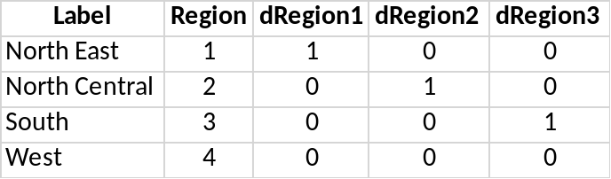
- 2. Dataset Description
- ID: Identification number
- County: County Name
- State: State Abbreviation
- Land: Land area in square miles Land Area (sq. mi.)
- Total_Pop: Estimated 1990 population Est. Pop.
- Pop18_34: Percent of 1990 population aged 18-34 Pop. Age 18-34 (%)
- Pop65plus: Percent of 1990 population aged 65 years old or older Pop. Age 65+ (%)
- Docs: Rate of professionally active nonfederal physicians per 1000 population Drs per 1000 Pop.
- Beds: Rate of beds, cribs and bassinets per 1000 population (proxy for number of beds per house) Approximate Avg Household Size
- Crimes: Rate of serious crimes in 1990, including murder, rape, robbery, aggravated assault as reported by law enforcement officers per 1000 population Serious Crimes per 1000 Pop.
- HSgrads: Percent of adult population (25 years old or older) who completed 12 or more years of school High School Attainment (%)
- Bgrads: Percent of adult population (25 years old or older) with bachelor’s degree. Bachelor Attainment (%)
- Poverty: Percent of 1990 population with income below poverty Poverty Rate (%)
- Unemp: Percent of 1990 labor force that is unemployed Unemployment Rate (%)
- PCIncome: Per capita income of 1990 population (dollars) Per Capita Income ($)
- Pers_Income: Total personal income of 1990 population (in millions of dollars) Total Personal Income (Mil $)
- Region: geographic region classification (1=North East, 2=North Central, 3=South, 4=West) Geographic Region
- dRegion1: (Region = 1) North East
- dRegion2: (Region = 2) North Central
- dRegion3: (Region = 3) South
- Population density: Total population/land area in square miles
- 3. Transformations in Renel’s Model:
Before: After:
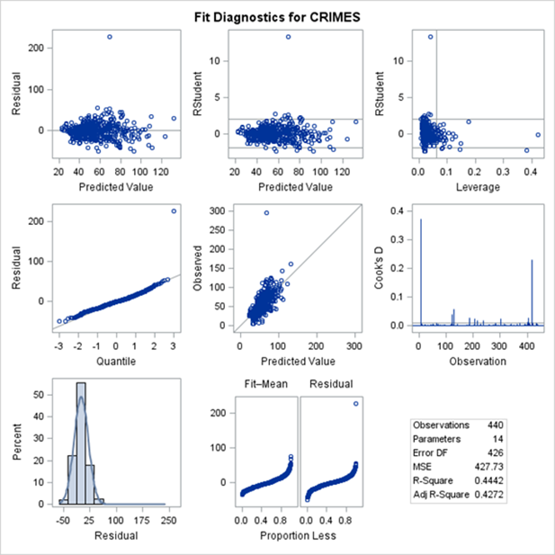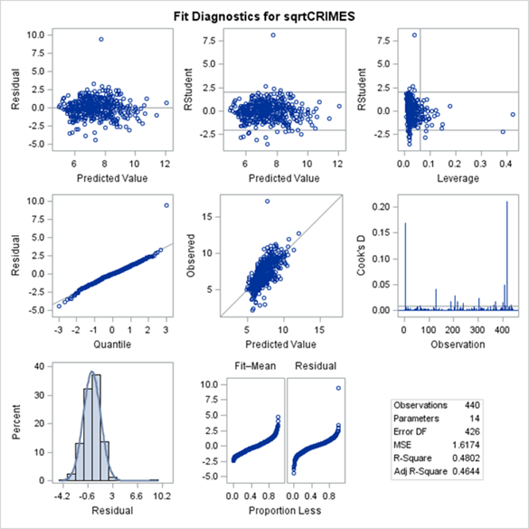
Before:
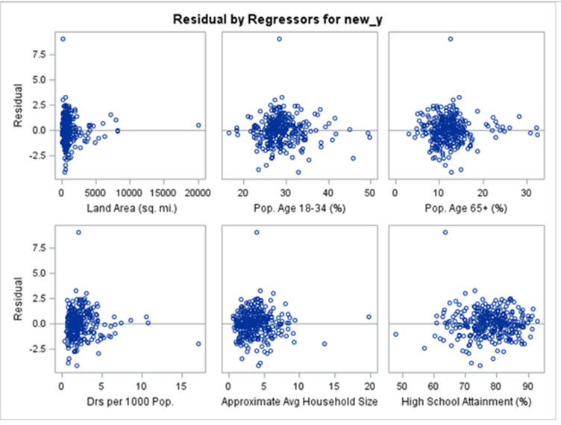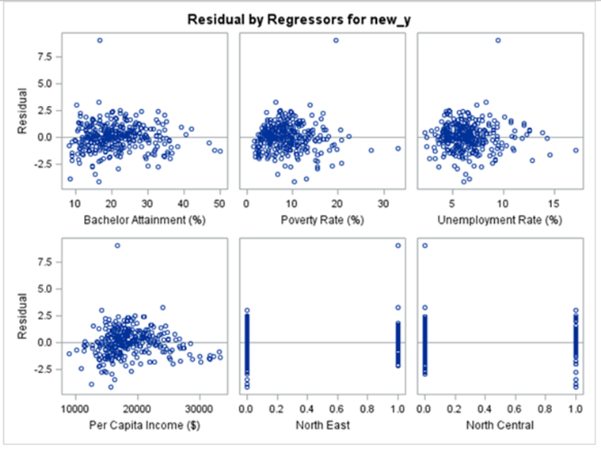

After:
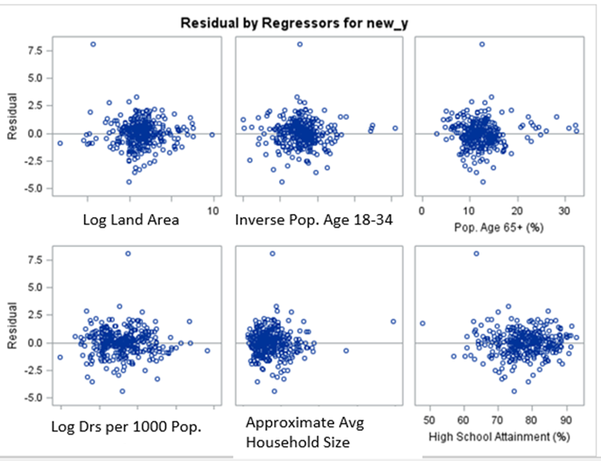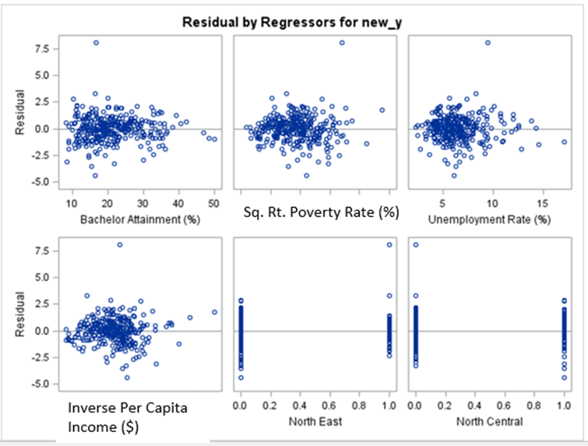
- 4. Outlier Detection
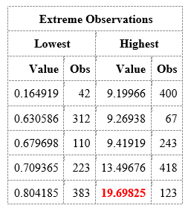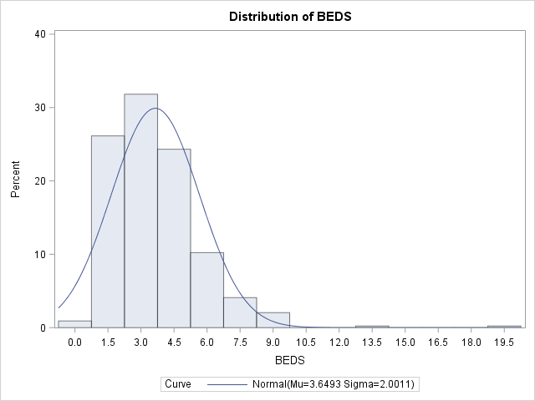
- 5. Correlations
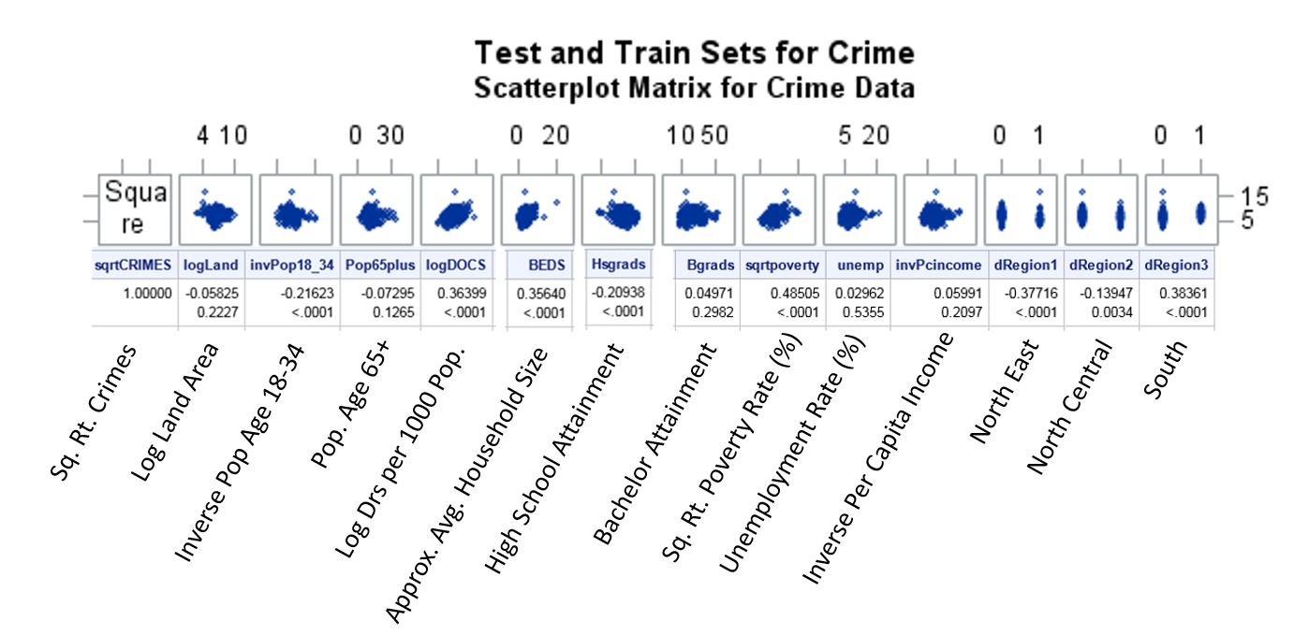
- //6. Correlations
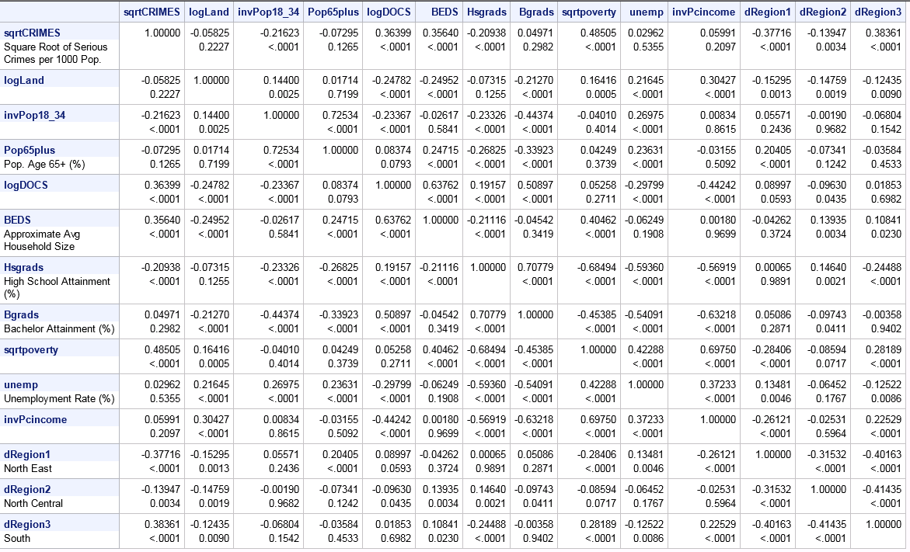/
- 7. Correlations
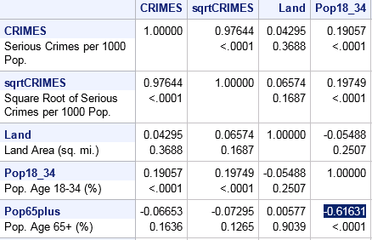/
- 8. Stepwise Selection Model
8 variables
The REG Procedure
Model: MODEL1
Dependent Variable: new_y
Number of Observations Read | 440
Number of Observations Used | 330
Number of Observations with Missing Values | 110

Analysis of Variance
Source | DF | Sum of  Squares | Mean  Square | F Value | Pr > F
Model | 8 | 536.16046 | 67.02006 | 47.08 | <.0001
Error | 321 | 456.99067 | 1.42365
Corrected Total | 329 | 993.15113

Root MSE | 1.19317 | R-Square | 0.5399
Dependent Mean | 7.38821 | Adj R-Sq | 0.5284
Coeff Var | 16.14961

Parameter Estimates
Variable | DF | Parameter  Estimate | Standard  Error | t Value | Pr > |t| | Standardized  Estimate | Tolerance | Variance  Inflation
Intercept | 1 | 11.48130 | 1.23380 | 9.31 | <.0001 | 0 | . | 0
logLand | 1 | -0.21498 | 0.08180 | -2.63 | 0.0090 | -0.10966 | 0.82337 | 1.21452
invPop18_34 | 1 | -40.03884 | 16.49034 | -2.43 | 0.0157 | -0.11335 | 0.65778 | 1.52027
logDOCS | 1 | 0.41147 | 0.17794 | 2.31 | 0.0214 | 0.13299 | 0.43341 | 2.30726
Bgrads | 1 | -0.03736 | 0.01529 | -2.44 | 0.0151 | -0.16043 | 0.33233 | 3.00908
sqrtpoverty | 1 | 1.50833 | 0.16511 | 9.14 | <.0001 | 0.64188 | 0.29036 | 3.44395
invPcincome | 1 | -78131 | 11460 | -6.82 | <.0001 | -0.51662 | 0.24965 | 4.00560
dRegion1 | 1 | -1.57263 | 0.18340 | -8.57 | <.0001 | -0.39012 | 0.69249 | 1.44407
dRegion2 | 1 | -1.05455 | 0.17667 | -5.97 | <.0001 | -0.25593 | 0.77970 | 1.28254

- 9. CP Selection Model
8 variables
The REG Procedure
Model: MODEL1
Dependent Variable: new_y
Number of Observations Read | 440
Number of Observations Used | 330
Number of Observations with Missing Values | 110

Analysis of Variance
Source | DF | Sum of  Squares | Mean  Square | F Value | Pr > F
Model | 8 | 536.16046 | 67.02006 | 47.08 | <.0001
Error | 321 | 456.99067 | 1.42365
Corrected Total | 329 | 993.15113

Root MSE | 1.19317 | R-Square | 0.5399
Dependent Mean | 7.38821 | Adj R-Sq | 0.5284
Coeff Var | 16.14961

Parameter Estimates
Variable | Label | DF | Parameter  Estimate | Standard  Error | t Value | Pr > |t| | Standardized  Estimate | Tolerance | Variance  Inflation
Intercept | Intercept | 1 | 11.48130 | 1.23380 | 9.31 | <.0001 | 0 | . | 0
logLand |  | 1 | -0.21498 | 0.08180 | -2.63 | 0.0090 | -0.10966 | 0.82337 | 1.21452
invPop18_34 |  | 1 | -40.03884 | 16.49034 | -2.43 | 0.0157 | -0.11335 | 0.65778 | 1.52027
logDOCS |  | 1 | 0.41147 | 0.17794 | 2.31 | 0.0214 | 0.13299 | 0.43341 | 2.30726
Bgrads | Bachelor Attainment (%) | 1 | -0.03736 | 0.01529 | -2.44 | 0.0151 | -0.16043 | 0.33233 | 3.00908
sqrtpoverty |  | 1 | 1.50833 | 0.16511 | 9.14 | <.0001 | 0.64188 | 0.29036 | 3.44395
invPcincome |  | 1 | -78131 | 11460 | -6.82 | <.0001 | -0.51662 | 0.24965 | 4.00560
dRegion1 | North East | 1 | -1.57263 | 0.18340 | -8.57 | <.0001 | -0.39012 | 0.69249 | 1.44407
dRegion2 | North Central | 1 | -1.05455 | 0.17667 | -5.97 | <.0001 | -0.25593 | 0.77970 | 1.28254

- 10. Adj-R2 Selection Model
5 variables
The REG Procedure
Model: MODEL1
Dependent Variable: new_y
Number of Observations Read | 440
Number of Observations Used | 330
Number of Observations with Missing Values | 110

Analysis of Variance
Source | DF | Sum of  Squares | Mean  Square | F Value | Pr > F
Model | 5 | 519.94312 | 103.98862 | 71.20 | <.0001
Error | 324 | 473.20800 | 1.46052
Corrected Total | 329 | 993.15113

Root MSE | 1.20852 | R-Square | 0.5235
Dependent Mean | 7.38821 | Adj R-Sq | 0.5162
Coeff Var | 16.35741

Parameter Estimates
Variable | Label | DF | Parameter  Estimate | Standard  Error | t Value | Pr > |t| | Standardized  Estimate | Tolerance | Variance  Inflation
Intercept | Intercept | 1 | 9.16276 | 0.59948 | 15.28 | <.0001 | 0 | . | 0
logLand |  | 1 | -0.26906 | 0.08088 | -3.33 | 0.0010 | -0.13724 | 0.86403 | 1.15736
sqrtpoverty |  | 1 | 1.78487 | 0.12951 | 13.78 | <.0001 | 0.75957 | 0.48414 | 2.06553
invPcincome |  | 1 | -80553 | 8416.48062 | -9.57 | <.0001 | -0.53263 | 0.47482 | 2.10605
dRegion1 | North East | 1 | -1.44166 | 0.17791 | -8.10 | <.0001 | -0.35763 | 0.75497 | 1.32455
dRegion2 | North Central | 1 | -0.96751 | 0.17331 | -5.58 | <.0001 | -0.23481 | 0.83126 | 1.20299

- 11. Backward Selection Model
8 variables
The REG Procedure
Model: MODEL1
Dependent Variable: new_y
Number of Observations Read | 440
Number of Observations Used | 330
Number of Observations with Missing Values | 110

Analysis of Variance
Source | DF | Sum of  Squares | Mean  Square | F Value | Pr > F
Model | 8 | 536.16046 | 67.02006 | 47.08 | <.0001
Error | 321 | 456.99067 | 1.42365
Corrected Total | 329 | 993.15113

Root MSE | 1.19317 | R-Square | 0.5399
Dependent Mean | 7.38821 | Adj R-Sq | 0.5284
Coeff Var | 16.14961

Parameter Estimates
Variable | Label | DF | Parameter  Estimate | Standard  Error | t Value | Pr > |t| | Standardized  Estimate | Tolerance | Variance  Inflation
Intercept | Intercept | 1 | 11.48130 | 1.23380 | 9.31 | <.0001 | 0 | . | 0
logLand |  | 1 | -0.21498 | 0.08180 | -2.63 | 0.0090 | -0.10966 | 0.82337 | 1.21452
invPop18_34 |  | 1 | -40.03884 | 16.49034 | -2.43 | 0.0157 | -0.11335 | 0.65778 | 1.52027
logDOCS |  | 1 | 0.41147 | 0.17794 | 2.31 | 0.0214 | 0.13299 | 0.43341 | 2.30726
Bgrads | Bachelor Attainment (%) | 1 | -0.03736 | 0.01529 | -2.44 | 0.0151 | -0.16043 | 0.33233 | 3.00908
sqrtpoverty |  | 1 | 1.50833 | 0.16511 | 9.14 | <.0001 | 0.64188 | 0.29036 | 3.44395
invPcincome |  | 1 | -78131 | 11460 | -6.82 | <.0001 | -0.51662 | 0.24965 | 4.00560
dRegion1 | North East | 1 | -1.57263 | 0.18340 | -8.57 | <.0001 | -0.39012 | 0.69249 | 1.44407
dRegion2 | North Central | 1 | -1.05455 | 0.17667 | -5.97 | <.0001 | -0.25593 | 0.77970 | 1.28254

- 12. Proc GLM Stepwise Selection Model
5 variables – new residuals look good
Model: MODEL1
Dependent Variable: new_y
Number of Observations Read | 440
Number of Observations Used | 330
Number of Observations with Missing Values | 110

Analysis of Variance
Source | DF | Sum of  Squares | Mean  Square | F Value | Pr > F
Model | 5 | 511.08041 | 102.21608 | 68.70 | <.0001
Error | 324 | 482.07072 | 1.48787
Corrected Total | 329 | 993.15113

Root MSE | 1.21978 | R-Square | 0.5146
Dependent Mean | 7.38821 | Adj R-Sq | 0.5071
Coeff Var | 16.50988

Parameter Estimates
Variable | DF | Parameter  Estimate | Standard  Error | t Value | Pr > |t| | Standardized  Estimate | Tolerance | Variance  Inflation
Intercept | 1 | 5.94771 | 0.40985 | 14.51 | <.0001 | 0 | . | 0
sqrtpoverty | 1 | 1.55487 | 0.17266 | 9.01 | <.0001 | 0.66169 | 0.27748 | 3.60390
logDOCS__unemp | 1 | 0.08829 | 0.02839 | 3.11 | 0.0020 | 0.17625 | 0.46632 | 2.14447
invPcincome | 1 | -61380 | 11364 | -5.40 | <.0001 | -0.40586 | 0.26533 | 3.76883
sqrtpoverty__dRegion1 | 1 | -0.24985 | 0.06966 | -3.59 | 0.0004 | -0.15688 | 0.78303 | 1.27709
Hsgrads__dRegion3 | 1 | 0.01137 | 0.00208 | 5.48 | <.0001 | 0.23644 | 0.80354 | 1.24450

- 13. Adj-R2 Selection: Number of variables in model. Adj-R2 for that model.
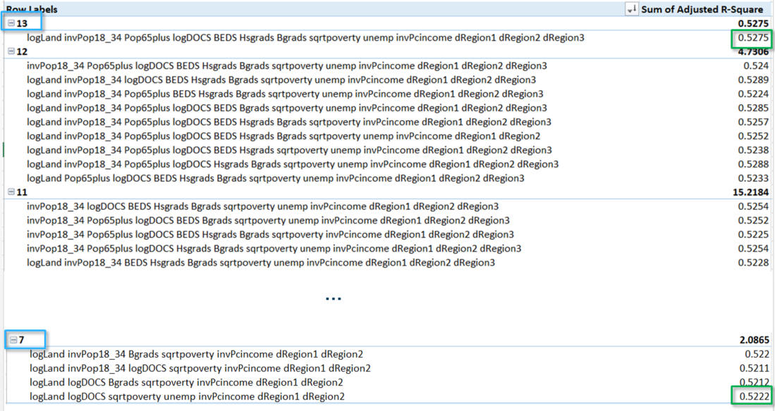/
- 14. CP Selection: |CP - k+1| Number of variables in model. Adj-R2 for that model.
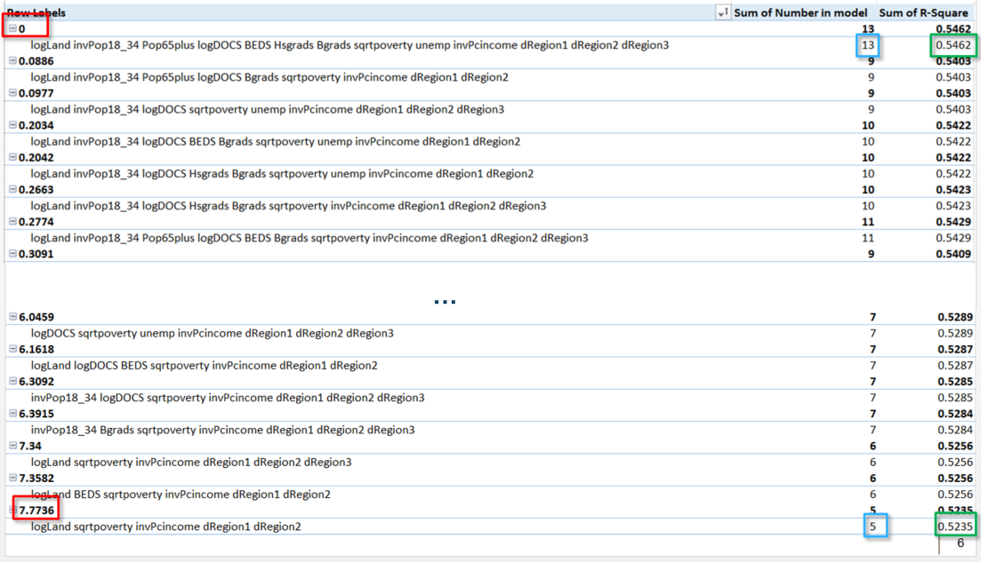/

15. Adj-R2 Selection Model Validation:

Obs | _TYPE_ | _FREQ_ | RMSE | MAE
1 | 0 | 110 | 1.24710 | 0.95111

The CORR Procedure
2 Variables: | sqrtCRIMES yhat

Simple Statistics
Variable | N | Mean | Std Dev | Sum | Minimum | Maximum | Label
sqrtCRIMES | 110 | 7.30364 | 1.74495 | 803.40061 | 2.14509 | 11.97275 | Sq. Root of Serious Crimes per 1000 Pop.
yhat | 110 | 7.45921 | 1.20143 | 820.51292 | 5.06688 | 10.94973 | Predicted Value of new_y

Pearson Correlation Coefficients, N = 110
Prob > |r| under H0: Rho=0
 | sqrtCRIMES | yhat
  sqrtCRIMES
  Sq. Root of Serious Crimes per 1000 Pop.
  1.00000
  0.69953
  <.0001
  yhat
  Predicted Value of new_y
  0.69953
  <.0001
  1.00000

16. CP Selection Model Validation:
Obs | _TYPE_ | _FREQ_ | RMSE | MAE
1 | 0 | 110 | 1.16748 | 0.87352

The CORR Procedure
2 Variables: | sqrtCRIMES yhat

Simple Statistics
Variable | N | Mean | Std Dev | Sum | Minimum | Maximum | Label
sqrtCRIMES | 110 | 7.30364 | 1.74495 | 803.40061 | 2.14509 | 11.97275 | Sq. Root of Serious Crimes per 1000 Pop.
yhat | 110 | 7.40990 | 1.21543 | 815.08863 | 4.56383 | 10.85835 | Predicted Value of new_y

Pearson Correlation Coefficients, N = 110
Prob > |r| under H0: Rho=0
 | sqrtCRIMES | yhat
  sqrtCRIMES
  Sq. Root of Serious Crimes per 1000 Pop.
  1.00000
  0.74477
  <.0001
  yhat
  Predicted Value of new_y
  0.74477
  <.0001
  1.00000

17. Correlations
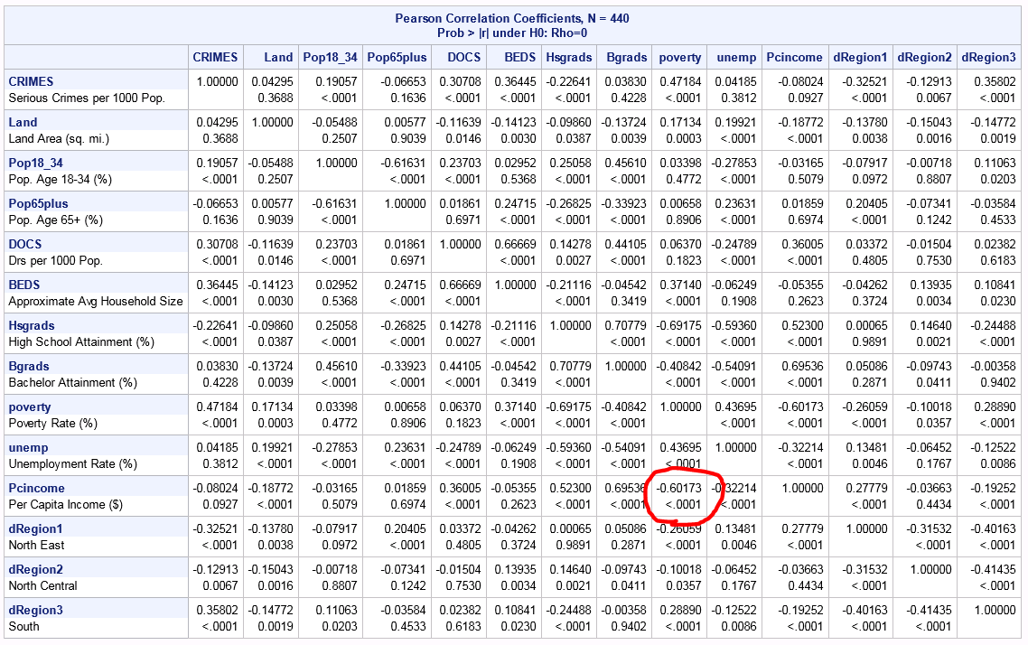/

18. Parameter Estimate Interpretations
Sqrtpoverty: 1.78487 NOTE: Independent and dependent variable are in the same units, so leave the parameter estimate as it is.
logLand: [|-0.26906|*ln(101/100)]² ≈ -7.203 E -4 NOTE: The natural log is a special case where simply taking the anti-log of your parameters will not properly back transform into the original metric used. This way of calculating it means the independent variable must be expressed as having a 1% increase to see the 7.203 E -4 increase in crime. See additional reading: “Interpreting Coefficients in Regression with Log Transformed Variables’. The order of the un-transformation doesn’t matter {(-0.26906)² *ln(101/100)≈ 7.203 E -4}. Transform without the sign, the sign is indicating if the variable has a positive or negative association with Y. Make 1,000 pop.→ 10 million pop. and you can make the parameter estimate 7.203.
invPcincome: [1/(-80,553)]² ≈ -1.5411 E -10 NOTE: Make $1 → $1 billion and you can use -0.154 as the parameter estimate. Also make crimes per 10,000 population and you can make the parameter estimate -1.54.
dRegion1: -(1.44166)² ≈ -2.0784
dRegion2: -(0.96751)² ≈ -0.9361

19. Renel’s Model Predictions
The REG Procedure
Model: MODEL1
Dependent Variable: new_y
Output Statistics
Obs | Dependent  Variable | Predicted  Value | Std  Error  Mean  Predict | 95% CL Mean |  | 95% CL Predict |  | Residual
1 | . | 8.2415 | 0.1913 | 7.8650 | 8.6179 | 5.8343 | 10.6486 | .
2 | . | 8.0474 | 0.1535 | 7.7455 | 8.3493 | 5.6508 | 10.4441 | .

data pred;
input logLand sqrtpoverty invPcincome dRegion1 dRegion2;
datalines;
6.8 3.2 0.000047617 0.0000257 1 0
7 2.28 0.000040984 0.000017 0 1
;

20. Histogram of Crimes, LogCrimes, SqrtCrimes
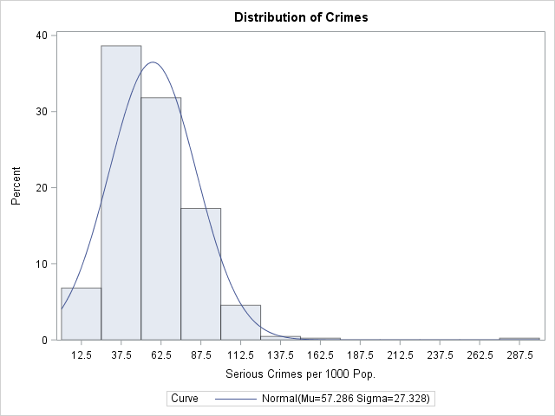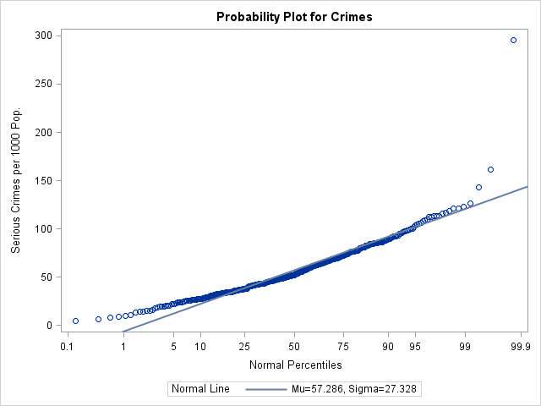
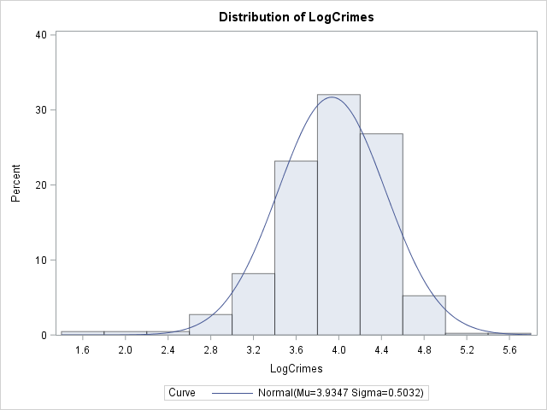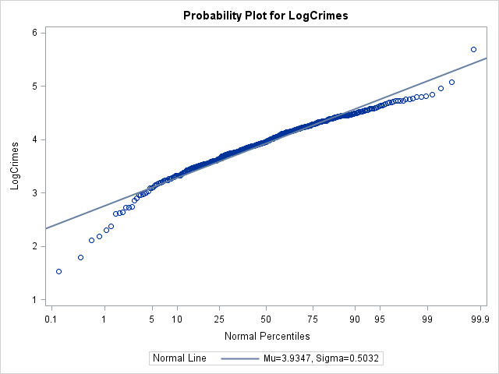
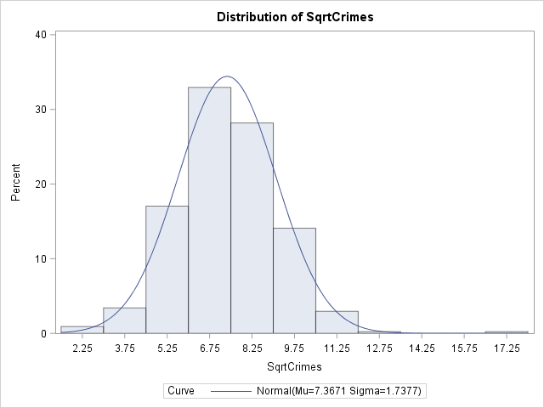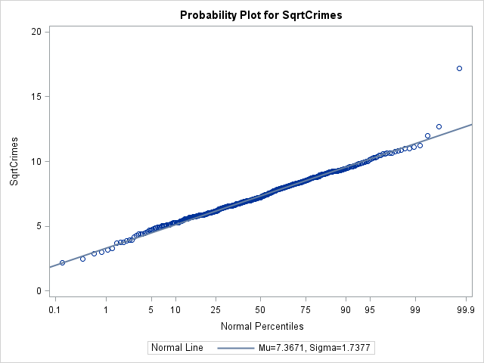

21. Table of 18 Categories/Possible Combinations
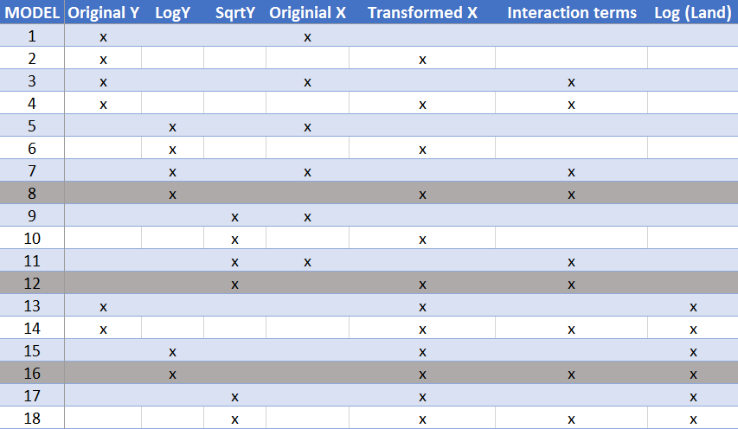

22. Table of Key Statistics about Best Models from Each Categories
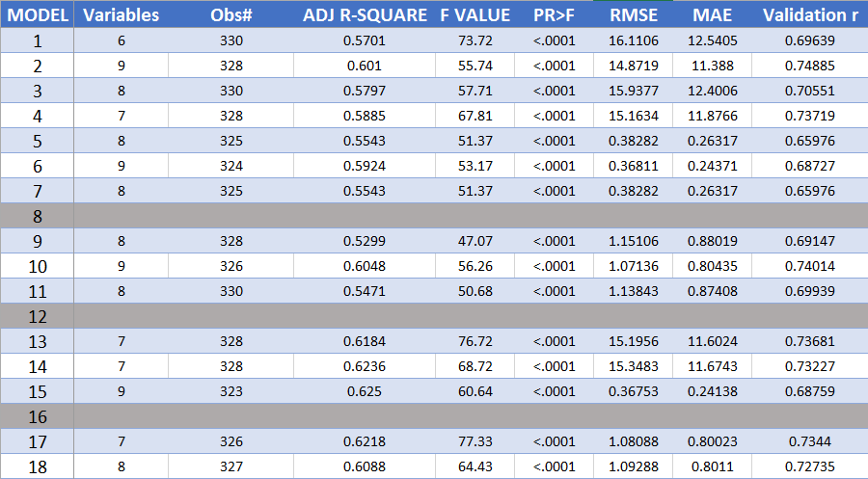

23. Model 14
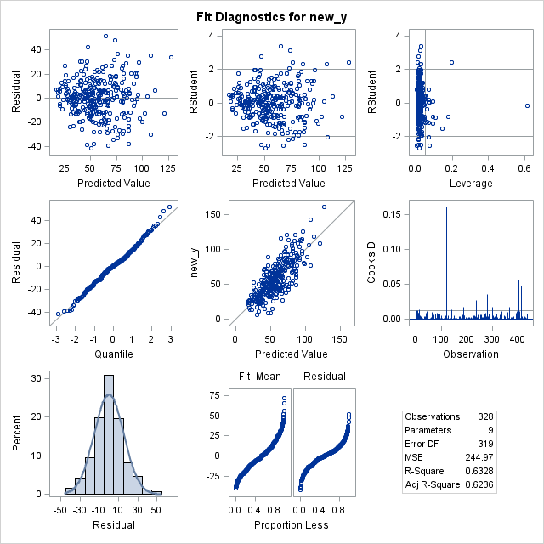
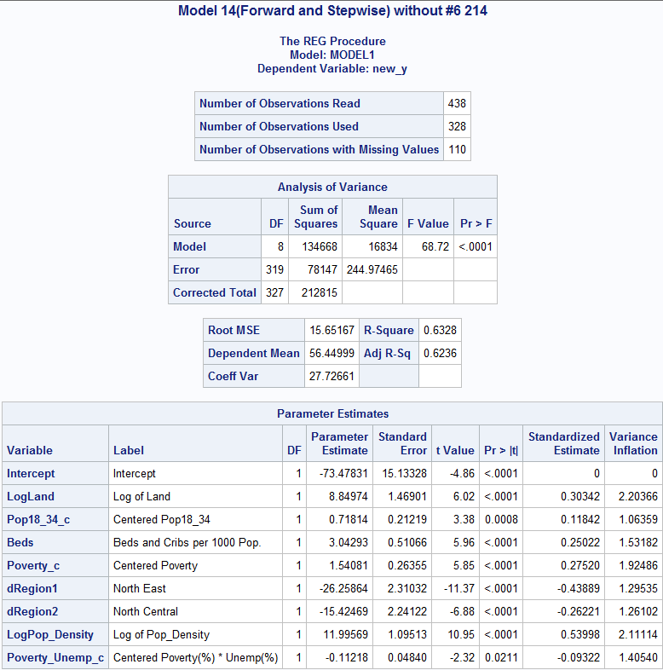
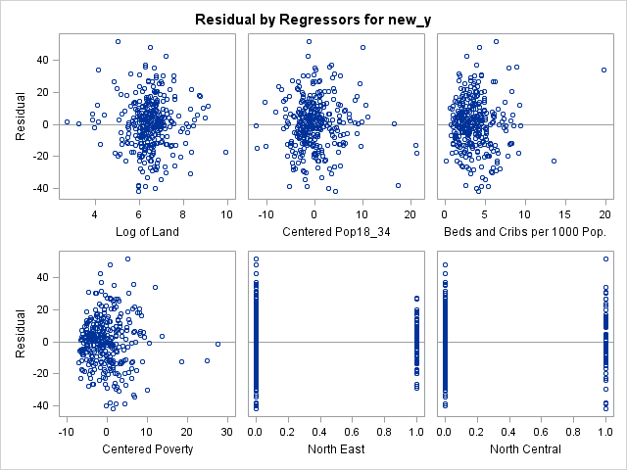
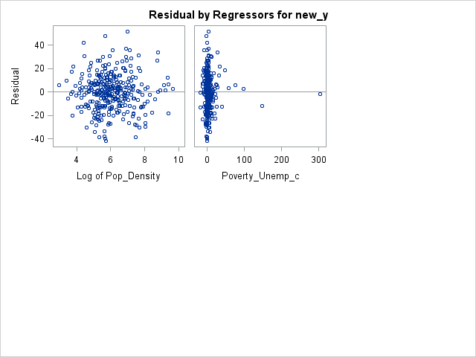
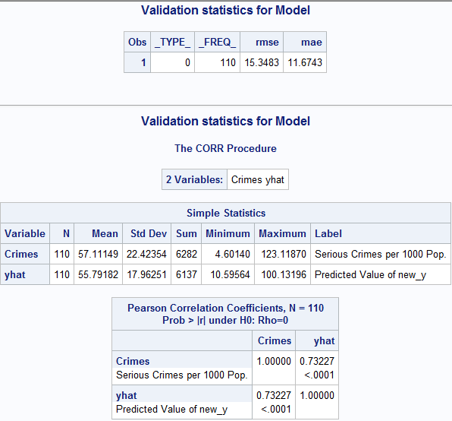

24. Model 17 (Final Model)
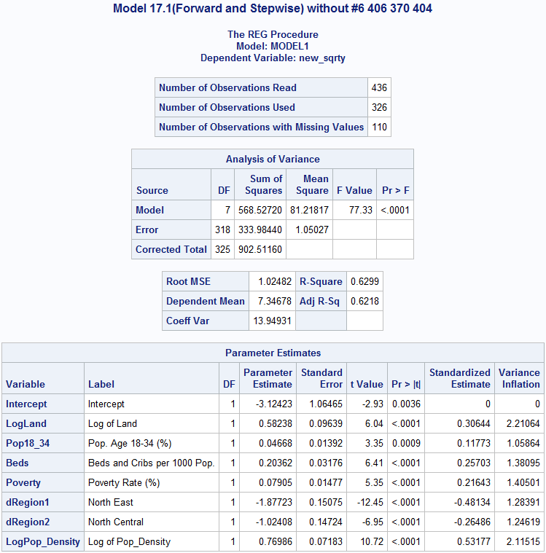
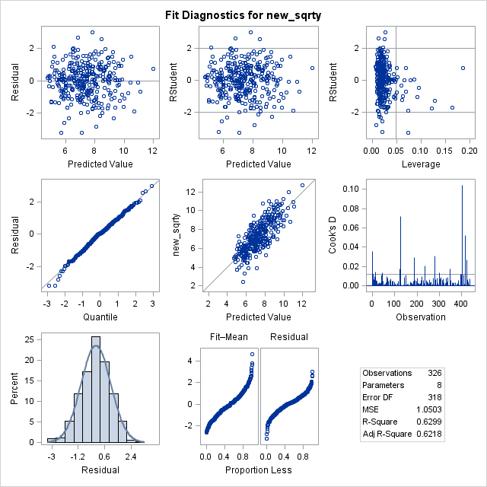
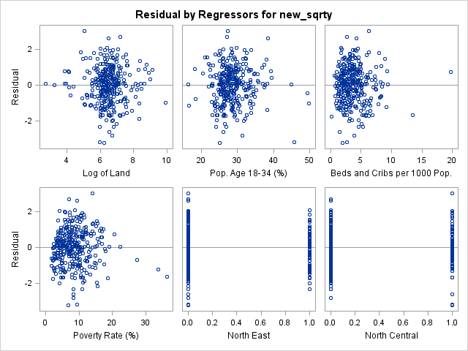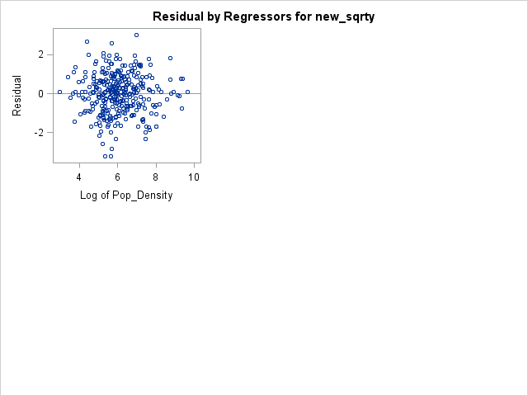
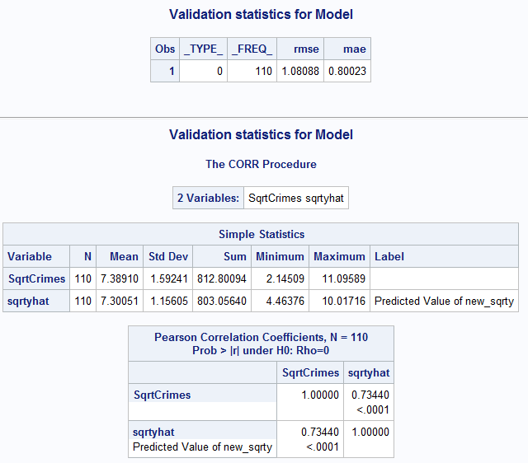

25. Model 10
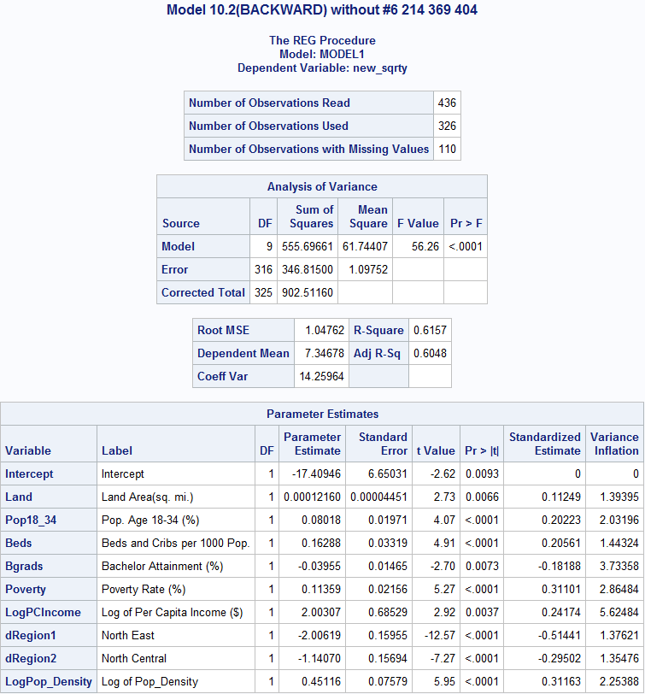

26. Model 4
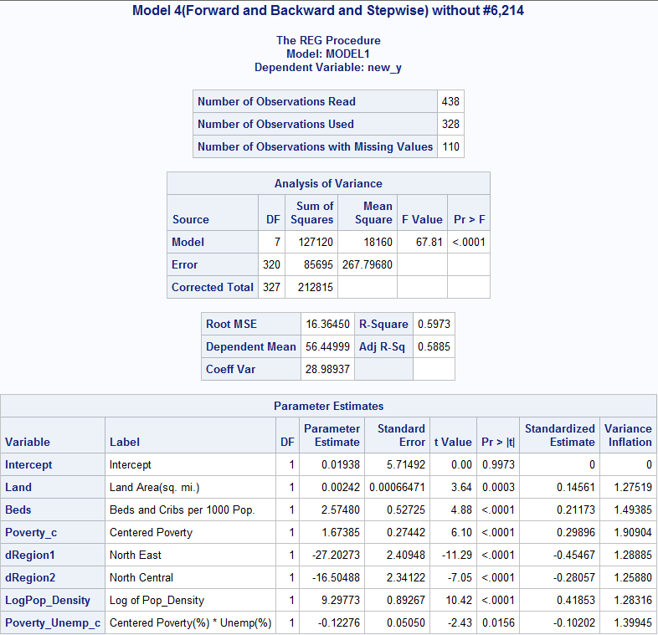

27. Nicole’s Model Predictions

*-------------[Prediction of Model 17]-------------------*
*this is the prediciton of the final model of the analysis, which is Model 17.1(Forward and Stepwise) without #6 406 370 404;
*add datalines to training set without the outliers and influential points, which is DATA=xv_all_no6_214_370_404;

*new dataset including predicting datalines;
data new;
input LogLand Pop18_34 Beds Poverty dRegion1 dRegion2 LogPop_Density;
datalines;
9.12739 29.2 2.8764 8.8 0 0 5.4405
6.32257 31.6 5.2255 6.4 0 1 7.5249
;

*join datasets;
data pred;
set new xv_all_no6_214_370_404;

*compute prediction;
proc reg;
model new_sqrty = LogLand Pop18_34 Beds Poverty dRegion1 dRegion2 LogPop_Density
/p clm cli alpha=0.05;
run;

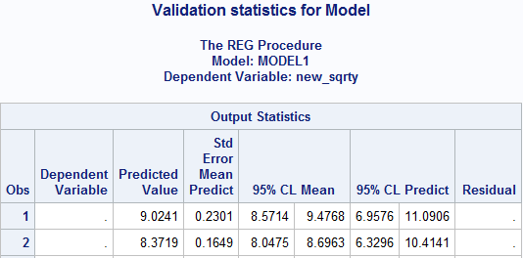

REFERENCES
Note: references list shows in the order of appearance.

Truman, J. L., Ph.D., & Planty, M., Ph.D. (2012). Criminal Victimization, 2011 (Rep. No. NCJ 239437). U.S. Department of Justice.

Davey, M. (2016, May 24). Chicago Police Try to Predict Who May Shoot or Be Shot. The New York Times, p. A11. Retrieved October 25, 2016, from http://www.nytimes.com/2016/05/24/us/armed-with-data-chicago-police-try-to-predict-who-may-shoot-or-be-shot.html?_r=1

Government Technology (2010). Chicago Using Predictive Analytics to Fight Crime, Police Chief Says [Online Posting]. (2010, August 9). Retrieved October 25, 2016, from http://www.govtech.com/public-safety/Chicago-Using-Predictive-Analytics-to-Fight.html

James, G. (1990, April 23). New York Killings Set a Record, While Other Crimes Fell in 1990 [Online Posting]. Retrieved October 25, 2016, from http://www.nytimes.com/1991/04/23/nyregion/new-york-killings-set-a-record-while-other-crimes-fell-in-1990.html

Siegel, E. (2013). Predictive Analytics: The Power to Predict Who Will Click, Buy, Lie, or Die. Hoboken, New Jersey: John Wiley & Sons, Inc.

Tita, G.E. and Boessen, A., 2011. Social networks and the ecology of crime: using social network data to understand the spatial distribution of crime. The SAGE handbook of criminological research methods, pp.128-142.

Buczak, A.L. and Gifford, C.M., 2010, July. Fuzzy association rule mining for community crime pattern discovery. In ACM SIGKDD Workshop on Intelligence and Security Informatics (p. 2). ACM.

Schneider S. (2002). Predicting Crime: A Review of the Research. School of Justice Studies. Toronto, Ontario: Research and Statistics Division, Ryerson University.

Baron, S.W., 2008. Street Youth, Unemployment, and Crime: Is It That Simple? Using General Strain Theory to Untangle the Relationship 1. Canadian Journal of Criminology and Criminal Justice, 50(4), pp.399-434.

Crutchfield, R.D. and Ramirez, S.R., 2012. Using census data and surveys to study labor markets and crime. The SAGE handbook of criminological research methods, pp.143-158.

Parker, R.N. and Horwitz, A.V., 1986. Unemployment, crime, and imprisonment: A panel approach. Criminology, 24(4), pp.751-773.

Crutchfield, R.D., 2011. Labor Force Participation, Labor Markets, and Crime. DIANE Publishing.
Chiricos, T. (1987). Rates of Crime and Unemployment: An Analysis of Aggregate Research Evidence. Social Problems, 34(2), pp.187-212.

Shover, N., 1996. Great pretenders: Pursuits and careers of persistent thieves. Boulder, CO: Westview Press.

Uggen, C., 2000. Work as a turning point in the life course of criminals: A duration model of age, employment, and recidivism. American sociological review, pp.529-546.
Hirschi, T. and Gottfredson, M., 1983. Age and the explanation of crime. American journal of sociology, pp.552-584.

Baron, S.W. and Hartnagel, T.F., 1997. ATTRIBUTIONS, AFFECT, AND CRIME: STREET YOUTHS'REACTIONS TO UNEMPLOYMENT. Criminology, 35(3), pp.409-434.

Lochner, L. and Moretti, E., 2004. The effect of education on crime: Evidence from prison inmates, arrests, and self-reports. The American Economic Review, 94(1), pp.155-189.

Gould, E.D., Weinberg, B.A. and Mustard, D.B., 2002. Crime rates and local labor market opportunities in the United States: 1979–1997. Review of Economics and statistics, 84(1), pp.45-61.

CODES

Renel’s Code
*import data from file, define new variables and labels;
data crime_original;
infile 'Crimerates_data.txt' DELIMITER = '09'x MISSOVER FIRSTOBS=2;
input ID county$ State$ Land total_Pop Pop18_34 Pop65plus DOCS BEDS CRIMES Hsgrads Bgrads poverty unemp Pcincome Pers_income region;
dRegion1 = (Region = 1); *Create dummy variables;
dRegion2 = (Region = 2);
dRegion3 = (Region = 3);
logCRIMES = log(CRIMES); *transformations of the dependent variable to see if normality can be improved;
sqrtCRIMES = sqrt(CRIMES);
squaredCRIMES = (CRIMES)**2;
cubeCRIMES = (CRIMES)**3;
invCRIMES = 1/(CRIMES);
LABEL county= 'County Name' State='State Abbreviation' Land='Land Area (sq. mi.)' logLand='Log of Land Area (sq. mi.)' total_Pop='Est. Pop.' Pop18_34='Pop. Age 18-34 (%)' invPop18_34='Inverse of Pop. Age 18-34 (%)' Pop65plus='Pop. Age 65+ (%)' DOCS='Drs per 1000 Pop.' logDOCS='Log of Drs per 1000 Pop.' BEDS='Approximate Avg Household Size' CRIMES='Serious Crimes per 1000 Pop.' sqrtCRIMES='Square Root of Serious Crimes per 1000 Pop.'
Hsgrads='High School Attainment (%)' Bgrads='Bachelor Attainment (%)' poverty='Poverty Rate (%)' sqrtpoverty='Square Root of Poverty Rate (%)' unemp='Unemployment Rate (%)' Pcincome='Per Capita Income ($)' invPcincome='Inverse of Per Capita Income ($)' Pers_income='Total Personal Income (Mil $)' dRegion1='North East' dRegion2='North Central' dRegion3='South';
run;

proc print data= crime_original;
run;

*-----------Split data into training and testing set--------------;
*Creates a next dataset - adds a column splitting train and test sets;
title "Test and Train Sets for Crime";
proc surveyselect data=crime_original out=crime_xv seed=227
samprate=0.75 outall; *outall - show all the data selected (1)and not selected (0) for training;
run;
proc print data=crime_xv;
run;
* create new variable new_y = Debt for training set, and new_y = NA for testing set;
data crime; *create blank dataset;
set crime_xv; *add the xv data do it;
if selected then new_y=sqrtCRIMES; *create a field "new_y" where the response variable will only appear if it was selected as part of the training set;
run;
proc print data=crime;
run;

*----------------Data exploration--------------------;
/* look at distributions of different transformations of the response variable to find the best one (creates histogram with normal density plotted on top of histogram);*/
TITLE2 "Histogram - Crimes";
proc univariate normal;
var CRIMES logCRIMES sqrtCRIMES squaredCRIMES cubeCRIMES invCRIMES;
histogram / normal(mu=est sigma=est);
run;

TITLE2 "Descriptive Statistics";
proc means min max mean std stderr clm p25 p50 p75 data=crime;
var CRIMES sqrtCRIMES Land Pop18_34 Pop65plus DOCS BEDS Hsgrads Bgrads poverty unemp Pcincome dRegion1 dRegion2 dRegion3;
run;

TITLE2 "Histogram - Suspicious Predictors";
proc univariate normal;
var beds Pcincome Pers_income;
histogram / normal(mu=est sigma=est);
run;

* creates scatterplot matrix;
proc sgscatter data=crime;
title2 "Scatterplot Matrix for Crime Data";
matrix CRIMES sqrtCRIMES Land Pop18_34 Pop65plus DOCS BEDS Hsgrads Bgrads poverty unemp Pcincome dRegion1 dRegion2 dRegion3;
run;

*computes correlation coefficient for all y and x-variables;
proc corr;
var CRIMES sqrtCRIMES Land Pop18_34 Pop65plus DOCS BEDS Hsgrads Bgrads poverty unemp Pcincome dRegion1 dRegion2 dRegion3;
run;

* creates scatterplot matrix for suspicious x-variables;
proc sgscatter data=crime;
title2 "Scatterplot Matrix for Suspicious Crime Data";
matrix total_Pop Pcincome Pers_income;
run;
*computes correlation coefficient for suspicious x-variables;
proc corr;
var total_Pop Pcincome Pers_income;
run;

*looking at residuals;
proc reg data=crime;
model sqrtCRIMES = Land Pop18_34 Pop65plus DOCS BEDS Hsgrads Bgrads poverty unemp Pcincome dRegion1 dRegion2 dRegion3;
run;
*looking at residuals;
proc reg data=crime;
model CRIMES = Land Pop18_34 Pop65plus DOCS BEDS Hsgrads Bgrads poverty unemp Pcincome dRegion1 dRegion2 dRegion3;
run;

*full model 1;
proc reg data=crime;
model new_y = Land Pop18_34 Pop65plus DOCS BEDS Hsgrads Bgrads poverty unemp Pcincome dRegion1 dRegion2 dRegion3 /vif tol influence r;
plot student.*(Land Pop18_34 Pop65plus DOCS BEDS Hsgrads Bgrads poverty unemp Pcincome dRegion1 dRegion2 dRegion3 predicted.); *plots studentized residuals against their original value, numbers more extreme than +-3 are outliers;
plot npp.*student.; *plots the studentized residuals (combined for all variables) against a theoretical probability of normality, shows if the residuals (of all variables overall) are normally distributed;
run;

*------------------ testing transformations --------------------;
*transform variables to improve residuals;
data crime1;
set crime;
logLand = log(Land);
sqrtLand = sqrt(Land);
squaredLand = (Land)**2;
cubeLand = (Land)**3;
invLand = 1/(Land);

logPop18_34 = log(Pop18_34);
sqrtPop18_34 = sqrt(Pop18_34);
squaredPop18_34 = (Pop18_34)**2;
cubePop18_34 = (Pop18_34)**3;
invPop18_34 = 1/(Pop18_34);

logDOCS = log(DOCS);
sqrtDOCS = sqrt(DOCS);
squaredDOCS = (DOCS)**2;
cubeDOCS = (DOCS)**3;
invDOCS = 1/(DOCS);

logpoverty = log(poverty);
sqrtpoverty = sqrt(poverty);
squaredpoverty = (poverty)**2;
cubepoverty = (poverty)**3;
invpoverty = 1/(poverty);

logPcincome = log(Pcincome);
sqrtPcincome = sqrt(Pcincome);
squaredPcincome = (Pcincome)**2;
cubePcincome = (Pcincome)**3;
invPcincome = 1/(Pcincome);

run;
proc print data= crime1;
run;

*full model testing log-transformed predictors;
proc reg data=crime1;
model new_y = logLand logPop18_34 Pop65plus logDOCS BEDS Hsgrads Bgrads logpoverty unemp logPcincome dRegion1 dRegion2 dRegion3;
plot student.*(logLand logPop18_34 Pop65plus logDOCS BEDS Hsgrads Bgrads logpoverty unemp logPcincome dRegion1 dRegion2 dRegion3 predicted.); *plots studentized residuals against their original value, numbers more extreme than +-3 are outliers;
plot npp.*student.; *plots the studentized residuals (combined for all variables) against a theoretical probability of normality, shows if the residuals (of all variables overall) are normally distributed;
run;
*full model testing sqrt-transformed predictors;
proc reg data=crime1;
model new_y = sqrtLand sqrtPop18_34 Pop65plus sqrtDOCS BEDS Hsgrads Bgrads sqrtpoverty unemp sqrtPcincome dRegion1 dRegion2 dRegion3;
plot student.*(sqrtLand sqrtPop18_34 Pop65plus sqrtDOCS BEDS Hsgrads Bgrads sqrtpoverty unemp sqrtPcincome dRegion1 dRegion2 dRegion3 predicted.); *plots studentized residuals against their original value, numbers more extreme than +-3 are outliers;
plot npp.*student.; *plots the studentized residuals (combined for all variables) against a theoretical probability of normality, shows if the residuals (of all variables overall) are normally distributed;
run;
*full model testing squared-transformed predictors;
proc reg data=crime1;
model new_y = squaredLand squaredPop18_34 Pop65plus squaredDOCS BEDS Hsgrads Bgrads squaredpoverty unemp squaredPcincome dRegion1 dRegion2 dRegion3;
plot student.*(squaredLand squaredPop18_34 Pop65plus squaredDOCS BEDS Hsgrads Bgrads squaredpoverty unemp squaredPcincome dRegion1 dRegion2 dRegion3 predicted.); *plots studentized residuals against their original value, numbers more extreme than +-3 are outliers;
plot npp.*student.; *plots the studentized residuals (combined for all variables) against a theoretical probability of normality, shows if the residuals (of all variables overall) are normally distributed;
run;
*full model testing cube-transformed predictors;
proc reg data=crime1;
model new_y = cubeLand cubePop18_34 Pop65plus cubeDOCS BEDS Hsgrads Bgrads cubepoverty unemp cubePcincome dRegion1 dRegion2 dRegion3;
plot student.*(cubeLand cubePop18_34 Pop65plus cubeDOCS BEDS Hsgrads Bgrads cubepoverty unemp cubePcincome dRegion1 dRegion2 dRegion3 predicted.); *plots studentized residuals against their original value, numbers more extreme than +-3 are outliers;
plot npp.*student.; *plots the studentized residuals (combined for all variables) against a theoretical probability of normality, shows if the residuals (of all variables overall) are normally distributed;
run;
*full model testing inv-transformed predictors;
proc reg data=crime1;
model new_y = invLand invPop18_34 Pop65plus invDOCS BEDS Hsgrads Bgrads invpoverty unemp invPcincome dRegion1 dRegion2 dRegion3;
plot student.*(invLand invPop18_34 Pop65plus invDOCS BEDS Hsgrads Bgrads invpoverty unemp invPcincome dRegion1 dRegion2 dRegion3 predicted.); *plots studentized residuals against their original value, numbers more extreme than +-3 are outliers;
plot npp.*student.; *plots the studentized residuals (combined for all variables) against a theoretical probability of normality, shows if the residuals (of all variables overall) are normally distributed;
run;
*full model 1 (for residual comparison);
proc reg data=crime1;
model new_y = Land Pop18_34 Pop65plus DOCS BEDS Hsgrads Bgrads poverty unemp Pcincome dRegion1 dRegion2 dRegion3 /vif tol influence r;
plot student.*(Land Pop18_34 Pop65plus DOCS BEDS Hsgrads Bgrads poverty unemp Pcincome dRegion1 dRegion2 dRegion3 predicted.); *plots studentized residuals against their original value, numbers more extreme than +-3 are outliers;
plot npp.*student.; *plots the studentized residuals (combined for all variables) against a theoretical probability of normality, shows if the residuals (of all variables overall) are normally distributed;
run;
*full model with BEST transformations;
proc reg data=crime1;
model new_y = logLand invPop18_34 Pop65plus logDOCS BEDS Hsgrads Bgrads sqrtpoverty unemp invPcincome dRegion1 dRegion2 dRegion3 /vif tol influence r;
plot student.*(logLand invPop18_34 Pop65plus logDOCS BEDS Hsgrads Bgrads sqrtpoverty unemp invPcincome dRegion1 dRegion2 dRegion3 predicted.); *plots studentized residuals against their original value, numbers more extreme than +-3 are outliers;
plot npp.*student.; *plots the studentized residuals (combined for all variables) against a theoretical probability of normality, shows if the residuals (of all variables overall) are normally distributed;
run;

*----------------------Data Exploration for Transformed Variables------------------;
TITLE2 "Descriptive Statistics";
proc means min max mean std stderr clm p25 p50 p75 data=crime1;
var sqrtCRIMES logLand invPop18_34 Pop65plus logDOCS BEDS Hsgrads Bgrads sqrtpoverty unemp invPcincome dRegion1 dRegion2 dRegion3;
run;

* creates scatterplot matrix;
proc sgscatter data=crime1;
title2 "Scatterplot Matrix for Crime Data";
matrix sqrtCRIMES logLand invPop18_34 Pop65plus logDOCS BEDS Hsgrads Bgrads sqrtpoverty unemp invPcincome dRegion1 dRegion2 dRegion3;
run;

*computes correlation coefficient for all y and x-variables;
proc corr data=crime1;
var sqrtCRIMES logLand invPop18_34 Pop65plus logDOCS BEDS Hsgrads Bgrads sqrtpoverty unemp invPcincome dRegion1 dRegion2 dRegion3;
run;

TITLE2 "Histogram - Suspicious Predictors";
proc univariate normal;
var beds Pcincome Pers_income;
histogram / normal(mu=est sigma=est);
run;

*-------------------Model Selection Methods----------------;
*STEPWISE variable selection;
proc reg data=crime1 alpha=0.05;
model new_y = logLand invPop18_34 Pop65plus logDOCS BEDS Hsgrads Bgrads sqrtpoverty unemp invPcincome dRegion1 dRegion2 dRegion3/selection=stepwise;
run;
*model selected from STEPWISE variable selection;
proc reg data=crime1 alpha=0.05;
model new_y = logLand invPop18_34 logDOCS Bgrads sqrtpoverty invPcincome dRegion1 dRegion2 /vif tol stb;
run;

* CP variable selection;
*Select the model that has the Cp ˜ p where p =k+1 (k = # of predictors);
proc reg data=crime1;
model new_y = logLand invPop18_34 Pop65plus logDOCS BEDS Hsgrads Bgrads sqrtpoverty unemp invPcincome dRegion1 dRegion2 dRegion3/selection=cp;
run;
*model selected from CP variable selection;
proc reg data=crime1;
model new_y = logLand invPop18_34 logDOCS Bgrads sqrtpoverty invPcincome dRegion1 dRegion2 /vif tol stb;
run;

* ADJ-R2 variable selection;
proc reg data=crime1 alpha=0.05;
model new_y = logLand invPop18_34 Pop65plus logDOCS BEDS Hsgrads Bgrads sqrtpoverty unemp invPcincome dRegion1 dRegion2 dRegion3/selection=adjrsq;
run;
*model selected from ADJ-R2 variable selection. NOTE: all had 0.54 adj-r2, so I chose the one with the fewest predictors and took out insig. predictors;
proc reg data=crime1;
model new_y = logLand sqrtpoverty invPcincome dRegion1 dRegion2 /vif tol stb;
run;

* BACKWARD variable selection;
proc reg data=crime1 alpha=0.05;
model new_y = logLand invPop18_34 Pop65plus logDOCS BEDS Hsgrads Bgrads sqrtpoverty unemp invPcincome dRegion1 dRegion2 dRegion3/selection=backward;
run;
*model selected from BACKWARD variable selection;
proc reg data=crime1;
model new_y = logLand invPop18_34 logDOCS Bgrads sqrtpoverty invPcincome dRegion1 dRegion2 /vif tol stb;
run;

*full SECOND-ORDER INTERACTION model;
proc glmselect data=crime1;
model new_y = logLand|invPop18_34|Pop65plus|logDOCS|BEDS|Hsgrads|Bgrads|sqrtpoverty|unemp|invPcincome|dRegion1|dRegion2|dRegion3 @2/ selection=none;
/*shorthand notation uses | to include interaction terms. @2 indicates that only second order interaction terms will be included in the model;*/
run;
*SECOND-ORDER INTERACTION model selection using STEPWISE selection;
proc glmselect data=crime1;
model new_y = logLand|invPop18_34|Pop65plus|logDOCS|BEDS|Hsgrads|Bgrads|sqrtpoverty|unemp|invPcincome|dRegion1|dRegion2|dRegion3 @2/selection=stepwise;
/*shorthand notation uses | to include interaction terms. @2 indicates that only second order interaction terms will be included in the model;*/
run;
*create interaction variables for the model selected from the above process;
data crime2;
set crime1;
BEDS__sqrtpoverty = BEDS*sqrtpoverty;
logDOCS__unemp = logDOCS*unemp;
logLand__dRegion1 = logLand*dRegion1;
sqrtpoverty__dRegion1 = sqrtpoverty*dRegion1;
BEDS__dRegion2 = BEDS*dRegion2;
unemp__dRegion2 = unemp*dRegion2;
invPcincome__dRegion2 = invPcincome*dRegion2;
Hsgrads__dRegion3 = Hsgrads*dRegion3;
run;
*model selected from SECOND-ORDER INTERACTION variable selection;
proc reg data=crime2;
model new_y = sqrtpoverty BEDS__sqrtpoverty logDOCS__unemp invPcincome logLand__dRegion1 sqrtpoverty__dRegion1 BEDS__dRegion2 unemp__dRegion2 invPcincome__dRegion2 Hsgrads__dRegion3 /vif tol stb;
run;
*CORRECTED model selected from SECOND-ORDER INTERACTION variable selection (removing collinear and insig. predictors);
proc reg data=crime2;
model new_y = sqrtpoverty logDOCS__unemp invPcincome sqrtpoverty__dRegion1 Hsgrads__dRegion3 /vif tol stb;
run;

*-----------Models Selected for Validation----------;
*Model 1 - selected from ADJ-R2 variable selection;
proc reg data=crime1;
Title "Model 1";
model new_y = logLand sqrtpoverty invPcincome dRegion1 dRegion2 /vif tol influence r;
plot student.*(logLand sqrtpoverty invPcincome dRegion1 dRegion2 predicted.); *plots studentized residuals against their original value, numbers more extreme than +-3 are outliers;
plot npp.*student.;
run;
*Model 2 - selected from SECOND-ORDER INTERACTION variable selection;
proc reg data=crime2;
Title "Model 2";
model new_y = invPop18_43__Hsgrads Hsgrads__sqrtpoverty BEDS__unemp invPcincome Hsgrads__invPers_income Pop65plus__dRegion1 invPers_income__dRegion2 dRegion3 /vif tol influence r;
plot student.*(invPop18_43__Hsgrads Hsgrads__sqrtpoverty BEDS__unemp invPcincome Hsgrads__invPers_income Pop65plus__dRegion1 invPers_income__dRegion2 dRegion3 predicted.); *plots studentized residuals against their original value, numbers more extreme than +-3 are outliers;
plot npp.*student.;
run;
*Model 3 - selected from CP variable selection;
proc reg data=crime2;
Title "Model 2";
model new_y = logLand invPop18_34 logDOCS Bgrads sqrtpoverty invPcincome dRegion1 dRegion2 /vif tol influence r;
plot student.*(logLand invPop18_34 logDOCS Bgrads sqrtpoverty invPcincome dRegion1 dRegion2 predicted.); *plots studentized residuals against their original value, numbers more extreme than +-3 are outliers;
plot npp.*student.;
run;

*--------------Testing Influential Points-----------;
data crime3; * write to a different dataset;
set crime2; * merge with old dataset;
*remove 123rd observation;
if _n_=123 then delete;
run;
*Model 1 - selected from ADJ-R2 variable selection;
proc reg data=crime3;
Title "Model 1";
model new_y = logLand sqrtpoverty invPcincome dRegion1 dRegion2 /vif tol influence r;
plot student.*(logLand sqrtpoverty invPcincome dRegion1 dRegion2 predicted.); *plots studentized residuals against their original value, numbers more extreme than +-3 are outliers;
plot npp.*student.;
run;
*Model 2 - selected from SECOND-ORDER INTERACTION variable selection;
proc reg data=crime3;
Title "Model 2";
model new_y = sqrtpoverty logDOCS__unemp invPcincome sqrtpoverty__dRegion1 Hsgrads__dRegion3 /vif tol influence r;
plot student.*(sqrtpoverty logDOCS__unemp invPcincome sqrtpoverty__dRegion1 Hsgrads__dRegion3 predicted.); *plots studentized residuals against their original value, numbers more extreme than +-3 are outliers;
plot npp.*student.;
run;

*--------------------Predictions Using the Training Set of Model 1------------;
*new dataset containing values for predictions;
data pred;
input logLand sqrtpoverty invPcincome dRegion1 dRegion2;
datalines;
6.8 3.2 0.000047617 0.0000257 1 0
7 2.28 0.000040984 0.000017 0 1
;
*join datasets;
data predict;
set pred crime2;
*computes prediction;
proc reg;
model new_y = logLand sqrtpoverty invPcincome dRegion1 dRegion2/p clm cli alpha=0.05;
run;

*------------------------Model Validation------------------------;
/* get predicted values for the missing new_y (test set rows) for 3 competing models*/
title "Validation - Test Set";
proc reg data=crime2;
* Model 1;
model new_y = logLand sqrtpoverty invPcincome dRegion1 dRegion2;
output out=M1(where=(new_y=.)) p=yhat; *out=M1 defines dataset containing Model 1's predicted values for test set;
* Model 2;
model new_y = sqrtpoverty logDOCS__unemp invPcincome sqrtpoverty__dRegion1 Hsgrads__dRegion3;
output out=M2(where=(new_y=.)) p=yhat; *out=M2 defines dataset containing Model 2's predicted values for test set;
* Model 3;
model new_y = logLand invPop18_34 logDOCS Bgrads sqrtpoverty invPcincome dRegion1 dRegion2;
output out=M3(where=(new_y=.)) p=yhat; *out=M3 defines dataset containing Model 3's predicted values for test set;
run;
/* summarize the results of the cross-validations for Model 1*/
title "Difference between Observed and Predicted in Test Set";
data M1_Summ;
set M1;
dif=sqrtCRIMES-yhat; *dif = difference between observed and predicted values in test set;
abs_dif=abs(dif); *define the absolute value of the difference;
run;
/* computes predictive statistics: root mean square error (RMSE)and mean absolute error (MAE)*/
proc summary data=M1_Summ;
var dif abs_dif;
output out=M1_Stats std(dif)=RMSE mean(abs_dif)=MAE ;
run;
proc print data=M1_Stats;
title 'Validation Statistics for Model 1';
run;
*computes correlation of observed and predicted values in test set;
proc corr data=M1;
var sqrtCRIMES yhat;
run;

/* summarize the results of the cross-validations for Model 2*/
title "Difference between Observed and Predicted in Test Set";
data M2_Summ;
set M2;
dif=sqrtCRIMES-yhat; *dif = difference between observed and predicted values in test set;
abs_dif=abs(dif); *define the absolute value of the difference;
run;
/* computes predictive statistics: root mean square error (RMSE)and mean absolute error (MAE)*/
proc summary data=M2_Summ;
var dif abs_dif;
output out=M2_Stats std(dif)=RMSE mean(abs_dif)=MAE ;
run;
proc print data=M2_Stats;
title 'Validation Statistics for Model 2';
run;
*computes correlation of observed and predicted values in test set;
proc corr data=M2;
var sqrtCRIMES yhat;
run;

/* summarize the results of the cross-validations for Model 3*/
title "Difference between Observed and Predicted in Test Set";
data M3_Summ;
set M3;
dif=sqrtCRIMES-yhat; *dif = difference between observed and predicted values in test set;
abs_dif=abs(dif); *define the absolute value of the difference;
run;
/* computes predictive statistics: root mean square error (RMSE)and mean absolute error (MAE)*/
proc summary data=M3_Summ;
var dif abs_dif;
output out=M3_Stats std(dif)=RMSE mean(abs_dif)=MAE ;
run;
proc print data=M3_Stats;
title 'Validation Statistics for Model 3';
run;
*computes correlation of observed and predicted values in test set;
proc corr data=M3;
var sqrtCRIMES yhat;
run;

Nicole’s Code
TITLE "Crimate Rates Dataset";
*insert data;
*create dummy variables for variable Region
*create new variablePop_Density;
*create logrithom transformed variables based on Land, Total_Pop, PCIncome, Pers_Income, and Pop_Density;
*create all the possible variables before head, so that there is only one split of the models;

DATA crimerates;
INFILE "Crimerates_data.txt" firstobs=2 delimiter='09'x;
INPUT ID County$ State$ Land Total_Pop Pop18_34 Pop65plus Docs Beds Crimes HSgrads Bgrads Poverty Unemp PCIncome Pers_Income Region;
dRegion1=(Region=1);
dRegion2=(Region=2);
dRegion3=(Region=3);
LogLand=log(Land);
Pop_Density=Total_Pop/Land;
LogTotal_Pop=log(Total_Pop);
*SqrtTotal_Pop=sqrt(Total_Pop);
LogPCIncome=log(PCIncome);
*SqrtPCIncome=sqrt(PCIncome);
LogPers_Income=log(Pers_Income);
*SqrtPers_Income=sqrt(Pers_Income);
LogPop_Density=log(Pop_Density);
*SqrtPop_Density=sqrt(Pop_Density);
Pop18_34_Unemp=Pop18_34*Unemp;
Pop65plus_Unemp=Pop65plus*Unemp;
Poverty_Unemp=Poverty*Unemp;
Pop18_34_PCIncome=Pop18_34*PCIncome;
Pop65plus_PCIncome=Pop65plus*PCIncome;
Pop18_34_LogPCIncome=Pop18_34*LogPCIncome;
Pop65plus_LogPCIncome=Pop65plus*LogPCIncome;

LABEL Land='Land Area(sq. mi.)'
Total_Pop='Est. Pop.'
Pop18_34='Pop. Age 18-34 (%)'
Pop65plus='% of Pop. Age 65+ (%)'
Docs='Drs per 1000 Pop.'
Beds='Beds and Cribs per 1000 Pop.'
Crimes='Serious Crimes per 1000 Pop.'
HSgrads='High School Attainment (%)'
Bgrads='Bachelor Attainment (%)'
Poverty='Poverty Rate (%)'
Unemp='Unemployment Rate (%)'
PCIncome='Per Capita Income ($)'
Pers_Income='Total Personal Income (Mil $)'
Region='Geographic Region'
dRegion1='North East'
dRegion2='North Central'
dRegion3='South'
logLand='Log of Land'
Pop_Density ='Population Density'
logTotal_Pop='Log of Total_Pop'
SqrtTotal_Pop='Sqrt of Total_Pop'
logPCIncome='Log of Per Capita Income ($)'
SqrtPCIncome='Sqrt of Per Capita Income ($)'
logPers_Income='Log of Total Personal Income (Mil $)'
SqrtPers_Income='Sqrt of Total Personal Income (Mil $)'
logPop_Density='Log of Pop_Density'
SqrtPop_Density='Sqrt of Pop_Density'
Pop18_34_Unemp='Pop18_34(%) * Unemp(%)'
Pop65plus_Unemp='Pop65plus(%) * Unemp(%)'
Poverty_Unemp='Poverty(%) * Unemp(%)'
Pop18_34_PCIncome='Pop18_34(%) * PCIncome($)'
Pop65plus_PCIncome='Pop65plus(%) * PCIncome($)'
Pop18_34_LogPCIncome='Pop18_34(%) * LogPCIncome($)'
Pop65plus_LogPCIncome='Pop65plus(%) * LogPCIncome($)';

RUN;

PROC PRINT;
RUN;

*EXPLORATION-visualization of dependent variable Crimes;
*first--to check whether the dependent variable Crimes is normal distributed--if not, consider transformation;

PROC UNIVARIATE;
VAR Crimes;
HISTOGRAM /NORMAL;
PROBPLOT /NORMAL(mu=est sigma=est);
RUN;

*try transformations&interaction terms;

DATA crimerates1;
SET crimerates;
LogCrimes=log(Crimes);
SqrtCrimes=sqrt(Crimes);
SquareCrimes=Crimes**2;
CubicCrimes=Crimes**3;
InverseCrimes=1/Crimes;
RUN;

PROC PRINT DATA=crimerates1;
RUN;

*EXPLORATION-visualization;
*check whether the transformations are normal distributed--LogCrimes, SqrtCrimes, SquareCrimes, CubicCrimes, InverseCrimes;
*check the distribution of new variables and compare with the orignal variable;
*data=crimerates1 is the dataset with all the transformed and new created data;

PROC UNIVARIATE DATA=crimerates1;
VAR LogCrimes
SqrtCrimes
SquareCrimes
/*LogCrimes & SqrtCrimes are enough for transformation*/
CubicCrimes
/*LogCrimes & SqrtCrimes are enough for transformation*/
InverseCrimes
/*LogCrimes & SqrtCrimes are enough for transformation*/
Pop_Density
LogLand
Total_Pop
LogTotal_Pop
PCIncome
LogPCIncome
Pers_Income
LogPers_Income
Pop_Density
LogPop_Density;
HISTOGRAM /NORMAL;
PROBPLOT /NORMAL(mu=est sigma=est);
RUN;

*explore the pearson correlaton coefficient values of all variables;

PROC CORR DATA=crimerates1;
VAR Land Total_Pop LogTotal_Pop Pop18_34 Pop65plus Docs Beds HSgrads Bgrads Poverty Unemp
PCIncome LogPCIncome Pers_Income LogPers_Income dRegion1 dRegion2 dRegion3 Pop_Density LogPop_Density
Pop18_34_Unemp Pop65plus_Unemp Poverty_Unemp Pop18_34_PCIncome Pop65plus_PCIncome Pop18_34_LogPCIncome Pop65plus_LogPCIncome
Crimes LogCrimes SqrtCrimes;
RUN;

PROC MEANS MEAN;
VAR Pop18_34 Pop65plus Poverty Unemp PCIncome LogPCIncome;
RUN;

*center interaction terms;
*data=crimerates2;

DATA crimerates2;
SET crimerates1;
Pop18_34_c=Pop18_34-28.5684091;
Pop65plus_c=Pop65plus-12.1697727;
Unemp_c=Unemp-6.5965909;
Poverty_c=Poverty-8.7206818;
PCIncome_c=PCIncome-18561.48;
LogPCIncome_c=LogPCIncome-9.8069546;
Pop18_34_Unemp_c=Pop18_34_c*Unemp_c;
Pop65plus_Unemp_c=Pop65plus_c*Unemp_c;
Poverty_Unemp_c=Poverty_c*Unemp_c;
Pop18_34_PCIncome_c=Pop18_34_c*PCIncome_c;
Pop65plus_PCIncome_c=Pop65plus_c*PCIncome_c;
Pop18_34_LogPCIncome_c=Pop18_34_c*LogPCIncome_c;
Pop65plus_LogPCIncome_c=Pop65plus_c*LogPCIncome_c;

LABEL Pop18_34_c='Centered Pop18_34'
Pop65plus_c='Centered Pop65plus'
Unemp_c='Centered Unemp'
Poverty_c='Centered Poverty'
PCIncome_c='Centered PCIncome'
LogPCIncome_c='Centered LogPCIncome'
Pop18_34_Unemp_c='Centered Pop18_34(%) * Unemp(%)'
Pop65plus_Unemp_c='Centered Pop65plus(%) * Unemp(%)'
Poverty_Unemp_c='Centered Poverty(%) * Unemp(%)'
Pop18_34_PCIncome_c='Centered Pop18_34(%) * PCIncome($)'
Pop65plus_PCIncome_c='Centered Pop65plus(%) * PCIncome($)'
Pop18_34_LogPCIncome_c='Centered Pop18_34(%) * LogPCIncome($)'
Pop65plus_LogPCIncome_c='Centered Pop65plus(%) * LogPCIncome($)';

RUN;

PROC PRINT DATA=crimerates2;
RUN;

*EXPLORATION-visualization;
*check whether the transformations are normal distributed--LogCrimes, SqrtCrimes, SquareCrimes, CubicCrimes, InverseCrimes;
*check the distribution of new variables and compare with the orignal variable;
*data=crimerates1 is the dataset with all the transformed and new created data;

PROC UNIVARIATE DATA=crimerates2;
VAR LogCrimes
SqrtCrimes
SquareCrimes
CubicCrimes
InverseCrimes
LogLand
Pop_Density
Total_Pop
LogTotal_Pop
SqrtTotal_Pop
PCIncome
LogPCIncome
SqrtPCIncome
Pers_Income
LogPers_Income
SqrtPers_Income
Pop_Density
LogPop_Density
SqrtPop_Density;
HISTOGRAM /NORMAL;
PROBPLOT /NORMAL(mu=est sigma=est);
RUN;

* -----[ Validation dataset split ]-----;
*split the datase for validation;
*creating training and testing set;

TITLE "Validation and Predition Power for Crimes";

PROC SURVEYSELECT DATA=crimerates2 OUT=xv_all seed=123
SAMPRATE=0.75 OUTALL;
RUN;

TITLE "Validation - Train Set";

PROC PRINT DATA=xv_all;
RUN;

DATA xv_all;
SET xv_all;
IF selected THEN new_y=Crimes;
IF selected THEN new_logy=LogCrimes;
IF selected THEN new_sqrty=SqrtCrimes;
RUN;

PROC PRINT DATA=xv_all;
RUN;

*-----[ Model Selection ]-----;
*model election based on the Crimerates_Train dataset;

* Model 1.1 Selection Methods;
* Model 1.1 - the model with the all original X wihh Pop_Density;
* Find the best regression model to predict crimes rate;
* Use all model selection methods to identify best method for this data;

/*Model 2--with original Y, original X*/

PROC REG DATA=xv_all;
*full model;
TITLE "Full Model 1.1 for Crimes";
MODEL new_y = Land Total_Pop Pop18_34 Pop65plus Docs Beds HSgrads Bgrads Poverty Unemp PCIncome Pers_Income dRegion1 dRegion2 dRegion3 Pop_Density/STB VIF;
RUN;

PROC REG DATA=xv_all;
*forward selection;
TITLE "Model 1.1 Selection - Forward";
MODEL new_y = Land Total_Pop Pop18_34 Pop65plus Docs Beds HSgrads Bgrads Poverty Unemp PCIncome Pers_Income dRegion1 dRegion2 dRegion3 Pop_Density
/selection=forward sle=0.05 sls=0.05;
RUN;

PROC REG DATA=xv_all;
*backward selection;
TITLE "Model 1.1 Selection - Backward";
MODEL new_y = Land Total_Pop Pop18_34 Pop65plus Docs Beds HSgrads Bgrads Poverty Unemp PCIncome Pers_Income dRegion1 dRegion2 dRegion3 Pop_Density
/selection=backward sle=0.05 sls=0.05;
RUN;

PROC REG DATA=xv_all;
*stepwise selection;
TITLE "Model 1.1 Selection - Stepwise";
MODEL new_y = Land Total_Pop Pop18_34 Pop65plus Docs Beds HSgrads Bgrads Poverty Unemp PCIncome Pers_Income dRegion1 dRegion2 dRegion3 Pop_Density
/selection=stepwise sle=0.05 sls=0.05;
RUN;

* -----[ Model 1.2 Selection Methods ]-----;
* Model 1.2 - the mode with the oriinal X wih Pop_Density and without Pers_Income and Total_Pop;
* Find the best regression model to predict crimes rate;
* Use all model selection methods to identify best method for this data;

PROC REG DATA=xv_all;
*full model;
TITLE "Full Model 1.2 for Crimes - Initial - without Pers_Income";
MODEL new_y = Land Pop18_34 Pop65plus Docs Beds HSgrads Bgrads Poverty Unemp PCIncome dRegion1 dRegion2 dRegion3 Pop_Density/STB VIF;
RUN;

PROC REG DATA=xv_all;
*forward selection;
TITLE "Model 1.2 Selection - Forward";
MODEL new_y = Land Pop18_34 Pop65plus Docs Beds HSgrads Bgrads Poverty Unemp PCIncome dRegion1 dRegion2 dRegion3 Pop_Density
/selection=forward sle=0.05 sls=0.05;
RUN;

PROC REG DATA=xv_all;
*backward selection;
TITLE "Model 1.2 Selection - Backward";
MODEL new_y = Land Pop18_34 Pop65plus Docs Beds HSgrads Bgrads Poverty Unemp PCIncome dRegion1 dRegion2 dRegion3 Pop_Density
/selection=backward sle=0.05 sls=0.05;
RUN;

PROC REG DATA=xv_all;
*stepwise selection;
TITLE "Model 1.2 Selection - Stepwise";
MODEL new_y = Land Pop18_34 Pop65plus Docs Beds HSgrads Bgrads Poverty Unemp PCIncome dRegion1 dRegion2 dRegion3 Pop_Density
/selection=stepwise sle=0.05 sls=0.05;
RUN;

*MODEL 1.2--based on forward and backward selection--Model 1.2.1;

PROC REG DATA=xv_all;
*model 1.2.1;
TITLE "Model 1.2.1(Forward and Backward)";
MODEL new_y = Land Pop18_34 Beds Poverty dRegion1 dRegion2 dRegion3 Pop_Density
/influence r stb vif;
plot student.*predicted.;
plot npp.*student.;
plot student.*(Land Pop18_34 Beds Poverty dRegion1 dRegion2 dRegion3 Pop_Density);
RUN;

*delete the obs#6 in the Model1.2.1;

DATA xv_all_no6;
SET xv_all;
IF _N_=6 THEN DELETE;
RUN;

PROC REG DATA=xv_all_no6;
*model 1.2.1-without #6;
TITLE "Model 1.2.1(Forward and Backward)";
MODEL new_y = Land Pop18_34 Beds Poverty dRegion1 dRegion2 dRegion3 Pop_Density
/influence r stb vif;
plot student.*predicted.;
plot npp.*student.;
plot student.*(Land Pop18_34 Beds Poverty dRegion1 dRegion2 dRegion3 Pop_Density);
RUN;

*delete the obs#168 in the Model1.2.1;

DATA xv_all_no6_168;
SET xv_all_no6;
IF _N_=168 THEN DELETE;
RUN;

PROC REG DATA=xv_all_no6_168;
*model 1.2.1-without #6&168;
TITLE "Model 1.2.1(Forward and Backward)";
MODEL new_y = Land Pop18_34 Beds Poverty dRegion1 dRegion2 dRegion3 Pop_Density
/influence r stb vif;
plot student.*predicted.;
plot npp.*student.;
plot student.*(Land Pop18_34 Beds Poverty dRegion1 dRegion2 dRegion3 Pop_Density);
RUN;

*MODEL 1.2.2, selected by stepwise;

PROC REG DATA=xv_all;
*model 1.2.2;
TITLE "Model 1.2.2(STEOWISE)";
MODEL new_y = Pop18_34 Beds Poverty dRegion1 dRegion2 Pop_Density
/influence r stb vif;
PLOT student.*predicted.;
PLOT npp.*student.;
PLOT student.*(Pop18_34 Beds Poverty dRegion1 dRegion2 Pop_Density);
RUN;

DATA xv_all_no6_215;
SET xv_all;
IF _N_=6 THEN DELETE;
IF _N_=215 THEN DELETE;
RUN;

PROC REG DATA=xv_all_no6_215;
*model 1.2.2;
TITLE "Model 1.2.2(STEOWISE) without #6,215";
MODEL new_y = Pop18_34 Beds Poverty dRegion1 dRegion2 Pop_Density
/influence r stb vif;
PLOT student.*predicted.;
PLOT npp.*student.;
PLOT student.*(Pop18_34 Beds Poverty dRegion1 dRegion2 Pop_Density);
RUN;

*For the model 1 category, two model left, compare the prediction performance to decide the final one;

proc reg data=xv_all;
* MODEL1.2.1;
model new_y=Land Pop18_34 Beds Poverty dRegion1 dRegion2 dRegion3 Pop_Density;
*out=outm1 defines dataset containing Model1 predicted values for test set;
output out=outm1(where=(new_y=.)) p=yhat;
* MODEL1.2.2;
model new_y=Pop18_34 Beds Poverty dRegion1 dRegion2 Pop_Density;
*out=outm2 defines dataset containing Model2 predicted values for test set;
output out=outm2(where=(new_y=.)) p=yhat;
run;

proc print data=outm1;
run;
proc print data=outm2;
run;

/* summarize the results of the cross-validations for model.2.1*/
title "Difference between Observed and Predicted in Test Set";
data outm1_sum;
set outm1;
d=CRIMES-yhat; *d is the difference between observed and predicted values in test set;
absd=abs(d);
run;
/* computes predictive statistics: root mean square error (rmse)
and mean absolute error (mae)*/
proc summary data=outm1_sum;
var d absd;
output out=outm1_stats std(d)=rmse mean(absd)=mae ;
run;
proc print data=outm1_stats;
title 'Validation statistics for Model';
run;
*computes correlation of observed and predicted values in test set;
proc corr data=outm1;
var CRIMES yhat;
run;

/* summarize the results of the cross-validations for model.2.2*/
title "Difference between Observed and Predicted in Test Set";
data outm2_sum;
set outm2;
d=CRIMES-yhat; *d is the difference between observed and predicted values in test set;
absd=abs(d);
run;
/* computes predictive statistics: root mean square error (rmse)
and mean absolute error (mae)*/
proc summary data=outm2_sum;
var d absd;
output out=outm2_stats std(d)=rmse mean(absd)=mae ;
run;
proc print data=outm2_stats;
title 'Validation statistics for Model';
run;
*computes correlation of observed and predicted values in test set;
proc corr data=outm2;
var CRIMES yhat;
run;

/*Model 2--with original Y, transformed X*/

PROC REG DATA=xv_all;
*full model;
TITLE "Full Model 2 for Crimes - Initial";
MODEL new_y = Land Pop18_34 Pop65plus Docs Beds HSgrads Bgrads Poverty Unemp LogPCIncome dRegion1 dRegion2 dRegion3 LogPop_Density/STB VIF;
RUN;

PROC REG DATA=xv_all;
*forward selection;
TITLE "Model 2 Selection - Forward";
MODEL new_y = Land Pop18_34 Pop65plus Docs Beds HSgrads Bgrads Poverty Unemp LogPCIncome dRegion1 dRegion2 dRegion3 LogPop_Density/selection=forward sle=0.05 sls=0.05;
RUN;

PROC REG DATA=xv_all;
*backward selection;
TITLE "Model 2 Selection - Backward";
MODEL new_y = Land Pop18_34 Pop65plus Docs Beds HSgrads Bgrads Poverty Unemp LogPCIncome dRegion1 dRegion2 dRegion3 LogPop_Density
/selection=backward sle=0.05 sls=0.05;
RUN;

PROC REG DATA=xv_all;
*stepwise selection;
TITLE "Model 2 Selection - Stepwise";
MODEL new_y = Land Pop18_34 Pop65plus Docs Beds HSgrads Bgrads Poverty Unemp LogPCIncome dRegion1 dRegion2 dRegion3 LogPop_Density/selection=stepwise sle=0.05 sls=0.05;
RUN;

*MODEL 2.1--based on forward and stepwise selection--Model 2.1;

PROC REG DATA=xv_all;
*model 2.1;
TITLE "Model 2.1(Forward and Stepwise)";
MODEL new_y = Land Pop18_34 Beds Poverty dRegion1 dRegion2 LogPop_Density
/influence r stb vif;
plot student.*predicted.;
plot npp.*student.;
plot student.*(Land Pop18_34 Beds Poverty dRegion1 dRegion2 LogPop_Density);
RUN;

*delete the obs#6 in the Model1.2.1;

PROC REG DATA=xv_all_no6;
*model 2.1-without #6;
TITLE "Model 2.1(Forward and Stepwise) without #6";
MODEL new_y = Land Pop18_34 Beds Poverty dRegion1 dRegion2 LogPop_Density
/influence r stb vif;
plot student.*predicted.;
plot npp.*student.;
plot student.*(Land Pop18_34 Beds Poverty dRegion1 dRegion2 LogPop_Density);
RUN;

*delete the obs#214 in the Model2.1;

DATA xv_all_no6_214;
SET xv_all_no6;
IF _N_=214 THEN DELETE;
RUN;

PROC REG DATA=xv_all_no6_214;
*model 2.1-without #6&214;
TITLE "Model 2.1(Forward and Stepwise) without #6,214";
MODEL new_y = Land Pop18_34 Beds Poverty dRegion1 dRegion2 LogPop_Density
/influence r stb vif;
plot student.*predicted.;
plot npp.*student.;
plot student.*(Land Pop18_34 Beds Poverty dRegion1 dRegion2 LogPop_Density);
RUN;

*MODEL 2.2, selected by backward;

PROC REG DATA=xv_all;
*model 2.2;
TITLE "Model 2.2(BACKWARD)";
MODEL new_y = Land Pop18_34 Beds Bgrads Poverty LogPCIncome dRegion1 dRegion2 LogPop_Density
/influence r stb vif;
PLOT student.*predicted.;
PLOT npp.*student.;
PLOT student.*(Land Pop18_34 Beds Bgrads Poverty LogPCIncome dRegion1 dRegion2 LogPop_Density);
RUN;

PROC REG DATA=xv_all_no6;
*model 2.2;
TITLE "Model 2.2(BACKWARD) without #6";
MODEL new_y = Land Pop18_34 Beds Bgrads Poverty LogPCIncome dRegion1 dRegion2 LogPop_Density
/influence r stb vif;
PLOT student.*predicted.;
PLOT npp.*student.;
PLOT student.*(Land Pop18_34 Beds Bgrads Poverty LogPCIncome dRegion1 dRegion2 LogPop_Density);
RUN;

PROC REG DATA=xv_all_no6_214;
*model 2.2;
TITLE "Model 2.2(BACKWARD) without #6,214";
MODEL new_y = Land Pop18_34 Beds Bgrads Poverty LogPCIncome dRegion1 dRegion2 LogPop_Density
/influence r stb vif;
PLOT student.*predicted.;
PLOT npp.*student.;
PLOT student.*(Land Pop18_34 Beds Bgrads Poverty LogPCIncome dRegion1 dRegion2 LogPop_Density);
RUN;

*For the model 2 category, two model left, compare the prediction performance to decide the final one;

proc reg data=xv_all_no6_214;
* MODEL 2.1;
model new_y=Land Pop18_34 Beds Poverty dRegion1 dRegion2 LogPop_Density;
*out=outm3 defines dataset containing Model1 predicted values for test set;
output out=outm3(where=(new_y=.)) p=yhat;
* MODEL 2.2;
model new_y=Land Pop18_34 Beds Bgrads Poverty LogPCIncome dRegion1 dRegion2 LogPop_Density;
*out=outm4 defines dataset containing Model2 predicted values for test set;
output out=outm4(where=(new_y=.)) p=yhat;
run;

proc print data=outm3;
run;
proc print data=outm4;
run;

/* summarize the results of the cross-validations for model.2.1*/
title "Difference between Observed and Predicted in Test Set";
data outm3_sum;
set outm3;
d=CRIMES-yhat; *d is the difference between observed and predicted values in test set;
absd=abs(d);
run;
/* computes predictive statistics: root mean square error (rmse)
and mean absolute error (mae)*/
proc summary data=outm3_sum;
var d absd;
output out=outm3_stats std(d)=rmse mean(absd)=mae ;
run;
proc print data=outm3_stats;
title 'Validation statistics for Model';
run;
*computes correlation of observed and predicted values in test set;
proc corr data=outm3;
var CRIMES yhat;
run;

/* summarize the results of the cross-validations for model.2.2*/
title "Difference between Observed and Predicted in Test Set";
data outm4_sum;
set outm4;
d=CRIMES-yhat; *d is the difference between observed and predicted values in test set;
absd=abs(d);
run;
/* computes predictive statistics: root mean square error (rmse)
and mean absolute error (mae)*/
proc summary data=outm4_sum;
var d absd;
output out=outm4_stats std(d)=rmse mean(absd)=mae ;
run;
proc print data=outm4_stats;
title 'Validation statistics for Model';
run;
*computes correlation of observed and predicted values in test set;
proc corr data=outm4;
var CRIMES yhat;
run;

/*MODEL 3*/

PROC REG DATA=xv_all;
*full model;
TITLE "Full Model 3 for Crimes";
MODEL new_y = Land Pop18_34_c Pop65plus_c Docs Beds HSgrads Bgrads Poverty_c Unemp_c PCIncome_c dRegion1 dRegion2 dRegion3 Pop_Density Pop18_34_Unemp_c Pop65plus_Unemp_c Poverty_Unemp_c Pop18_34_PCIncome_c Pop65plus_PCIncome_c/STB VIF;
RUN;

PROC REG DATA=xv_all;
*forward selection;
TITLE "Model 3 Selection - Forward";
MODEL new_y = Land Pop18_34_c Pop65plus_c Docs Beds HSgrads Bgrads Poverty_c Unemp_c PCIncome_c dRegion1 dRegion2 dRegion3 Pop_Density Pop18_34_Unemp_c Pop65plus_Unemp_c Poverty_Unemp_c Pop18_34_PCIncome_c Pop65plus_PCIncome_c
/selection=forward sle=0.05 sls=0.05;
RUN;

PROC REG DATA=xv_all;
*backward selection;
TITLE "Model 3 Selection - Backward";
MODEL new_y = Land Pop18_34_c Pop65plus_c Docs Beds HSgrads Bgrads Poverty_c Unemp_c PCIncome_c dRegion1 dRegion2 dRegion3 Pop_Density Pop18_34_Unemp_c Pop65plus_Unemp_c Poverty_Unemp_c Pop18_34_PCIncome_c Pop65plus_PCIncome_c
/selection=backward sle=0.05 sls=0.05;
RUN;

PROC REG DATA=xv_all;
*stepwise selection;
TITLE "Model 3 Selection - Stepwise";
MODEL new_y = Land Pop18_34_c Pop65plus_c Docs Beds HSgrads Bgrads Poverty_c Unemp_c PCIncome_c dRegion1 dRegion2 dRegion3 Pop_Density Pop18_34_Unemp_c Pop65plus_Unemp_c Poverty_Unemp_c Pop18_34_PCIncome_c Pop65plus_PCIncome_c
/selection=stepwise sle=0.05 sls=0.05;
RUN;

*MODEL 3--based on forward and backward selection--Model 3.1;

PROC REG DATA=xv_all;
*model 3.1;
TITLE "Model 3.1(Forward and Backward)";
MODEL new_y = Land Pop18_34_c Beds Poverty_c PCIncome_c dRegion1 dRegion2 dRegion3 Pop_Density Poverty_Unemp_c
/influence r stb vif;
plot student.*predicted.;
plot npp.*student.;
plot student.*(Land Pop18_34_c Beds Poverty_c PCIncome_c dRegion1 dRegion2 dRegion3 Pop_Density Poverty_Unemp_c);
RUN;

*delete the obs#6 in the Model3.1;

PROC REG DATA=xv_all_no6;
*model 3.1-without #6;
TITLE "Model 3.1(Forward and Backward) without #6";
MODEL new_y = Land Pop18_34_c Beds Poverty_c PCIncome_c dRegion1 dRegion2 dRegion3 Pop_Density Poverty_Unemp_c
/influence r stb vif;
plot student.*predicted.;
plot npp.*student.;
plot student.*(Land Pop18_34_c Beds Poverty_c PCIncome_c dRegion1 dRegion2 dRegion3 Pop_Density Poverty_Unemp_c);
RUN;

PROC REG DATA=xv_all_no6_214;
*model 3.1-without #6,214;
TITLE "Model 3.1(Forward and Backward) without #6,214";
MODEL new_y = Land Pop18_34_c Beds Poverty_c PCIncome_c dRegion1 dRegion2 dRegion3 Pop_Density Poverty_Unemp_c
/influence r stb vif;
plot student.*predicted.;
plot npp.*student.;
plot student.*(Land Pop18_34_c Beds Poverty_c PCIncome_c dRegion1 dRegion2 dRegion3 Pop_Density Poverty_Unemp_c);
RUN;

*MODEL 3.2, selected by stepwise;

PROC REG DATA=xv_all;
*model 3.2;
TITLE "Model 3.2(STEOWISE)";
MODEL new_y = Pop18_34_c Beds Poverty_c PCIncome_c dRegion1 dRegion2 Pop_Density Poverty_Unemp_c
/influence r stb vif;
plot student.*predicted.;
plot npp.*student.;
plot student.*(Pop18_34_c Beds Poverty_c PCIncome_c dRegion1 dRegion2 Pop_Density Poverty_Unemp_c);
RUN;

PROC REG DATA=xv_all_no6_214;
*model 3.2;
TITLE "Model 3.2(STEOWISE) without #6,215";
MODEL new_y = Pop18_34_c Beds Poverty_c PCIncome_c dRegion1 dRegion2 Pop_Density Poverty_Unemp_c
/influence r stb vif;
plot student.*predicted.;
plot npp.*student.;
plot student.*(Pop18_34_c Beds Poverty_c PCIncome_c dRegion1 dRegion2 Pop_Density Poverty_Unemp_c);
RUN;

*For the model 3 category, two model left, compare the prediction performance to decide the final one;

proc reg data=xv_all;
* MODEL 3;
model new_y=Land Pop18_34_c Beds Poverty_c PCIncome_c dRegion1 dRegion2 dRegion3 Pop_Density Poverty_Unemp_c;
*out=outm1 defines dataset containing Model1 predicted values for test set;
output out=outm5(where=(new_y=.)) p=yhat;
* MODEL1.2.2;
model new_y=Pop18_34_c Beds Poverty_c PCIncome_c dRegion1 dRegion2 Pop_Density Poverty_Unemp_c;
*out=outm2 defines dataset containing Model2 predicted values for test set;
output out=outm6(where=(new_y=.)) p=yhat;
run;

proc print data=outm5;
run;
proc print data=outm6;
run;

/* summarize the results of the cross-validations for model3*/
title "Difference between Observed and Predicted in Test Set";
data outm5_sum;
set outm5;
d=CRIMES-yhat; *d is the difference between observed and predicted values in test set;
absd=abs(d);
run;
/* computes predictive statistics: root mean square error (rmse)
and mean absolute error (mae)*/
proc summary data=outm5_sum;
var d absd;
output out=outm5_stats std(d)=rmse mean(absd)=mae ;
run;
proc print data=outm5_stats;
title 'Validation statistics for Model';
run;
*computes correlation of observed and predicted values in test set;
proc corr data=outm5;
var CRIMES yhat;
run;

/* summarize the results of the cross-validations for model.2.2*/
title "Difference between Observed and Predicted in Test Set";
data outm6_sum;
set outm6;
d=CRIMES-yhat; *d is the difference between observed and predicted values in test set;
absd=abs(d);
run;
/* computes predictive statistics: root mean square error (rmse)
and mean absolute error (mae)*/
proc summary data=outm6_sum;
var d absd;
output out=outm6_stats std(d)=rmse mean(absd)=mae ;
run;
proc print data=outm6_stats;
title 'Validation statistics for Model';
run;
*computes correlation of observed and predicted values in test set;
proc corr data=outm6;
var CRIMES yhat;
run;

/*MODEL 4*/

PROC REG DATA=xv_all;
*full model;
TITLE "Full Model 4 for Crimes";
MODEL new_y = Land Pop18_34_c Pop65plus_c Docs Beds HSgrads Bgrads Poverty_c Unemp_c LogPCIncome_c dRegion1 dRegion2 dRegion3 LogPop_Density Pop18_34_Unemp_c Pop65plus_Unemp_c Poverty_Unemp_c Pop18_34_LogPCIncome_c Pop65plus_LogPCIncome_c/STB VIF;
RUN;

PROC REG DATA=xv_all;
*forward selection;
TITLE "Model 4 Selection - Forward";
MODEL new_y = Land Pop18_34_c Pop65plus_c Docs Beds HSgrads Bgrads Poverty_c Unemp_c LogPCIncome_c dRegion1 dRegion2 dRegion3 LogPop_Density Pop18_34_Unemp_c Pop65plus_Unemp_c Poverty_Unemp_c Pop18_34_LogPCIncome_c Pop65plus_LogPCIncome_c
/selection=forward sle=0.05 sls=0.05;
RUN;

PROC REG DATA=xv_all;
*backward selection;
TITLE "Model 4 Selection - Backward";
MODEL new_y = Land Pop18_34_c Pop65plus_c Docs Beds HSgrads Bgrads Poverty_c Unemp_c LogPCIncome_c dRegion1 dRegion2 dRegion3 LogPop_Density Pop18_34_Unemp_c Pop65plus_Unemp_c Poverty_Unemp_c Pop18_34_LogPCIncome_c Pop65plus_LogPCIncome_c
/selection=backward sle=0.05 sls=0.05;
RUN;

PROC REG DATA=xv_all;
*stepwise selection;
TITLE "Model 4 Selection - Stepwise";
MODEL new_y = Land Pop18_34_c Pop65plus_c Docs Beds HSgrads Bgrads Poverty_c Unemp_c LogPCIncome_c dRegion1 dRegion2 dRegion3 LogPop_Density Pop18_34_Unemp_c Pop65plus_Unemp_c Poverty_Unemp_c Pop18_34_LogPCIncome_c Pop65plus_LogPCIncome_c
/selection=stepwise sle=0.05 sls=0.05;
RUN;

*MODEL 4--based on all selection;

PROC REG DATA=xv_all;
*model 4;
TITLE "Model 4(Forward and Backward and Stepwise)";
MODEL new_y = Land Beds Poverty_c dRegion1 dRegion2 LogPop_Density Poverty_Unemp_c
/influence r stb vif;
plot student.*predicted.;
plot npp.*student.;
plot student.*(Land Beds Poverty_c dRegion1 dRegion2 LogPop_Density Poverty_Unemp_c);
RUN;

PROC REG DATA=xv_all_no6;
*model 4;
TITLE "Model 4(Forward and Backward and Stepwise) without #6";
MODEL new_y = Land Beds Poverty_c dRegion1 dRegion2 LogPop_Density Poverty_Unemp_c
/influence r stb vif;
plot student.*predicted.;
plot npp.*student.;
plot student.*(Land Beds Poverty_c dRegion1 dRegion2 LogPop_Density Poverty_Unemp_c);
RUN;

PROC REG DATA=xv_all_no6_214;
*model 4;
TITLE "Model 4(Forward and Backward and Stepwise) without #6,214";
MODEL new_y = Land Beds Poverty_c dRegion1 dRegion2 LogPop_Density Poverty_Unemp_c
/influence r stb vif;
plot student.*predicted.;
plot npp.*student.;
plot student.*(Land Beds Poverty_c dRegion1 dRegion2 LogPop_Density Poverty_Unemp_c);
RUN;

DATA xv_all_no6_214_13;
SET xv_all_no6_214;
IF _N_=13 THEN DELETE;
RUN;

PROC REG DATA=xv_all_no6_214_13;
*model 4;
TITLE "Model 4(Forward and Backward and Stepwise) without #6,214";
MODEL new_y = Land Beds Poverty_c dRegion1 dRegion2 LogPop_Density Poverty_Unemp_c
/influence r stb vif;
plot student.*predicted.;
plot npp.*student.;
plot student.*(Land Beds Poverty_c dRegion1 dRegion2 LogPop_Density Poverty_Unemp_c);
RUN;

*For the model 4 category;

proc reg data=xv_all;
* MODEL 4;
model new_y=Land Beds Poverty_c dRegion1 dRegion2 LogPop_Density Poverty_Unemp_c;
*out=outm7 defines dataset containing Model1 predicted values for test set;
output out=outm7(where=(new_y=.)) p=yhat;
RUN;

proc reg data=xv_all_no6;
* MODEL 4;
model new_y=Land Beds Poverty_c dRegion1 dRegion2 LogPop_Density Poverty_Unemp_c;
*out=outm2 defines dataset containing Model2 predicted values for test set;
output out=outm8(where=(new_y=.)) p=yhat;
run;

proc reg data=xv_all_no6_214;
* MODEL 4;
model new_y=Land Beds Poverty_c dRegion1 dRegion2 LogPop_Density Poverty_Unemp_c;
*out=outm2 defines dataset containing Model2 predicted values for test set;
output out=outm9(where=(new_y=.)) p=yhat;
run;

proc reg data=xv_all_no6_214_13;
* MODEL 4;
model new_y=Land Beds Poverty_c dRegion1 dRegion2 LogPop_Density Poverty_Unemp_c;
*out=outm2 defines dataset containing Model2 predicted values for test set;
output out=outm10(where=(new_y=.)) p=yhat;
run;

proc print data=outm7;
run;
proc print data=outm8;
run;
proc print data=outm9;
run;
proc print data=outm10;
run;

/* summarize the results of the cross-validations for model3*/
title "Difference between Observed and Predicted in Test Set";
data outm7_sum;
set outm7;
d=CRIMES-yhat; *d is the difference between observed and predicted values in test set;
absd=abs(d);
run;
/* computes predictive statistics: root mean square error (rmse)
and mean absolute error (mae)*/
proc summary data=outm7_sum;
var d absd;
output out=outm7_stats std(d)=rmse mean(absd)=mae ;
run;
proc print data=outm7_stats;
title 'Validation statistics for Model';
run;
*computes correlation of observed and predicted values in test set;
proc corr data=outm7;
var CRIMES yhat;
run;

title "Difference between Observed and Predicted in Test Set";
data outm8_sum;
set outm8;
d=CRIMES-yhat; *d is the difference between observed and predicted values in test set;
absd=abs(d);
run;
/* computes predictive statistics: root mean square error (rmse)
and mean absolute error (mae)*/
proc summary data=outm8_sum;
var d absd;
output out=outm8_stats std(d)=rmse mean(absd)=mae ;
run;
proc print data=outm8_stats;
title 'Validation statistics for Model';
run;
*computes correlation of observed and predicted values in test set;
proc corr data=outm8;
var CRIMES yhat;
run;

title "Difference between Observed and Predicted in Test Set";
data outm9_sum;
set outm9;
d=CRIMES-yhat; *d is the difference between observed and predicted values in test set;
absd=abs(d);
run;
/* computes predictive statistics: root mean square error (rmse)
and mean absolute error (mae)*/
proc summary data=outm9_sum;
var d absd;
output out=outm9_stats std(d)=rmse mean(absd)=mae ;
run;
proc print data=outm9_stats;
title 'Validation statistics for Model';
run;
*computes correlation of observed and predicted values in test set;
proc corr data=outm9;
var CRIMES yhat;
run;

title "Difference between Observed and Predicted in Test Set";
data outm10_sum;
set outm10;
d=CRIMES-yhat; *d is the difference between observed and predicted values in test set;
absd=abs(d);
run;
/* computes predictive statistics: root mean square error (rmse)
and mean absolute error (mae)*/
proc summary data=outm10_sum;
var d absd;
output out=outm10_stats std(d)=rmse mean(absd)=mae ;
run;
proc print data=outm10_stats;
title 'Validation statistics for Model';
run;
*computes correlation of observed and predicted values in test set;
proc corr data=outm10;
var CRIMES yhat;
run;

/*MODEL 5*/

PROC REG DATA=xv_all;
*full model;
TITLE "Full Model 5 for LogCrimes";
MODEL new_logy = Land Pop18_34 Pop65plus Docs Beds HSgrads Bgrads Poverty Unemp PCIncome dRegion1 dRegion2 dRegion3 Pop_Density/STB VIF;
RUN;

PROC REG DATA=xv_all;
*forward selection;
TITLE "Model 5 Selection - Forward";
MODEL new_logy = Land Pop18_34 Pop65plus Docs Beds HSgrads Bgrads Poverty Unemp PCIncome dRegion1 dRegion2 dRegion3 Pop_Density
/selection=forward sle=0.05 sls=0.05;
RUN;

PROC REG DATA=xv_all;
*backward selection;
TITLE "Model 5 Selection - Backward";
MODEL new_logy = Land Pop18_34 Pop65plus Docs Beds HSgrads Bgrads Poverty Unemp PCIncome dRegion1 dRegion2 dRegion3 Pop_Density
/selection=backward sle=0.05 sls=0.05;
RUN;

PROC REG DATA=xv_all;
*stepwise selection;
TITLE "Model 5 Selection - Stepwise";
MODEL new_logy = Land Pop18_34 Pop65plus Docs Beds HSgrads Bgrads Poverty Unemp PCIncome dRegion1 dRegion2 dRegion3 Pop_Density
/selection=stepwise sle=0.05 sls=0.05;
RUN;

*MODEL 5--based on forward selection--Model 5.1;

PROC REG DATA=xv_all;
*model 5.1;
TITLE "Model 5.1(Forward)";
MODEL new_logy = Pop18_34 Docs Beds Bgrads Poverty PCIncome dRegion1 dRegion2 dRegion3 Pop_Density
/influence r stb vif;
plot student.*predicted.;
plot npp.*student.;
plot student.*(Pop18_34 Docs Beds Bgrads Poverty PCIncome dRegion1 dRegion2 dRegion3 Pop_Density);
RUN;

DATA xv_all_no371_407_427;
SET xv_all;
IF _N_=371 THEN DELETE;
IF _N_=407 THEN DELETE;
IF _N_=427 THEN DELETE;
RUN;

PROC REG DATA=xv_all_no371_407_427;
*model 5.1;
TITLE "Model 5.1(Forward) without #371 407 427";
MODEL new_logy = Pop18_34 Docs Beds Bgrads Poverty PCIncome dRegion1 dRegion2 dRegion3 Pop_Density
/influence r stb vif;
plot student.*predicted.;
plot npp.*student.;
plot student.*(Pop18_34 Docs Beds Bgrads Poverty PCIncome dRegion1 dRegion2 dRegion3 Pop_Density);
RUN;

DATA xv_all_no371_407_427_349_404;
SET xv_all_no371_407_427;
IF _N_=349 THEN DELETE;
IF _N_=404 THEN DELETE;
RUN;

PROC REG DATA=xv_all_no371_407_427_349_404;
*model 5.1;
TITLE "Model 5.1(Forward) without #371 407 427 349 404";
MODEL new_logy = Pop18_34 Docs Beds Bgrads Poverty PCIncome dRegion1 dRegion2 dRegion3 Pop_Density
/influence r stb vif;
plot student.*predicted.;
plot npp.*student.;
plot student.*(Pop18_34 Docs Beds Bgrads Poverty PCIncome dRegion1 dRegion2 dRegion3 Pop_Density);
RUN;

*MODEL 5--based on Backward and Stepwise selection--Model 5.2;

PROC REG DATA=xv_all;
*model 5.2;
TITLE "Model 5.2(Backward and Stepwise)";
MODEL new_logy = Pop18_34 Beds Bgrads Poverty PCIncome dRegion1 dRegion2 Pop_Density
/influence r stb vif;
plot student.*predicted.;
plot npp.*student.;
plot student.*(Pop18_34 Beds Bgrads Poverty PCIncome dRegion1 dRegion2 Pop_Density);
RUN;

PROC REG DATA=xv_all_no371_407_427;
*model 5.2;
TITLE "Model 5.2(Backward and Stepwise) without #371 407 427";
MODEL new_logy = Pop18_34 Beds Bgrads Poverty PCIncome dRegion1 dRegion2 Pop_Density
/influence r stb vif;
plot student.*predicted.;
plot npp.*student.;
plot student.*(Pop18_34 Beds Bgrads Poverty PCIncome dRegion1 dRegion2 Pop_Density);
RUN;

PROC REG DATA=xv_all_no371_407_427_349_404;
*model 5.2;
TITLE "Model 5.2(Backward and Stepwise) without #371 407 427 349 404";
MODEL new_logy = Pop18_34 Beds Bgrads Poverty PCIncome dRegion1 dRegion2 Pop_Density
/influence r stb vif;
plot student.*predicted.;
plot npp.*student.;
plot student.*(Pop18_34 Beds Bgrads Poverty PCIncome dRegion1 dRegion2 Pop_Density);
RUN;

*For the model 5 category, one model left, but still try with the first two best models in this category;

proc reg data=xv_all_no371_407_427_349_404;
* MODEL5.1;
model new_logy=Pop18_34 Docs Beds Bgrads Poverty PCIncome dRegion1 dRegion2 dRegion3 Pop_Density;
*out=outm1 defines dataset containing Model1 predicted values for test set;
output out=outm11(where=(new_y=.)) p=yhat;
* MODEL5.2;
model new_logy=Pop18_34 Beds Bgrads Poverty PCIncome dRegion1 dRegion2 Pop_Density;
*out=outm2 defines dataset containing Model2 predicted values for test set;
output out=outm12(where=(new_y=.)) p=yhat;
run;

proc print data=outm11;
run;
proc print data=outm12;
run;

/* summarize the results of the cross-validations for mode5.1*/
title "Difference between Observed and Predicted in Test Set";
data outm11_sum;
set outm11;
d=logCRIMES-yhat; *d is the difference between observed and predicted values in test set;
absd=abs(d);
run;
/* computes predictive statistics: root mean square error (rmse)
and mean absolute error (mae)*/
proc summary data=outm11_sum;
var d absd;
output out=outm11_stats std(d)=rmse mean(absd)=mae ;
run;
proc print data=outm11_stats;
title 'Validation statistics for Model';
run;
*computes correlation of observed and predicted values in test set;
proc corr data=outm11;
var logCRIMES yhat;
run;

/* summarize the results of the cross-validations for model.2.2*/
title "Difference between Observed and Predicted in Test Set";
data outm12_sum;
set outm12;
d=logCRIMES-yhat; *d is the difference between observed and predicted values in test set;
absd=abs(d);
run;
/* computes predictive statistics: root mean square error (rmse)
and mean absolute error (mae)*/
proc summary data=outm12_sum;
var d absd;
output out=outm12_stats std(d)=rmse mean(absd)=mae ;
run;
proc print data=outm12_stats;
title 'Validation statistics for Model';
run;
*computes correlation of observed and predicted values in test set;
proc corr data=outm2;
var logCRIMES yhat;
run;

/*MODEL 6--with LOG Y, transformed X*/

PROC REG DATA=xv_all;
*full model;
TITLE "Full Model 6 for Crimes - Initial";
MODEL new_logy = Land Pop18_34 Pop65plus Docs Beds HSgrads Bgrads Poverty Unemp LogPCIncome dRegion1 dRegion2 dRegion3 LogPop_Density/STB VIF;
RUN;

PROC REG DATA=xv_all;
*forward selection;
TITLE "Model 6 Selection - Forward";
MODEL new_logy = Land Pop18_34 Pop65plus Docs Beds HSgrads Bgrads Poverty Unemp LogPCIncome dRegion1 dRegion2 dRegion3 LogPop_Density/selection=forward sle=0.05 sls=0.05;
RUN;

PROC REG DATA=xv_all;
*backward selection;
TITLE "Model 6 Selection - Backward";
MODEL new_logy = Land Pop18_34 Pop65plus Docs Beds HSgrads Bgrads Poverty Unemp LogPCIncome dRegion1 dRegion2 dRegion3 LogPop_Density
/selection=backward sle=0.05 sls=0.05;
RUN;

PROC REG DATA=xv_all;
*stepwise selection;
TITLE "Model 6 Selection - Stepwise";
MODEL new_logy = Land Pop18_34 Pop65plus Docs Beds HSgrads Bgrads Poverty Unemp LogPCIncome dRegion1 dRegion2 dRegion3 LogPop_Density/selection=stepwise sle=0.05 sls=0.05;
RUN;

*MODEL 6.1--based on forward and stepwise selection--Model 6.1;

PROC REG DATA=xv_all;
*model 6.1;
TITLE "Model 6.1(Forward and Stepwise)";
MODEL new_logy = Land Pop18_34 Beds Poverty dRegion1 dRegion2 LogPop_Density
/influence r stb vif;
plot student.*predicted.;
plot npp.*student.;
plot student.*(Land Pop18_34 Beds Poverty dRegion1 dRegion2 LogPop_Density);
RUN;

PROC REG DATA=xv_all_no371_407_427;
*model 6.1;
TITLE "Model 6.1(Forward and Stepwise) without #371 407 427";
MODEL new_logy = Land Pop18_34 Beds Poverty dRegion1 dRegion2 LogPop_Density
/influence r stb vif;
plot student.*predicted.;
plot npp.*student.;
plot student.*(Land Pop18_34 Beds Poverty dRegion1 dRegion2 LogPop_Density);
RUN;

DATA xv_all_no371_407_427_6_349_404;
SET xv_all_no371_407_427;
IF _N_=6 THEN DELETE;
IF _N_=349 THEN DELETE;
IF _N_=404 THEN DELETE;
RUN;

PROC REG DATA=xv_all_no371_407_427_6_349_404;
*model 6.1;
TITLE "Model 6.1(Forward and Stepwise) without #371 407 427 6 349 404";
MODEL new_logy = Land Pop18_34 Beds Poverty dRegion1 dRegion2 LogPop_Density
/influence r stb vif;
plot student.*predicted.;
plot npp.*student.;
plot student.*(Land Pop18_34 Beds Poverty dRegion1 dRegion2 LogPop_Density);
RUN;

*MODEL 2.2, selected by backward;

PROC REG DATA=xv_all;
*model 6.2;
TITLE "Model 6.2(BACKWARD)";
MODEL new_logy = Land Pop18_34 Beds Bgrads Poverty LogPCIncome dRegion1 dRegion2 LogPop_Density
/influence r stb vif;
PLOT student.*predicted.;
PLOT npp.*student.;
PLOT student.*(Land Pop18_34 Beds Bgrads Poverty LogPCIncome dRegion1 dRegion2 LogPop_Density);
RUN;

DATA xv_all_no6_371_407_427;
SET xv_all;
IF _N_=6 THEN DELETE;
IF _N_=371 THEN DELETE;
IF _N_=407 THEN DELETE;
IF _N_=427 THEN DELETE;
RUN;

PROC REG DATA=xv_all_no6_371_407_427;
*model 6.2;
TITLE "Model 6.2(BACKWARD) without 6 371 407 427";
MODEL new_logy = Land Pop18_34 Beds Bgrads Poverty LogPCIncome dRegion1 dRegion2 LogPop_Density
/influence r stb vif;
PLOT student.*predicted.;
PLOT npp.*student.;
PLOT student.*(Land Pop18_34 Beds Bgrads Poverty LogPCIncome dRegion1 dRegion2 LogPop_Density);
RUN;

DATA xv_all_no6_371_407_427_403;
SET xv_all_no6_371_407_427;
IF _N_=403 THEN DELETE;
RUN;

PROC REG DATA=xv_all_no6_371_407_427_403;
*model 6.2;
TITLE "Model 6.2(BACKWARD) without 6 371 407 427 403";
MODEL new_logy = Land Pop18_34 Beds Bgrads Poverty LogPCIncome dRegion1 dRegion2 LogPop_Density
/influence r stb vif;
PLOT student.*predicted.;
PLOT npp.*student.;
PLOT student.*(Land Pop18_34 Beds Bgrads Poverty LogPCIncome dRegion1 dRegion2 LogPop_Density);
RUN;

DATA xv_all_no6_371_407_427_403_348;
SET xv_all_no6_371_407_427_403;
IF _N_=348 THEN DELETE;
RUN;

PROC REG DATA=xv_all_no6_371_407_427_403_348;
*model 6.2;
TITLE "Model 6.2(BACKWARD) without 6 371 407 427 403 348";
MODEL new_logy = Land Pop18_34 Beds Bgrads Poverty LogPCIncome dRegion1 dRegion2 LogPop_Density
/influence r stb vif;
PLOT student.*predicted.;
PLOT npp.*student.;
PLOT student.*(Land Pop18_34 Beds Bgrads Poverty LogPCIncome dRegion1 dRegion2 LogPop_Density);
RUN;

*For the model 6 category, two model left, compare the prediction performance to decide the final one;

proc reg data=xv_all_no371_407_427_6_349_404;
* MODEL 6.1;
model new_logy=Land Pop18_34 Beds Poverty dRegion1 dRegion2 LogPop_Density;
*out=outm3 defines dataset containing Model1 predicted values for test set;
output out=outm13(where=(new_logy=.)) p=logyhat;
RUN;

PROC REG DATA=xv_all_no6_371_407_427_403_348;
* MODEL 6.2;
model new_logy=Land Pop18_34 Beds Bgrads Poverty LogPCIncome dRegion1 dRegion2 LogPop_Density;
*out=outm4 defines dataset containing Model2 predicted values for test set;
output out=outm14(where=(new_logy=.)) p=logyhat;
run;

proc print data=outm13;
run;
proc print data=outm14;
run;

/* summarize the results of the cross-validations for model.2.1*/
title "Difference between Observed and Predicted in Test Set";
data outm13_sum;
set outm13;
d=logCRIMES-logyhat; *d is the difference between observed and predicted values in test set;
absd=abs(d);
run;
/* computes predictive statistics: root mean square error (rmse)
and mean absolute error (mae)*/
proc summary data=outm13_sum;
var d absd;
output out=outm13_stats std(d)=rmse mean(absd)=mae ;
run;
proc print data=outm13_stats;
title 'Validation statistics for Model';
run;
*computes correlation of observed and predicted values in test set;
proc corr data=outm13;
var logCRIMES logyhat;
run;

/* summarize the results of the cross-validations for model.2.2*/
title "Difference between Observed and Predicted in Test Set";
data outm14_sum;
set outm14;
d=logCRIMES-logyhat; *d is the difference between observed and predicted values in test set;
absd=abs(d);
run;
/* computes predictive statistics: root mean square error (rmse)
and mean absolute error (mae)*/
proc summary data=outm14_sum;
var d absd;
output out=outm14_stats std(d)=rmse mean(absd)=mae ;
run;
proc print data=outm14_stats;
title 'Validation statistics for Model';
run;
*computes correlation of observed and predicted values in test set;
proc corr data=outm14;
var logCRIMES logyhat;
run;

/*MODEL 7*/

PROC REG DATA=xv_all;
*full model;
TITLE "Full Model 7 for Crimes";
MODEL new_logy = Land Pop18_34_c Pop65plus_c Docs Beds HSgrads Bgrads Poverty_c Unemp_c PCIncome_c dRegion1 dRegion2 dRegion3 Pop_Density Pop18_34_Unemp_c Pop65plus_Unemp_c Poverty_Unemp_c Pop18_34_PCIncome_c Pop65plus_PCIncome_c/STB VIF;
RUN;

PROC REG DATA=xv_all;
*forward selection;
TITLE "Model 7 Selection - Forward";
MODEL new_logy = Land Pop18_34_c Pop65plus_c Docs Beds HSgrads Bgrads Poverty_c Unemp_c PCIncome_c dRegion1 dRegion2 dRegion3 Pop_Density Pop18_34_Unemp_c Pop65plus_Unemp_c Poverty_Unemp_c Pop18_34_PCIncome_c Pop65plus_PCIncome_c
/selection=forward sle=0.05 sls=0.05;
RUN;

PROC REG DATA=xv_all;
*backward selection;
TITLE "Model 7 Selection - Backward";
MODEL new_logy = Land Pop18_34_c Pop65plus_c Docs Beds HSgrads Bgrads Poverty_c Unemp_c PCIncome_c dRegion1 dRegion2 dRegion3 Pop_Density Pop18_34_Unemp_c Pop65plus_Unemp_c Poverty_Unemp_c Pop18_34_PCIncome_c Pop65plus_PCIncome_c
/selection=backward sle=0.05 sls=0.05;
RUN;

PROC REG DATA=xv_all;
*stepwise selection;
TITLE "Model 7 Selection - Stepwise";
MODEL new_logy = Land Pop18_34_c Pop65plus_c Docs Beds HSgrads Bgrads Poverty_c Unemp_c PCIncome_c dRegion1 dRegion2 dRegion3 Pop_Density Pop18_34_Unemp_c Pop65plus_Unemp_c Poverty_Unemp_c Pop18_34_PCIncome_c Pop65plus_PCIncome_c
/selection=stepwise sle=0.05 sls=0.05;
RUN;

*MODEL 7--based on forward vselection--Model 7.1;

PROC REG DATA=xv_all;
*model 7.1;
TITLE "Model 7.1(Forward)";
MODEL new_logy = Land Pop18_34_c Docs Beds Bgrads Poverty_c PCIncome_c dRegion1 dRegion2 dRegion3 Pop_Density Poverty_Unemp_c
/influence r stb vif;
plot student.*predicted.;
plot npp.*student.;
plot student.*(Land Pop18_34_c Docs Beds Bgrads Poverty_c PCIncome_c dRegion1 dRegion2 dRegion3 Pop_Density Poverty_Unemp_c);
RUN;

PROC REG DATA=xv_all_no371_407_427;
*model 7.1;
TITLE "Model 7.1(Forward) without 371 407 427";
MODEL new_logy = Land Pop18_34_c Docs Beds Bgrads Poverty_c PCIncome_c dRegion1 dRegion2 dRegion3 Pop_Density Poverty_Unemp_c
/influence r stb vif;
plot student.*predicted.;
plot npp.*student.;
plot student.*(Land Pop18_34_c Docs Beds Bgrads Poverty_c PCIncome_c dRegion1 dRegion2 dRegion3 Pop_Density Poverty_Unemp_c);
RUN;

PROC REG DATA=xv_all_no371_407_427_349_404;
*model 7.1;
TITLE "Model 7.1(Forward) without 371 407 427 349 404";
MODEL new_logy = Land Pop18_34_c Docs Beds Bgrads Poverty_c PCIncome_c dRegion1 dRegion2 dRegion3 Pop_Density Poverty_Unemp_c
/influence r stb vif;
plot student.*predicted.;
plot npp.*student.;
plot student.*(Land Pop18_34_c Docs Beds Bgrads Poverty_c PCIncome_c dRegion1 dRegion2 dRegion3 Pop_Density Poverty_Unemp_c);
RUN;

*MODEL 7--based on backward and stepwise selection--Model 7.2 = M5.2;

*For the model 7 category, one model left, compare the prediction performance to decide the final one;

proc reg data=xv_all_no371_407_427_349_404;
* MODEL 7.1;
model new_logy=Land Pop18_34_c Docs Beds Bgrads Poverty_c PCIncome_c dRegion1 dRegion2 dRegion3 Pop_Density Poverty_Unemp_c;
*out=outm1 defines dataset containing Model1 predicted values for test set;
output out=outm15(where=(new_logy=.)) p=logyhat;
run;

proc print data=outm15;
run;

/* summarize the results of the cross-validations for model3*/
title "Difference between Observed and Predicted in Test Set";
data outm15_sum;
set outm15;
d=logCRIMES-logyhat; *d is the difference between observed and predicted values in test set;
absd=abs(d);
run;
/* computes predictive statistics: root mean square error (rmse)
and mean absolute error (mae)*/
proc summary data=outm15_sum;
var d absd;
output out=outm15_stats std(d)=rmse mean(absd)=mae ;
run;
proc print data=outm15_stats;
title 'Validation statistics for Model';
run;
*computes correlation of observed and predicted values in test set;
proc corr data=outm15;
var logCRIMES logyhat;
run;

/*MODEL 8*/

PROC REG DATA=xv_all;
*full model;
TITLE "Full Model 8 for Crimes";
MODEL new_logy = Land Pop18_34_c Pop65plus_c Docs Beds HSgrads Bgrads Poverty_c Unemp_c LogPCIncome_c dRegion1 dRegion2 dRegion3 LogPop_Density Pop18_34_Unemp_c Pop65plus_Unemp_c Poverty_Unemp_c Pop18_34_LogPCIncome_c Pop65plus_LogPCIncome_c/STB VIF;
RUN;

PROC REG DATA=xv_all;
*forward selection;
TITLE "Model 8 Selection - Forward";
MODEL new_logy = Land Pop18_34_c Pop65plus_c Docs Beds HSgrads Bgrads Poverty_c Unemp_c LogPCIncome_c dRegion1 dRegion2 dRegion3 LogPop_Density Pop18_34_Unemp_c Pop65plus_Unemp_c Poverty_Unemp_c Pop18_34_LogPCIncome_c Pop65plus_LogPCIncome_c
/selection=forward sle=0.05 sls=0.05;
RUN;

PROC REG DATA=xv_all;
*backward selection;
TITLE "Model 8 Selection - Backward";
MODEL new_logy = Land Pop18_34_c Pop65plus_c Docs Beds HSgrads Bgrads Poverty_c Unemp_c LogPCIncome_c dRegion1 dRegion2 dRegion3 LogPop_Density Pop18_34_Unemp_c Pop65plus_Unemp_c Poverty_Unemp_c Pop18_34_LogPCIncome_c Pop65plus_LogPCIncome_c
/selection=backward sle=0.05 sls=0.05;
RUN;

PROC REG DATA=xv_all;
*stepwise selection;
TITLE "Model 8 Selection - Stepwise";
MODEL new_logy = Land Pop18_34_c Pop65plus_c Docs Beds HSgrads Bgrads Poverty_c Unemp_c LogPCIncome_c dRegion1 dRegion2 dRegion3 LogPop_Density Pop18_34_Unemp_c Pop65plus_Unemp_c Poverty_Unemp_c Pop18_34_LogPCIncome_c Pop65plus_LogPCIncome_c
/selection=stepwise sle=0.05 sls=0.05;
RUN;

/*MODLE 9*/

PROC REG DATA=xv_all;
*full model;
TITLE "Full Model 9 for LogCrimes";
MODEL new_sqrty = Land Pop18_34 Pop65plus Docs Beds HSgrads Bgrads Poverty Unemp PCIncome dRegion1 dRegion2 dRegion3 Pop_Density/STB VIF;
RUN;

PROC REG DATA=xv_all;
*forward selection;
TITLE "Model 9 Selection - Forward";
MODEL new_sqrty = Land Pop18_34 Pop65plus Docs Beds HSgrads Bgrads Poverty Unemp PCIncome dRegion1 dRegion2 dRegion3 Pop_Density
/selection=forward sle=0.05 sls=0.05;
RUN;

PROC REG DATA=xv_all;
*backward selection;
TITLE "Model 9 Selection - Backward";
MODEL new_sqrty = Land Pop18_34 Pop65plus Docs Beds HSgrads Bgrads Poverty Unemp PCIncome dRegion1 dRegion2 dRegion3 Pop_Density
/selection=backward sle=0.05 sls=0.05;
RUN;

PROC REG DATA=xv_all;
*stepwise selection;
TITLE "Model 9 Selection - Stepwise";
MODEL new_sqrty = Land Pop18_34 Pop65plus Docs Beds HSgrads Bgrads Poverty Unemp PCIncome dRegion1 dRegion2 dRegion3 Pop_Density
/selection=stepwise sle=0.05 sls=0.05;
RUN;

*MODEL 9--based on all selections--Model 9;

PROC REG DATA=xv_all;
*model 9;
TITLE "Model 9(All)";
MODEL new_sqrty = Pop18_34 Beds Bgrads Poverty PCIncome dRegion1 dRegion2 Pop_Density
/influence r stb vif;
plot student.*predicted.;
plot npp.*student.;
plot student.*(Pop18_34 Beds Bgrads Poverty PCIncome dRegion1 dRegion2 Pop_Density);
RUN;

DATA xv_all_no6;
SET xv_all;
IF _N_=6 THEN DELETE;
RUN;

PROC REG DATA=xv_all_no6;
*model 9;
TITLE "Model 9(All) without #6";
MODEL new_sqrty = Pop18_34 Beds Bgrads Poverty PCIncome dRegion1 dRegion2 Pop_Density
/influence r stb vif;
plot student.*predicted.;
plot npp.*student.;
plot student.*(Pop18_34 Beds Bgrads Poverty PCIncome dRegion1 dRegion2 Pop_Density);
RUN;

DATA xv_all_no6_370;
SET xv_all_no6;
IF _N_=370 THEN DELETE;
RUN;

PROC REG DATA=xv_all_no6_370;
*model 9;
TITLE "Model 9(All) without #6 370";
MODEL new_sqrty = Pop18_34 Beds Bgrads Poverty PCIncome dRegion1 dRegion2 Pop_Density
/influence r stb vif;
plot student.*predicted.;
plot npp.*student.;
plot student.*(Pop18_34 Beds Bgrads Poverty PCIncome dRegion1 dRegion2 Pop_Density);
RUN;

*For the model 5 category, one model left, but still try with the first two best models in this category;

proc reg data=xv_all_no6_370;
* MODEL9;
model new_sqrty=Pop18_34 Beds Bgrads Poverty PCIncome dRegion1 dRegion2 Pop_Density;
*out=outm1 defines dataset containing Model1 predicted values for test set;
output out=outm16(where=(new_sqrty=.)) p=sqrtyhat;
run;

proc print data=outm16;
run;

/* summarize the results of the cross-validations for mode5.1*/
title "Difference between Observed and Predicted in Test Set";
data outm16_sum;
set outm16;
d=sqrtCRIMES-sqrtyhat; *d is the difference between observed and predicted values in test set;
absd=abs(d);
run;
/* computes predictive statistics: root mean square error (rmse)
and mean absolute error (mae)*/
proc summary data=outm16_sum;
var d absd;
output out=outm16_stats std(d)=rmse mean(absd)=mae ;
run;
proc print data=outm16_stats;
title 'Validation statistics for Model';
run;
*computes correlation of observed and predicted values in test set;
proc corr data=outm16;
var sqrtCRIMES sqrtyhat;
run;

/*MODEL 10--with LOG Y, transformed X*/

PROC REG DATA=xv_all;
*full model;
TITLE "Full Model 10 for Crimes - Initial";
MODEL new_sqrty = Land Pop18_34 Pop65plus Docs Beds HSgrads Bgrads Poverty Unemp LogPCIncome dRegion1 dRegion2 dRegion3 LogPop_Density/STB VIF;
RUN;

PROC REG DATA=xv_all;
*forward selection;
TITLE "Model 10 Selection - Forward";
MODEL new_sqrty = Land Pop18_34 Pop65plus Docs Beds HSgrads Bgrads Poverty Unemp LogPCIncome dRegion1 dRegion2 dRegion3 LogPop_Density/selection=forward sle=0.05 sls=0.05;
RUN;

PROC REG DATA=xv_all;
*backward selection;
TITLE "Model 10 Selection - Backward";
MODEL new_sqrty = Land Pop18_34 Pop65plus Docs Beds HSgrads Bgrads Poverty Unemp LogPCIncome dRegion1 dRegion2 dRegion3 LogPop_Density
/selection=backward sle=0.05 sls=0.05;
RUN;

PROC REG DATA=xv_all;
*stepwise selection;
TITLE "Model 10 Selection - Stepwise";
MODEL new_sqrty = Land Pop18_34 Pop65plus Docs Beds HSgrads Bgrads Poverty Unemp LogPCIncome dRegion1 dRegion2 dRegion3 LogPop_Density/selection=stepwise sle=0.05 sls=0.05;
RUN;

*MODEL 6.1--based on forward and stepwise selection--Model 6.1;

PROC REG DATA=xv_all;
*model 6.1;
TITLE "Model 10.1(Forward and Stepwise)";
MODEL new_sqrty = Land Pop18_34 Beds Poverty dRegion1 dRegion2 LogPop_Density
/influence r stb vif;
plot student.*predicted.;
plot npp.*student.;
plot student.*(Land Pop18_34 Beds Poverty dRegion1 dRegion2 LogPop_Density);
RUN;

PROC REG DATA=xv_all_no6;
*model 6.1;
TITLE "Model 10.1(Forward and Stepwise) without #6";
MODEL new_sqrty = Land Pop18_34 Beds Poverty dRegion1 dRegion2 LogPop_Density
/influence r stb vif;
plot student.*predicted.;
plot npp.*student.;
plot student.*(Land Pop18_34 Beds Poverty dRegion1 dRegion2 LogPop_Density);
RUN;

DATA xv_all_no6_406;
SET xv_all_no6;
IF _N_=406 THEN DELETE;
RUN;

PROC REG DATA=xv_all_no6_406;
*model 6.1;
TITLE "Model 10.1(Forward and Stepwise) without #6 406";
MODEL new_sqrty = Land Pop18_34 Beds Poverty dRegion1 dRegion2 LogPop_Density
/influence r stb vif;
plot student.*predicted.;
plot npp.*student.;
plot student.*(Land Pop18_34 Beds Poverty dRegion1 dRegion2 LogPop_Density);
RUN;

DATA xv_all_no6_406_370;
SET xv_all_no6_406;
IF _N_=370 THEN DELETE;
RUN;

PROC REG DATA=xv_all_no6_406_370;
*model 6.1;
TITLE "Model 10.1(Forward and Stepwise) without #6 406 370";
MODEL new_sqrty = Land Pop18_34 Beds Poverty dRegion1 dRegion2 LogPop_Density
/influence r stb vif;
plot student.*predicted.;
plot npp.*student.;
plot student.*(Land Pop18_34 Beds Poverty dRegion1 dRegion2 LogPop_Density);
RUN;

DATA xv_all_no6_406_370_214;
SET xv_all_no6_406_370;
IF _N_=214 THEN DELETE;
RUN;

PROC REG DATA=xv_all_no6_406_370_214;
*model 10.1;
TITLE "Model 10.1(Forward and Stepwise) without #6 406 370 214";
MODEL new_sqrty = Land Pop18_34 Beds Poverty dRegion1 dRegion2 LogPop_Density
/influence r stb vif;
plot student.*predicted.;
plot npp.*student.;
plot student.*(Land Pop18_34 Beds Poverty dRegion1 dRegion2 LogPop_Density);
RUN;

*MODEL 10.2, selected by backward;

PROC REG DATA=xv_all;
*model 10.2;
TITLE "Model 10.2(BACKWARD)";
MODEL new_sqrty = Land Pop18_34 Beds Bgrads Poverty LogPCIncome dRegion1 dRegion2 LogPop_Density
/influence r stb vif;
PLOT student.*predicted.;
PLOT npp.*student.;
PLOT student.*(Land Pop18_34 Beds Bgrads Poverty LogPCIncome dRegion1 dRegion2 LogPop_Density);
RUN;

PROC REG DATA=xv_all_no6;
*model 10.2;
TITLE "Model 10.2(BACKWARD) without #6";
MODEL new_sqrty = Land Pop18_34 Beds Bgrads Poverty LogPCIncome dRegion1 dRegion2 LogPop_Density
/influence r stb vif;
PLOT student.*predicted.;
PLOT npp.*student.;
PLOT student.*(Land Pop18_34 Beds Bgrads Poverty LogPCIncome dRegion1 dRegion2 LogPop_Density);
RUN;

DATA xv_all_no6_214;
SET xv_all_no6;
IF _N_=214 THEN DELETE;
RUN;

PROC REG DATA=xv_all_no6_214;
*model 10.2;
TITLE "Model 10.2(BACKWARD) without #6 214";
MODEL new_sqrty = Land Pop18_34 Beds Bgrads Poverty LogPCIncome dRegion1 dRegion2 LogPop_Density
/influence r stb vif;
PLOT student.*predicted.;
PLOT npp.*student.;
PLOT student.*(Land Pop18_34 Beds Bgrads Poverty LogPCIncome dRegion1 dRegion2 LogPop_Density);
RUN;

DATA xv_all_no6_214_369;
SET xv_all_no6_214;
IF _N_=369 THEN DELETE;
RUN;

PROC REG DATA=xv_all_no6_214_369;
*model 10.2;
TITLE "Model 10.2(BACKWARD) without #6 214 369";
MODEL new_sqrty = Land Pop18_34 Beds Bgrads Poverty LogPCIncome dRegion1 dRegion2 LogPop_Density
/influence r stb vif;
PLOT student.*predicted.;
PLOT npp.*student.;
PLOT student.*(Land Pop18_34 Beds Bgrads Poverty LogPCIncome dRegion1 dRegion2 LogPop_Density);
RUN;

DATA xv_all_no6_214_369_404;
SET xv_all_no6_214_369;
IF _N_=404 THEN DELETE;
RUN;

PROC REG DATA=xv_all_no6_214_369_404;
*model 10.2;
TITLE "Model 10.2(BACKWARD) without #6 214 369 404";
MODEL new_sqrty = Land Pop18_34 Beds Bgrads Poverty LogPCIncome dRegion1 dRegion2 LogPop_Density
/influence r stb vif;
PLOT student.*predicted.;
PLOT npp.*student.;
PLOT student.*(Land Pop18_34 Beds Bgrads Poverty LogPCIncome dRegion1 dRegion2 LogPop_Density);
RUN;

*For the model 10 category, two model left, compare the prediction performance to decide the final one;
;

proc reg data=xv_all_no6_406_370_214;
* MODEL 10.1;
model new_sqrty=Land Pop18_34 Beds Poverty dRegion1 dRegion2 LogPop_Density;
*out=outm17 defines dataset containing Model1 predicted values for test set;
output out=outm17(where=(new_sqrty=.)) p=sqrtyhat;
RUN;

PROC REG DATA=xv_all_no6_214_369_404;
* MODEL 10.2;
model new_sqrty=Land Pop18_34 Beds Bgrads Poverty LogPCIncome dRegion1 dRegion2 LogPop_Density;
*out=outm4 defines dataset containing Model2 predicted values for test set;
output out=outm18(where=(new_sqrty=.)) p=sqrtyhat;
run;

proc print data=outm17;
run;
proc print data=outm18;
run;

/* summarize the results of the cross-validations for model.2.1*/
title "Difference between Observed and Predicted in Test Set";
data outm17_sum;
set outm17;
d=sqrtCRIMES-sqrtyhat; *d is the difference between observed and predicted values in test set;
absd=abs(d);
run;
/* computes predictive statistics: root mean square error (rmse)
and mean absolute error (mae)*/
proc summary data=outm17_sum;
var d absd;
output out=outm17_stats std(d)=rmse mean(absd)=mae ;
run;
proc print data=outm17_stats;
title 'Validation statistics for Model';
run;
*computes correlation of observed and predicted values in test set;
proc corr data=outm17;
var sqrtCRIMES sqrtyhat;
run;

/* summarize the results of the cross-validations for model.2.2*/
title "Difference between Observed and Predicted in Test Set";
data outm18_sum;
set outm18;
d=sqrtCRIMES-sqrtyhat; *d is the difference between observed and predicted values in test set;
absd=abs(d);
run;
/* computes predictive statistics: root mean square error (rmse)
and mean absolute error (mae)*/
proc summary data=outm18_sum;
var d absd;
output out=outm18_stats std(d)=rmse mean(absd)=mae ;
run;
proc print data=outm18_stats;
title 'Validation statistics for Model';
run;
*computes correlation of observed and predicted values in test set;
proc corr data=outm18;
var sqrtCRIMES sqrtyhat;
run;

/*MODEL 11*/

PROC REG DATA=xv_all;
*full model;
TITLE "Full Model 11 for Crimes";
MODEL new_sqrty = Land Pop18_34_c Pop65plus_c Docs Beds HSgrads Bgrads Poverty_c Unemp_c PCIncome_c dRegion1 dRegion2 dRegion3 Pop_Density Pop18_34_Unemp_c Pop65plus_Unemp_c Poverty_Unemp_c Pop18_34_PCIncome_c Pop65plus_PCIncome_c/STB VIF;
RUN;

PROC REG DATA=xv_all;
*forward selection;
TITLE "Model 11 Selection - Forward";
MODEL new_sqrty = Land Pop18_34_c Pop65plus_c Docs Beds HSgrads Bgrads Poverty_c Unemp_c PCIncome_c dRegion1 dRegion2 dRegion3 Pop_Density Pop18_34_Unemp_c Pop65plus_Unemp_c Poverty_Unemp_c Pop18_34_PCIncome_c Pop65plus_PCIncome_c
/selection=forward sle=0.05 sls=0.05;
RUN;

PROC REG DATA=xv_all;
*backward selection;
TITLE "Model 11 Selection - Backward";
MODEL new_sqrty = Land Pop18_34_c Pop65plus_c Docs Beds HSgrads Bgrads Poverty_c Unemp_c PCIncome_c dRegion1 dRegion2 dRegion3 Pop_Density Pop18_34_Unemp_c Pop65plus_Unemp_c Poverty_Unemp_c Pop18_34_PCIncome_c Pop65plus_PCIncome_c
/selection=backward sle=0.05 sls=0.05;
RUN;

PROC REG DATA=xv_all;
*stepwise selection;
TITLE "Model 11 Selection - Stepwise";
MODEL new_sqrty = Land Pop18_34_c Pop65plus_c Docs Beds HSgrads Bgrads Poverty_c Unemp_c PCIncome_c dRegion1 dRegion2 dRegion3 Pop_Density Pop18_34_Unemp_c Pop65plus_Unemp_c Poverty_Unemp_c Pop18_34_PCIncome_c Pop65plus_PCIncome_c
/selection=stepwise sle=0.05 sls=0.05;
RUN;

*MODEL 7--based on all vselection--Model 7;

PROC REG DATA=xv_all;
*model 11.1;
TITLE "Model 11.1(All)";
MODEL new_sqrty = Pop18_34_c Beds Poverty_c PCIncome_c dRegion1 dRegion2 Pop_Density Poverty_Unemp_c
/influence r stb vif;
plot student.*predicted.;
plot npp.*student.;
plot student.*(Pop18_34_c Beds Poverty_c PCIncome_c dRegion1 dRegion2 Pop_Density Poverty_Unemp_c);
RUN;

DATA xv_all_no6_215_371_405_407;
SET xv_all;
IF _N_=6 THEN DELETE;
IF _N_=215 THEN DELETE;
IF _N_=371 THEN DELETE;
IF _N_=405 THEN DELETE;
IF _N_=407 THEN DELETE;
RUN;

PROC REG DATA=xv_all_no6_215_371_405_407;
*model 11.1;
TITLE "Model 11.1(All) without #6 215 371 405 407";
MODEL new_sqrty = Pop18_34_c Beds Poverty_c PCIncome_c dRegion1 dRegion2 Pop_Density Poverty_Unemp_c
/influence r stb vif;
plot student.*predicted.;
plot npp.*student.;
plot student.*(Pop18_34_c Beds Poverty_c PCIncome_c dRegion1 dRegion2 Pop_Density Poverty_Unemp_c);
RUN;

*For the model 11 category, two models left, compare the prediction performance to decide the final one;

proc reg data=xv_all;
* MODEL 11.1;
model new_sqrty=Pop18_34_c Beds Poverty_c PCIncome_c dRegion1 dRegion2 Pop_Density Poverty_Unemp_c;
*out=outm1 defines dataset containing Model1 predicted values for test set;
output out=outm19(where=(new_sqrty=.)) p=sqrtyhat;
run;

proc reg data=xv_all_no6_215_371_405_407;
* MODEL 11.2;
model new_sqrty=Pop18_34_c Beds Poverty_c PCIncome_c dRegion1 dRegion2 Pop_Density Poverty_Unemp_c;
*out=outm1 defines dataset containing Model1 predicted values for test set;
output out=outm20(where=(new_sqrty=.)) p=sqrtyhat;
run;

proc print data=outm19;
run;

proc print data=outm20;
run;

/* summarize the results of the cross-validations for model3*/
title "Difference between Observed and Predicted in Test Set";
data outm19_sum;
set outm19;
d=sqrtCRIMES-sqrtyhat; *d is the difference between observed and predicted values in test set;
absd=abs(d);
run;
/* computes predictive statistics: root mean square error (rmse)
and mean absolute error (mae)*/
proc summary data=outm19_sum;
var d absd;
output out=outm19_stats std(d)=rmse mean(absd)=mae ;
run;
proc print data=outm19_stats;
title 'Validation statistics for Model';
run;
*computes correlation of observed and predicted values in test set;
proc corr data=outm19;
var sqrtCRIMES sqrtyhat;
run;

/* summarize the results of the cross-validations for model3*/
title "Difference between Observed and Predicted in Test Set";
data outm20_sum;
set outm20;
d=sqrtCRIMES-sqrtyhat; *d is the difference between observed and predicted values in test set;
absd=abs(d);
run;
/* computes predictive statistics: root mean square error (rmse)
and mean absolute error (mae)*/
proc summary data=outm20_sum;
var d absd;
output out=outm20_stats std(d)=rmse mean(absd)=mae ;
run;
proc print data=outm20_stats;
title 'Validation statistics for Model';
run;
*computes correlation of observed and predicted values in test set;
proc corr data=outm20;
var sqrtCRIMES sqrtyhat;
run;

/*MODEL 12*/

PROC REG DATA=xv_all;
*full model;
TITLE "Full Model 12 for Crimes";
MODEL new_sqrty = Land Pop18_34_c Pop65plus_c Docs Beds HSgrads Bgrads Poverty_c Unemp_c LogPCIncome_c dRegion1 dRegion2 dRegion3 LogPop_Density Pop18_34_Unemp_c Pop65plus_Unemp_c Poverty_Unemp_c Pop18_34_LogPCIncome_c Pop65plus_LogPCIncome_c/STB VIF;
RUN;

PROC REG DATA=xv_all;
*forward selection;
TITLE "Model 12 Selection - Forward";
MODEL new_sqrty = Land Pop18_34_c Pop65plus_c Docs Beds HSgrads Bgrads Poverty_c Unemp_c LogPCIncome_c dRegion1 dRegion2 dRegion3 LogPop_Density Pop18_34_Unemp_c Pop65plus_Unemp_c Poverty_Unemp_c Pop18_34_LogPCIncome_c Pop65plus_LogPCIncome_c
/selection=forward sle=0.05 sls=0.05;
RUN;

PROC REG DATA=xv_all;
*backward selection;
TITLE "Model 12 Selection - Backward";
MODEL new_sqrty = Land Pop18_34_c Pop65plus_c Docs Beds HSgrads Bgrads Poverty_c Unemp_c LogPCIncome_c dRegion1 dRegion2 dRegion3 LogPop_Density Pop18_34_Unemp_c Pop65plus_Unemp_c Poverty_Unemp_c Pop18_34_LogPCIncome_c Pop65plus_LogPCIncome_c
/selection=backward sle=0.05 sls=0.05;
RUN;

PROC REG DATA=xv_all;
*stepwise selection;
TITLE "Model 12 Selection - Stepwise";
MODEL new_sqrty = Land Pop18_34_c Pop65plus_c Docs Beds HSgrads Bgrads Poverty_c Unemp_c LogPCIncome_c dRegion1 dRegion2 dRegion3 LogPop_Density Pop18_34_Unemp_c Pop65plus_Unemp_c Poverty_Unemp_c Pop18_34_LogPCIncome_c Pop65plus_LogPCIncome_c
/selection=stepwise sle=0.05 sls=0.05;
RUN;

*MODEL 12--same with model 10;

/*MODEL 13--MODEL 2 with transformed Land LogLand*/

PROC REG DATA=xv_all;
*full model;
TITLE "Full Model 13 for Crimes - Initial";
MODEL new_y = LogLand Pop18_34 Pop65plus Docs Beds HSgrads Bgrads Poverty Unemp LogPCIncome dRegion1 dRegion2 dRegion3 LogPop_Density/STB VIF;
RUN;

PROC REG DATA=xv_all;
*forward selection;
TITLE "Model 13 Selection - Forward";
MODEL new_y = LogLand Pop18_34 Pop65plus Docs Beds HSgrads Bgrads Poverty Unemp LogPCIncome dRegion1 dRegion2 dRegion3 LogPop_Density/selection=forward sle=0.05 sls=0.05;
RUN;

PROC REG DATA=xv_all;
*backward selection;
TITLE "Model 13 Selection - Backward";
MODEL new_y = LogLand Pop18_34 Pop65plus Docs Beds HSgrads Bgrads Poverty Unemp LogPCIncome dRegion1 dRegion2 dRegion3 LogPop_Density
/selection=backward sle=0.05 sls=0.05;
RUN;

PROC REG DATA=xv_all;
*stepwise selection;
TITLE "Model 13 Selection - Stepwise";
MODEL new_y = LogLand Pop18_34 Pop65plus Docs Beds HSgrads Bgrads Poverty Unemp LogPCIncome dRegion1 dRegion2 dRegion3 LogPop_Density/selection=stepwise sle=0.05 sls=0.05;
RUN;

*MODEL 13--based on all selections--Model 13;

PROC REG DATA=xv_all;
*model 13;
TITLE "Model 13 (All)";
MODEL new_y = LogLand Pop18_34 Beds Poverty dRegion1 dRegion2 LogPop_Density
/influence r stb vif;
plot student.*predicted.;
plot npp.*student.;
plot student.*(LogLand Pop18_34 Beds Poverty dRegion1 dRegion2 LogPop_Density);
RUN;

*delete the obs#6 in the Model1.2.1;

DATA xv_all_no6;
SET xv_all;
IF _N_=6 THEN DELETE;
RUN;

PROC REG DATA=xv_all_no6;
*model 13-without #6;
TITLE "Model 13 (All) without #6";
MODEL new_y = LogLand Pop18_34 Beds Poverty dRegion1 dRegion2 LogPop_Density
/influence r stb vif;
plot student.*predicted.;
plot npp.*student.;
plot student.*(LogLand Pop18_34 Beds Poverty dRegion1 dRegion2 LogPop_Density);
RUN;

*delete the obs#214 in the Model13;

DATA xv_all_no6_214;
SET xv_all_no6;
IF _N_=214 THEN DELETE;
RUN;

PROC REG DATA=xv_all_no6_214;
*model 13-without #6 214;
TITLE "Model 13(All) without #6 214";
MODEL new_y = LogLand Pop18_34 Beds Poverty dRegion1 dRegion2 LogPop_Density
/influence r stb vif;
plot student.*predicted.;
plot npp.*student.;
plot student.*(LogLand Pop18_34 Beds Poverty dRegion1 dRegion2 LogPop_Density);
RUN;

*For the model 13 category, one model left;

proc reg data=xv_all_no6_214;
* MODEL 13-without #6 214;
model new_y=LogLand Pop18_34 Beds Poverty dRegion1 dRegion2 LogPop_Density;
*out=outm21 defines dataset containing Model1 predicted values for test set;
output out=outm21(where=(new_y=.)) p=yhat;
RUN;

proc print data=outm21;
run;

/* summarize the results of the cross-validations for mode13*/
title "Difference between Observed and Predicted in Test Set";
data outm21_sum;
set outm21;
d=CRIMES-yhat; *d is the difference between observed and predicted values in test set;
absd=abs(d);
run;
/* computes predictive statistics: root mean square error (rmse)
and mean absolute error (mae)*/
proc summary data=outm21_sum;
var d absd;
output out=outm21_stats std(d)=rmse mean(absd)=mae ;
run;
proc print data=outm21_stats;
title 'Validation statistics for Model';
run;
*computes correlation of observed and predicted values in test set;
proc corr data=outm21;
var CRIMES yhat;
run;

/*MODLE 14*/

PROC REG DATA=xv_all;
*full model;
TITLE "Full Model 14 for Crimes";
MODEL new_y = LogLand Pop18_34_c Pop65plus_c Docs Beds HSgrads Bgrads Poverty_c Unemp_c LogPCIncome_c dRegion1 dRegion2 dRegion3 LogPop_Density Pop18_34_Unemp_c Pop65plus_Unemp_c Poverty_Unemp_c Pop18_34_LogPCIncome_c Pop65plus_LogPCIncome_c/STB VIF;
RUN;

PROC REG DATA=xv_all;
*forward selection;
TITLE "Model 14 Selection - Forward";
MODEL new_y = LogLand Pop18_34_c Pop65plus_c Docs Beds HSgrads Bgrads Poverty_c Unemp_c LogPCIncome_c dRegion1 dRegion2 dRegion3 LogPop_Density Pop18_34_Unemp_c Pop65plus_Unemp_c Poverty_Unemp_c Pop18_34_LogPCIncome_c Pop65plus_LogPCIncome_c
/selection=forward sle=0.05 sls=0.05;
RUN;

PROC REG DATA=xv_all;
*backward selection;
TITLE "Model 14 Selection - Backward";
MODEL new_y = LogLand Pop18_34_c Pop65plus_c Docs Beds HSgrads Bgrads Poverty_c Unemp_c LogPCIncome_c dRegion1 dRegion2 dRegion3 LogPop_Density Pop18_34_Unemp_c Pop65plus_Unemp_c Poverty_Unemp_c Pop18_34_LogPCIncome_c Pop65plus_LogPCIncome_c
/selection=backward sle=0.05 sls=0.05;
RUN;

PROC REG DATA=xv_all;
*stepwise selection;
TITLE "Model 14 Selection - Stepwise";
MODEL new_y = LogLand Pop18_34_c Pop65plus_c Docs Beds HSgrads Bgrads Poverty_c Unemp_c LogPCIncome_c dRegion1 dRegion2 dRegion3 LogPop_Density Pop18_34_Unemp_c Pop65plus_Unemp_c Poverty_Unemp_c Pop18_34_LogPCIncome_c Pop65plus_LogPCIncome_c
/selection=stepwise sle=0.05 sls=0.05;
RUN;

*MODEL 14--based on all selection;

PROC REG DATA=xv_all;
*model 4;
TITLE "Model 14(Forward and Stepwise)";
MODEL new_y = LogLand Pop18_34_c Beds Poverty_c dRegion1 dRegion2 LogPop_Density Poverty_Unemp_c
/influence r stb vif;
plot student.*predicted.;
plot npp.*student.;
plot student.*(LogLand Pop18_34_c Beds Poverty_c dRegion1 dRegion2 LogPop_Density Poverty_Unemp_c);
RUN;

PROC REG DATA=xv_all_no6;
*model 14;
TITLE "Model 14(Forward and Stepwise) without #6";
MODEL new_y = LogLand Pop18_34_c Beds Poverty_c dRegion1 dRegion2 LogPop_Density Poverty_Unemp_c
/influence r stb vif;
plot student.*predicted.;
plot npp.*student.;
plot student.*(LogLand Pop18_34_c Beds Poverty_c dRegion1 dRegion2 LogPop_Density Poverty_Unemp_c);
RUN;

PROC REG DATA=xv_all_no6_214;
*model 14;
TITLE "Model 14(Forward and Stepwise) without #6 214";
MODEL new_y = LogLand Pop18_34_c Beds Poverty_c dRegion1 dRegion2 LogPop_Density Poverty_Unemp_c
/influence r stb vif;
plot student.*predicted.;
plot npp.*student.;
plot student.*(LogLand Pop18_34_c Beds Poverty_c dRegion1 dRegion2 LogPop_Density Poverty_Unemp_c);
RUN;

*For the model 4 category;

proc reg data=xv_all_no6_214;
* MODEL 14;
model new_y=LogLand Pop18_34_c Beds Poverty_c dRegion1 dRegion2 LogPop_Density Poverty_Unemp_c;
*out=outm7 defines dataset containing Model1 predicted values for test set;
output out=outm22(where=(new_y=.)) p=yhat;
RUN;

proc print data=outm22;
run;

/* summarize the results of the cross-validations for model3*/
title "Difference between Observed and Predicted in Test Set";
data outm22_sum;
set outm22;
d=CRIMES-yhat; *d is the difference between observed and predicted values in test set;
absd=abs(d);
run;
/* computes predictive statistics: root mean square error (rmse)
and mean absolute error (mae)*/
proc summary data=outm22_sum;
var d absd;
output out=outm22_stats std(d)=rmse mean(absd)=mae ;
run;
proc print data=outm22_stats;
title 'Validation statistics for Model';
run;
*computes correlation of observed and predicted values in test set;
proc corr data=outm22;
var CRIMES yhat;
run;

/*MODEL 15*/

PROC REG DATA=xv_all;
*full model;
TITLE "Full Model 15 for Crimes - Initial";
MODEL new_logy = LogLand Pop18_34 Pop65plus Docs Beds HSgrads Bgrads Poverty Unemp LogPCIncome dRegion1 dRegion2 dRegion3 LogPop_Density/STB VIF;
RUN;

PROC REG DATA=xv_all;
*forward selection;
TITLE "Model 15 Selection - Forward";
MODEL new_logy = LogLand Pop18_34 Pop65plus Docs Beds HSgrads Bgrads Poverty Unemp LogPCIncome dRegion1 dRegion2 dRegion3 LogPop_Density/selection=forward sle=0.05 sls=0.05;
RUN;

PROC REG DATA=xv_all;
*backward selection;
TITLE "Model 15 Selection - Backward";
MODEL new_logy = LogLand Pop18_34 Pop65plus Docs Beds HSgrads Bgrads Poverty Unemp LogPCIncome dRegion1 dRegion2 dRegion3 LogPop_Density
/selection=backward sle=0.05 sls=0.05;
RUN;

PROC REG DATA=xv_all;
*stepwise selection;
TITLE "Model 15 Selection - Stepwise";
MODEL new_logy = LogLand Pop18_34 Pop65plus Docs Beds HSgrads Bgrads Poverty Unemp LogPCIncome dRegion1 dRegion2 dRegion3 LogPop_Density
/selection=stepwise sle=0.05 sls=0.05;
RUN;

*MODEL 15--based on forward and stepwise selection--Model 15.1;

PROC REG DATA=xv_all;
*model 15.1;
TITLE "Model 15.1(Forward and Stepwise)";
MODEL new_logy = LogLand Pop18_34 Beds Poverty dRegion1 dRegion2 LogPop_Density
/influence r stb vif;
plot student.*predicted.;
plot npp.*student.;
plot student.*(LogLand Pop18_34 Beds Poverty dRegion1 dRegion2 LogPop_Density);
RUN;

DATA xv_all_no6_371_407_427;
SET xv_all;
IF _N_=6 THEN DELETE;
IF _N_=371 THEN DELETE;
IF _N_=407 THEN DELETE;
IF _N_=427 THEN DELETE;
RUN;

PROC REG DATA=xv_all_no6_371_407_427;
*model 6.1;
TITLE "Model 15.1(Forward and Stepwise) without #6 371 407 427";
MODEL new_logy = LogLand Pop18_34 Beds Poverty dRegion1 dRegion2 LogPop_Density
/influence r stb vif;
plot student.*predicted.;
plot npp.*student.;
plot student.*(LogLand Pop18_34 Beds Poverty dRegion1 dRegion2 LogPop_Density);
RUN;

DATA xv_all_no6_371_407_427_348_403;
SET xv_all_no6_371_407_427;
IF _N_=348 THEN DELETE;
IF _N_=403 THEN DELETE;
RUN;

PROC REG DATA=xv_all_no6_371_407_427_348_403;
*model 15.1;
TITLE "Model 15.1(Forward and Stepwise) without #6 371 407 427 348 403";
MODEL new_logy = LogLand Pop18_34 Beds Poverty dRegion1 dRegion2 LogPop_Density
/influence r stb vif;
plot student.*predicted.;
plot npp.*student.;
plot student.*(LogLand Pop18_34 Beds Poverty dRegion1 dRegion2 LogPop_Density);
RUN;

*MODEL 15.2, selected by backward;

PROC REG DATA=xv_all;
*model 15.2;
TITLE "Model 15.2(BACKWARD)";
MODEL new_logy = LogLand Pop18_34 Beds Bgrads Poverty LogPCIncome dRegion1 dRegion2 LogPop_Density
/influence r stb vif;
PLOT student.*predicted.;
PLOT npp.*student.;
PLOT student.*(LogLand Pop18_34 Beds Bgrads Poverty LogPCIncome dRegion1 dRegion2 LogPop_Density);
RUN;

PROC REG DATA=xv_all_no6_371_407_427;
*model 15.2;
TITLE "Model 15.2(BACKWARD) without #6 371 407 427";
MODEL new_logy = LogLand Pop18_34 Beds Bgrads Poverty LogPCIncome dRegion1 dRegion2 LogPop_Density
/influence r stb vif;
PLOT student.*predicted.;
PLOT npp.*student.;
PLOT student.*(LogLand Pop18_34 Beds Bgrads Poverty LogPCIncome dRegion1 dRegion2 LogPop_Density);
RUN;

PROC REG DATA=xv_all_no6_371_407_427_348_403;
*model 15.2;
TITLE "Model 15.2(BACKWARD) without 6 371 407 427 348 403";
MODEL new_logy = LogLand Pop18_34 Beds Bgrads Poverty LogPCIncome dRegion1 dRegion2 LogPop_Density
/influence r stb vif;
PLOT student.*predicted.;
PLOT npp.*student.;
PLOT student.*(LogLand Pop18_34 Beds Bgrads Poverty LogPCIncome dRegion1 dRegion2 LogPop_Density);
RUN;

DATA xv_all_no6_371_407_427348403214;
SET xv_all_no6_371_407_427_348_403;
IF _N_=214 THEN DELETE;
RUN;

PROC REG DATA=xv_all_no6_371_407_427348403214;
*model 15.2;
TITLE "Model 15.2(BACKWARD) without 6 371 407 427 348 403 214";
MODEL new_logy = LogLand Pop18_34 Beds Bgrads Poverty LogPCIncome dRegion1 dRegion2 LogPop_Density
/influence r stb vif;
PLOT student.*predicted.;
PLOT npp.*student.;
PLOT student.*(LogLand Pop18_34 Beds Bgrads Poverty LogPCIncome dRegion1 dRegion2 LogPop_Density);
RUN;

*For the model 15 category, 5 models left, compare the prediction performance to decide the final one;

proc reg data=xv_all_no6_371_407_427;
* MODEL 15.1;
model new_logy=LogLand Pop18_34 Beds Poverty dRegion1 dRegion2 LogPop_Density;
*out=outm3 defines dataset containing Model1 predicted values for test set;
output out=outm23(where=(new_logy=.)) p=logyhat;
RUN;

PROC REG DATA=xv_all_no6_371_407_427_348_403;
* MODEL 15.1;
model new_logy=LogLand Pop18_34 Beds Poverty dRegion1 dRegion2 LogPop_Density;
*out=outm4 defines dataset containing Model2 predicted values for test set;
output out=outm24(where=(new_logy=.)) p=logyhat;
run;

proc reg data=xv_all_no6_371_407_427;
* MODEL 15.2;
model new_logy=LogLand Pop18_34 Beds Bgrads Poverty LogPCIncome dRegion1 dRegion2 LogPop_Density;
*out=outm3 defines dataset containing Model1 predicted values for test set;
output out=outm25(where=(new_logy=.)) p=logyhat;
RUN;

PROC REG DATA=xv_all_no6_371_407_427_348_403;
* MODEL 15.2;
model new_logy=LogLand Pop18_34 Beds Bgrads Poverty LogPCIncome dRegion1 dRegion2 LogPop_Density;
*out=outm4 defines dataset containing Model2 predicted values for test set;
output out=outm26(where=(new_logy=.)) p=logyhat;
run;

PROC REG DATA=xv_all_no6_371_407_427348403214;
* MODEL 15.2;
model new_logy=LogLand Pop18_34 Beds Bgrads Poverty LogPCIncome dRegion1 dRegion2 LogPop_Density;
*out=outm4 defines dataset containing Model2 predicted values for test set;
output out=outm27(where=(new_logy=.)) p=logyhat;
run;

proc print data=outm23;
run;

proc print data=outm24;
run;

proc print data=outm25;
run;

proc print data=outm26;
run;

proc print data=outm27;
run;

/* summarize the results of the cross-validations for model.2.1*/
title "Difference between Observed and Predicted in Test Set";
data outm23_sum;
set outm23;
d=logCRIMES-logyhat; *d is the difference between observed and predicted values in test set;
absd=abs(d);
run;
/* computes predictive statistics: root mean square error (rmse)
and mean absolute error (mae)*/
proc summary data=outm23_sum;
var d absd;
output out=outm23_stats std(d)=rmse mean(absd)=mae ;
run;
proc print data=outm23_stats;
title 'Validation statistics for Model';
run;
*computes correlation of observed and predicted values in test set;
proc corr data=outm23;
var logCRIMES logyhat;
run;

/* summarize the results of the cross-validations for model.2.2*/
title "Difference between Observed and Predicted in Test Set";
data outm24_sum;
set outm24;
d=logCRIMES-logyhat; *d is the difference between observed and predicted values in test set;
absd=abs(d);
run;
/* computes predictive statistics: root mean square error (rmse)
and mean absolute error (mae)*/
proc summary data=outm24_sum;
var d absd;
output out=outm24_stats std(d)=rmse mean(absd)=mae ;
run;
proc print data=outm24_stats;
title 'Validation statistics for Model';
run;
*computes correlation of observed and predicted values in test set;
proc corr data=outm24;
var logCRIMES logyhat;
run;

/* summarize the results of the cross-validations for model.2.1*/
title "Difference between Observed and Predicted in Test Set";
data outm25_sum;
set outm25;
d=logCRIMES-logyhat; *d is the difference between observed and predicted values in test set;
absd=abs(d);
run;
/* computes predictive statistics: root mean square error (rmse)
and mean absolute error (mae)*/
proc summary data=outm25_sum;
var d absd;
output out=outm25_stats std(d)=rmse mean(absd)=mae ;
run;
proc print data=outm25_stats;
title 'Validation statistics for Model';
run;
*computes correlation of observed and predicted values in test set;
proc corr data=outm25;
var logCRIMES logyhat;
run;

/* summarize the results of the cross-validations for model.2.2*/
title "Difference between Observed and Predicted in Test Set";
data outm26_sum;
set outm26;
d=logCRIMES-logyhat; *d is the difference between observed and predicted values in test set;
absd=abs(d);
run;
/* computes predictive statistics: root mean square error (rmse)
and mean absolute error (mae)*/
proc summary data=outm26_sum;
var d absd;
output out=outm26_stats std(d)=rmse mean(absd)=mae ;
run;
proc print data=outm26_stats;
title 'Validation statistics for Model';
run;
*computes correlation of observed and predicted values in test set;
proc corr data=outm26;
var logCRIMES logyhat;
run;

/* summarize the results of the cross-validations for model.2.2*/
title "Difference between Observed and Predicted in Test Set";
data outm27_sum;
set outm27;
d=logCRIMES-logyhat; *d is the difference between observed and predicted values in test set;
absd=abs(d);
run;
/* computes predictive statistics: root mean square error (rmse)
and mean absolute error (mae)*/
proc summary data=outm27_sum;
var d absd;
output out=outm27_stats std(d)=rmse mean(absd)=mae ;
run;
proc print data=outm27_stats;
title 'Validation statistics for Model';
run;
*computes correlation of observed and predicted values in test set;
proc corr data=outm27;
var logCRIMES logyhat;
run;

/*MODEL 16*/

PROC REG DATA=xv_all;
*full model;
TITLE "Full Model 16 for Crimes";
MODEL new_logy = LogLand Pop18_34_c Pop65plus_c Docs Beds HSgrads Bgrads Poverty_c Unemp_c LogPCIncome_c dRegion1 dRegion2 dRegion3 LogPop_Density Pop18_34_Unemp_c Pop65plus_Unemp_c Poverty_Unemp_c Pop18_34_LogPCIncome_c Pop65plus_LogPCIncome_c/STB VIF;
RUN;

PROC REG DATA=xv_all;
*forward selection;
TITLE "Model 16 Selection - Forward";
MODEL new_logy = LogLand Pop18_34_c Pop65plus_c Docs Beds HSgrads Bgrads Poverty_c Unemp_c LogPCIncome_c dRegion1 dRegion2 dRegion3 LogPop_Density Pop18_34_Unemp_c Pop65plus_Unemp_c Poverty_Unemp_c Pop18_34_LogPCIncome_c Pop65plus_LogPCIncome_c
/selection=forward sle=0.05 sls=0.05;
RUN;

PROC REG DATA=xv_all;
*backward selection;
TITLE "Model 16 Selection - Backward";
MODEL new_logy = LogLand Pop18_34_c Pop65plus_c Docs Beds HSgrads Bgrads Poverty_c Unemp_c LogPCIncome_c dRegion1 dRegion2 dRegion3 LogPop_Density Pop18_34_Unemp_c Pop65plus_Unemp_c Poverty_Unemp_c Pop18_34_LogPCIncome_c Pop65plus_LogPCIncome_c
/selection=backward sle=0.05 sls=0.05;
RUN;

PROC REG DATA=xv_all;
*stepwise selection;
TITLE "Model 16 Selection - Stepwise";
MODEL new_logy = LogLand Pop18_34_c Pop65plus_c Docs Beds HSgrads Bgrads Poverty_c Unemp_c LogPCIncome_c dRegion1 dRegion2 dRegion3 LogPop_Density Pop18_34_Unemp_c Pop65plus_Unemp_c Poverty_Unemp_c Pop18_34_LogPCIncome_c Pop65plus_LogPCIncome_c
/selection=stepwise sle=0.05 sls=0.05;
RUN;

/*MODEL 17*/

PROC REG DATA=xv_all;
*full model;
TITLE "Full Model 17 for Crimes - Initial";
MODEL new_sqrty = LogLand Pop18_34 Pop65plus Docs Beds HSgrads Bgrads Poverty Unemp LogPCIncome dRegion1 dRegion2 dRegion3 LogPop_Density/STB VIF;
RUN;

PROC REG DATA=xv_all;
*forward selection;
TITLE "Model 17 Selection - Forward";
MODEL new_sqrty = LogLand Pop18_34 Pop65plus Docs Beds HSgrads Bgrads Poverty Unemp LogPCIncome dRegion1 dRegion2 dRegion3 LogPop_Density/selection=forward sle=0.05 sls=0.05;
RUN;

PROC REG DATA=xv_all;
*backward selection;
TITLE "Model 17 Selection - Backward";
MODEL new_sqrty = LogLand Pop18_34 Pop65plus Docs Beds HSgrads Bgrads Poverty Unemp LogPCIncome dRegion1 dRegion2 dRegion3 LogPop_Density
/selection=backward sle=0.05 sls=0.05;
RUN;

PROC REG DATA=xv_all;
*stepwise selection;
TITLE "Model 17 Selection - Stepwise";
MODEL new_sqrty = LogLand Pop18_34 Pop65plus Docs Beds HSgrads Bgrads Poverty Unemp LogPCIncome dRegion1 dRegion2 dRegion3 LogPop_Density/selection=stepwise sle=0.05 sls=0.05;
RUN;

*MODEL 17.1--based on forward and stepwise selection--Model 6.1;

PROC REG DATA=xv_all;
*model 6.1;
TITLE "Model 17.1(Forward and Stepwise)";
MODEL new_sqrty = LogLand Pop18_34 Beds Poverty dRegion1 dRegion2 LogPop_Density
/influence r stb vif;
plot student.*predicted.;
plot npp.*student.;
plot student.*(LogLand Pop18_34 Beds Poverty dRegion1 dRegion2 LogPop_Density);
RUN;

DATA xv_all_no6;
SET xv_all;
IF _N_=6 THEN DELETE;
RUN;

PROC REG DATA=xv_all_no6;
*model 6.1;
TITLE "Model 17.1(Forward and Stepwise) without #6";
MODEL new_sqrty = LogLand Pop18_34 Beds Poverty dRegion1 dRegion2 LogPop_Density
/influence r stb vif;
plot student.*predicted.;
plot npp.*student.;
plot student.*(LogLand Pop18_34 Beds Poverty dRegion1 dRegion2 LogPop_Density);
RUN;

DATA xv_all_no6_214_370;
SET xv_all_no6;
IF _N_=214 THEN DELETE;
IF _N_=370 THEN DELETE;
RUN;

PROC REG DATA=xv_all_no6_214_370;
*model 6.1;
TITLE "Model 17.1(Forward and Stepwise) without #6 214 370";
MODEL new_sqrty = LogLand Pop18_34 Beds Poverty dRegion1 dRegion2 LogPop_Density
/influence r stb vif;
plot student.*predicted.;
plot npp.*student.;
plot student.*(LogLand Pop18_34 Beds Poverty dRegion1 dRegion2 LogPop_Density);
RUN;

DATA xv_all_no6_214_370_404;
SET xv_all_no6_214_370;
IF _N_=404 THEN DELETE;
RUN;

PROC REG DATA=xv_all_no6_214_370_404;
*model 17.1;
TITLE "Model 17.1(Forward and Stepwise) without #6 406 370 404";
MODEL new_sqrty = LogLand Pop18_34 Beds Poverty dRegion1 dRegion2 LogPop_Density
/influence r stb vif;
plot student.*predicted.;
plot npp.*student.;
plot student.*(LogLand Pop18_34 Beds Poverty dRegion1 dRegion2 LogPop_Density);
RUN;

*MODEL 17.2, selected by backward;

PROC REG DATA=xv_all;
*model 17.2;
TITLE "Model 17.2(BACKWARD)";
MODEL new_sqrty = LogLand Pop18_34 Beds Bgrads Poverty LogPCIncome dRegion1 dRegion2 LogPop_Density
/influence r stb vif;
PLOT student.*predicted.;
PLOT npp.*student.;
PLOT student.*(LogLand Pop18_34 Beds Bgrads Poverty LogPCIncome dRegion1 dRegion2 LogPop_Density);
RUN;

PROC REG DATA=xv_all_no6;
*model 17.2;
TITLE "Model 17.2(BACKWARD) without #6";
MODEL new_sqrty = LogLand Pop18_34 Beds Bgrads Poverty LogPCIncome dRegion1 dRegion2 LogPop_Density
/influence r stb vif;
PLOT student.*predicted.;
PLOT npp.*student.;
PLOT student.*(LogLand Pop18_34 Beds Bgrads Poverty LogPCIncome dRegion1 dRegion2 LogPop_Density);
RUN;

PROC REG DATA=xv_all_no6_214_370;
*model 17.2;
TITLE "Model 17.2(BACKWARD) without #6 214 370";
MODEL new_sqrty = LogLand Pop18_34 Beds Bgrads Poverty LogPCIncome dRegion1 dRegion2 LogPop_Density
/influence r stb vif;
PLOT student.*predicted.;
PLOT npp.*student.;
PLOT student.*(LogLand Pop18_34 Beds Bgrads Poverty LogPCIncome dRegion1 dRegion2 LogPop_Density);
RUN;

PROC REG DATA=xv_all_no6_214_370_404;
*model 17.2;
TITLE "Model 17.2(BACKWARD) without #6 214 370 404";
MODEL new_sqrty = LogLand Pop18_34 Beds Bgrads Poverty LogPCIncome dRegion1 dRegion2 LogPop_Density
/influence r stb vif;
PLOT student.*predicted.;
PLOT npp.*student.;
PLOT student.*(LogLand Pop18_34 Beds Bgrads Poverty LogPCIncome dRegion1 dRegion2 LogPop_Density);
RUN;

*For the model 17 category, two model left, compare the prediction performance to decide the final one;
;

proc reg data=xv_all_no6_214_370_404;
* MODEL 17.1;
model new_sqrty=LogLand Pop18_34 Beds Poverty dRegion1 dRegion2 LogPop_Density;
*out=outm17 defines dataset containing Model1 predicted values for test set;
output out=outm28(where=(new_sqrty=.)) p=sqrtyhat;
* MODEL 17.2;
model new_sqrty=LogLand Pop18_34 Beds Bgrads Poverty LogPCIncome dRegion1 dRegion2 LogPop_Density;
*out=outm4 defines dataset containing Model2 predicted values for test set;
output out=outm29(where=(new_sqrty=.)) p=sqrtyhat;
RUN;

proc print data=outm28;
run;

proc print data=outm29;
run;

/* summarize the results of the cross-validations for model7.1*/
title "Difference between Observed and Predicted in Test Set";
data outm28_sum;
set outm28;
d=sqrtCRIMES-sqrtyhat; *d is the difference between observed and predicted values in test set;
absd=abs(d);
run;
/* computes predictive statistics: root mean square error (rmse)
and mean absolute error (mae)*/
proc summary data=outm28_sum;
var d absd;
output out=outm28_stats std(d)=rmse mean(absd)=mae ;
run;
proc print data=outm28_stats;
title 'Validation statistics for Model';
run;
*computes correlation of observed and predicted values in test set;
proc corr data=outm28;
var sqrtCRIMES sqrtyhat;
run;

/* summarize the results of the cross-validations for model.2.2*/
title "Difference between Observed and Predicted in Test Set";
data outm29_sum;
set outm29;
d=sqrtCRIMES-sqrtyhat; *d is the difference between observed and predicted values in test set;
absd=abs(d);
run;
/* computes predictive statistics: root mean square error (rmse)
and mean absolute error (mae)*/
proc summary data=outm29_sum;
var d absd;
output out=outm29_stats std(d)=rmse mean(absd)=mae ;
run;
proc print data=outm29_stats;
title 'Validation statistics for Model';
run;
*computes correlation of observed and predicted values in test set;
proc corr data=outm29;
var sqrtCRIMES sqrtyhat;
run;

*-------------[Prediction of Model 17]-------------------*
*this is the prediciton of the final model of the analysis, which is Model 17.1(Forward and Stepwise) without #6 406 370 404;
*add datalines to training set without the outliers and influential points, which is DATA=xv_all_no6_214_370_404;

*new dataset including predicting datalines;
data new;
input LogLand Pop18_34 Beds Poverty dRegion1 dRegion2 LogPop_Density;
datalines;
9.12739 29.2 2.8764 8.8 0 0 5.4405
6.32257 31.6 5.2255 6.4 0 1 7.5249
;

*join datasets;
data pred;
set new xv_all_no6_214_370_404;

*compute prediction;
proc reg;
model new_sqrty = LogLand Pop18_34 Beds Poverty dRegion1 dRegion2 LogPop_Density
/p clm cli alpha=0.05;
run;

/*MODEL 18*/

PROC REG DATA=xv_all;
*full model;
TITLE "Full Model 18 for Crimes";
MODEL new_sqrty = LogLand Pop18_34_c Pop65plus_c Docs Beds HSgrads Bgrads Poverty_c Unemp_c LogPCIncome_c dRegion1 dRegion2 dRegion3 LogPop_Density Pop18_34_Unemp_c Pop65plus_Unemp_c Poverty_Unemp_c Pop18_34_LogPCIncome_c Pop65plus_LogPCIncome_c/STB VIF;
RUN;

PROC REG DATA=xv_all;
*forward selection;
TITLE "Model 18 Selection - Forward";
MODEL new_sqrty = LogLand Pop18_34_c Pop65plus_c Docs Beds HSgrads Bgrads Poverty_c Unemp_c LogPCIncome_c dRegion1 dRegion2 dRegion3 LogPop_Density Pop18_34_Unemp_c Pop65plus_Unemp_c Poverty_Unemp_c Pop18_34_LogPCIncome_c Pop65plus_LogPCIncome_c
/selection=forward sle=0.05 sls=0.05;
RUN;

PROC REG DATA=xv_all;
*backward selection;
TITLE "Model 18 Selection - Backward";
MODEL new_sqrty = LogLand Pop18_34_c Pop65plus_c Docs Beds HSgrads Bgrads Poverty_c Unemp_c LogPCIncome_c dRegion1 dRegion2 dRegion3 LogPop_Density Pop18_34_Unemp_c Pop65plus_Unemp_c Poverty_Unemp_c Pop18_34_LogPCIncome_c Pop65plus_LogPCIncome_c
/selection=backward sle=0.05 sls=0.05;
RUN;

PROC REG DATA=xv_all;
*stepwise selection;
TITLE "Model 18 Selection - Stepwise";
MODEL new_sqrty = LogLand Pop18_34_c Pop65plus_c Docs Beds HSgrads Bgrads Poverty_c Unemp_c LogPCIncome_c dRegion1 dRegion2 dRegion3 LogPop_Density Pop18_34_Unemp_c Pop65plus_Unemp_c Poverty_Unemp_c Pop18_34_LogPCIncome_c Pop65plus_LogPCIncome_c
/selection=stepwise sle=0.05 sls=0.05;
RUN;

*model 18--selected by Forward and Stepwise;

PROC REG DATA=xv_all;
*model 18;
TITLE "Model 18(Forward and Stepwise)";
MODEL new_sqrty = LogLand Pop18_34_c Beds Poverty_c dRegion1 dRegion2 LogPop_Density Poverty_Unemp_c
/influence r stb vif;
PLOT student.*predicted.;
PLOT npp.*student.;
PLOT student.*(LogLand Pop18_34_c Beds Poverty_c dRegion1 dRegion2 LogPop_Density Poverty_Unemp_c);
RUN;

PROC REG DATA=xv_all_no6;
*model 18;
TITLE "Model 18(Forward and Stepwise) without #6";
MODEL new_sqrty = LogLand Pop18_34_c Beds Poverty_c dRegion1 dRegion2 LogPop_Density Poverty_Unemp_c
/influence r stb vif;
PLOT student.*predicted.;
PLOT npp.*student.;
PLOT student.*(LogLand Pop18_34_c Beds Poverty_c dRegion1 dRegion2 LogPop_Density Poverty_Unemp_c);
RUN;

DATA xv_all_no6_370_406;
SET xv_all_no6;
IF _N_=370 THEN DELETE;
IF _N_=406 THEN DELETE;
RUN;

PROC REG DATA=xv_all_no6_370_406;
*model 18;
TITLE "Model 18(Forward and Stepwise) without #6 370 406";
MODEL new_sqrty = LogLand Pop18_34_c Beds Poverty_c dRegion1 dRegion2 LogPop_Density Poverty_Unemp_c
/influence r stb vif;
PLOT student.*predicted.;
PLOT npp.*student.;
PLOT student.*(LogLand Pop18_34_c Beds Poverty_c dRegion1 dRegion2 LogPop_Density Poverty_Unemp_c);
RUN;

*For model 18 validation;

proc reg data=xv_all_no6_370_406;
* MODEL 18;
model new_sqrty=LogLand Pop18_34_c Beds Poverty_c dRegion1 dRegion2 LogPop_Density Poverty_Unemp_c;
*out=outm17 defines dataset containing Model1 predicted values for test set;
output out=outm30(where=(new_sqrty=.)) p=sqrtyhat;
RUN;

proc print data=outm30;
run;

/* summarize the results of the cross-validations for model.2.1*/
title "Difference between Observed and Predicted in Test Set";
data outm30_sum;
set outm30;
d=sqrtCRIMES-sqrtyhat; *d is the difference between observed and predicted values in test set;
absd=abs(d);
run;
/* computes predictive statistics: root mean square error (rmse)
and mean absolute error (mae)*/
proc summary data=outm30_sum;
var d absd;
output out=outm30_stats std(d)=rmse mean(absd)=mae ;
run;
proc print data=outm30_stats;
title 'Validation statistics for Model';
run;
*computes correlation of observed and predicted values in test set;
proc corr data=outm30;
var sqrtCRIMES sqrtyhat;
run;

